Names: ____________________________, _________________________________

 | Computer Simulation: Combination Circuits  Open the PHET simulation Circuit Construction Kit. In this experiment you will be using a simulation to explore the relationships between current, voltage, and power in series and parallel circuits: KIRCHOFF’S LAWS | 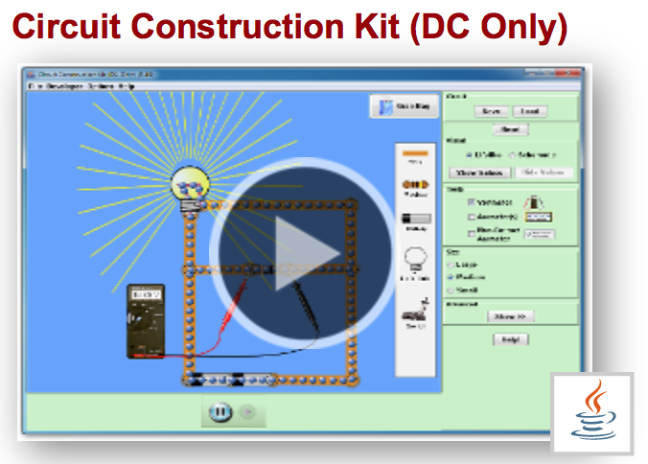

Objectives:
• to verify Kirchoff’s Voltage Law and Current Law
• to determine the effects on total resistance and power by adding or removing resistors in series
• to determine the effects on total resistance and power by adding or removing resistors in parallel

Description
Open the Circuit Construction Kit software from the computer, or download it from the Phet website. Select the Load option, and open the files named Series Circuit, Parallel Circuit, or Combination Circuit; they should resemble the diagrams shown below. Voltmeters and ammeters can be added to take measurements on each circuit element.

Series Circuits  Switches can be used to bypass a light bulb, or include it in the series section | Parallel Circuits  Switches can be used to bypass a light bulb, or include it in the parallel section | Combination Circuits  Switches can be used to bypass a light bulb, or include it in either the parallel or series section
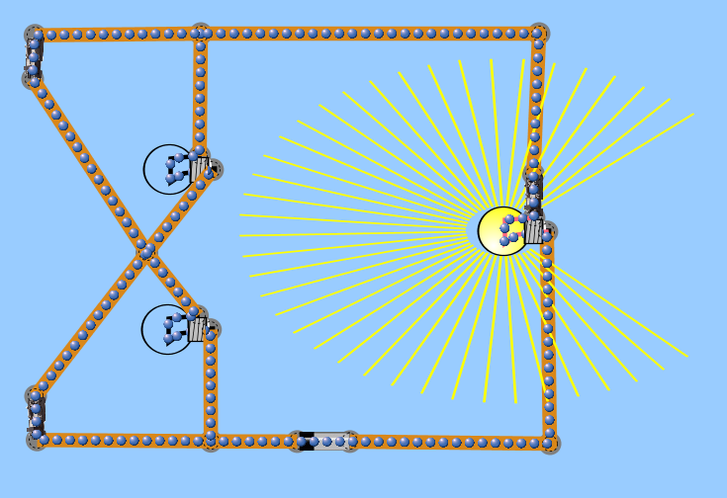 | 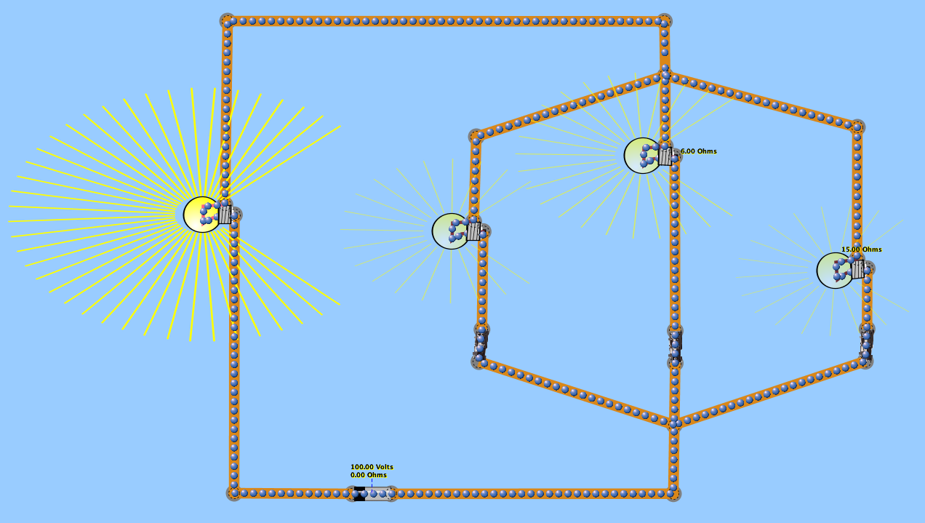 | 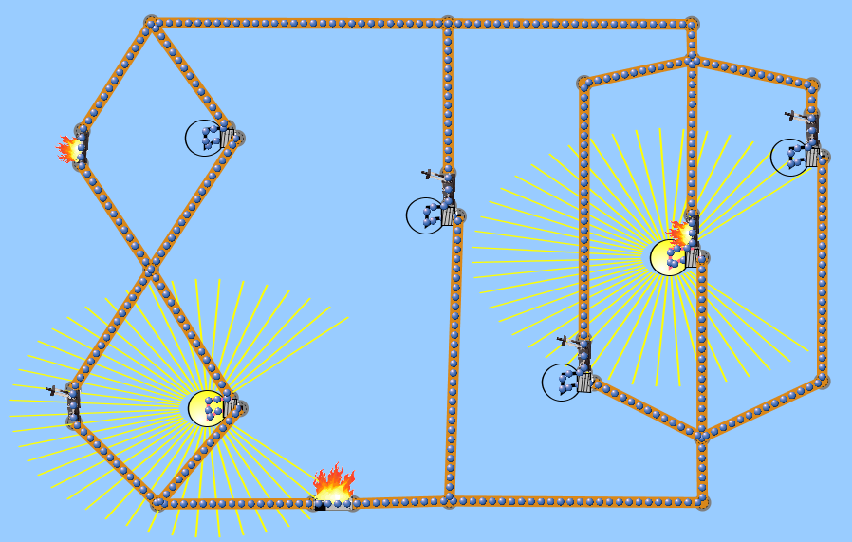

Data Collection and Analysis: Effect of Resistors in Series (simulation file: Series Circuits.cck)

- Use the switches to have all three bulbs active in series. Draw the circuit diagram below including the resistance of each bulb.

- Record the voltage and current through each item, then calculate the power loss in each bulb.
Voltage (battery):_______ Current (battery):_______

• Bulb #1: Voltage :_______ Current:_______ Power: _________

• Bulb #2: Voltage :_______ Current:_______ Power: _________

• Bulb #3: Voltage :_______ Current:_______ Power: _________

Total Power loss in all bulbs: _______________

Check: total power using values for the battery. (P = IV)

3. Remove one of the bulbs from your series circuit (use the switches!). Record the voltage and current through the battery, and calculate the power loss in all the active bulbs.
Voltage (battery):_______ Current (battery):_______

• Bulb #1: Voltage :_______ Current:_______ Power: _________

• Bulb #2: Voltage :_______ Current:_______ Power: _________

Total Power in all bulbs: _______________

Check: total power using values for the battery (P = IV)

Experiment with the simulation using the switches to bypass individual bulbs.

A. What is the effect of adding another resistor in series on the total resistance of the circuit?

________________________________________________________________________________

supporting calculation:

B. What is the effect of adding another resistor in series on the total power loss in the circuit?

________________________________________________________________________________

supporting calculation:

C. What is the effect of adding another resistor in series on the current in one of the other resistors?

________________________________________________________________________________

supporting calculation:

D. What is the effect of adding another resistor in series on the voltage in one of the other resistors?

________________________________________________________________________________

supporting calculation:

Data Collection and Analysis: Effect of Resistors in Parallel (simulation file: Parallel Circuits.cck)
Use the switches to have all three bulbs active in parallel; the forth bulb in series will always be on. Draw the circuit diagram below including the resistance of each bulb.

- Record the voltage and current through each item, then calculate the power loss in each bulb.
Voltage (battery):_______ Current (battery):_______

• Bulb #1: Voltage :_______ Current:_______ Power: _________

• Bulb #2: Voltage :_______ Current:_______ Power: _________

• Bulb #3: Voltage :_______ Current:_______ Power: _________

• Bulb #4: Voltage :_______ Current:_______ Power: _________

Total Power loss in all bulbs: _______________

Check: Total power using values for the battery, minus the power loss in the one bulb in series. (P = IV)

2. Remove one of the bulbs from your parallel circuit (use the switches!) Record the voltage and current through each active bulb, then calculate the power loss in all the active bulbs.
Voltage (battery):_______ Current (battery):_______

• Bulb #1: Voltage :_______ Current:_______ Power: _________

• Bulb #2: Voltage :_______ Current:_______ Power: _________

Total Power loss in all bulbs: _______________

Check: total power using values for the battery (P = IV)

Experiment with the simulation using the switches to bypass individual bulbs.

A. What is the effect of adding another resistor in parallel on the total resistance of the circuit?

________________________________________________________________________________

supporting calculation:

B. What is the effect of adding another resistor in parallel on the total power loss in the circuit?

________________________________________________________________________________

supporting calculation:

C. What is the effect of adding another resistor in parallel on the current in one of the other resistors?

________________________________________________________________________________

supporting calculation:

D. What is the effect of adding another resistor in parallel on the voltage in one of the other resistors?

________________________________________________________________________________

supporting calculation:

Data Collection and Analysis: Kirchoff’s Laws (simulation file: Parallel Circuits.cck)

1. Use the switches to have all six bulbs active. Draw the circuit diagram below including the resistance of each bulb. Calculate the total resistance of the entire circuit when all of the bulbs are active, using the resistance equations for series and parallel resistors.

2. Calculate the total resistance of the circuit when all of the bulbs are active using Ohm’s Law and the current flowing through the battery. How does your answer compare to that from step #2?

3. Use values from the simulation to verify Kirchoff’s current law for two junctions in the circuit. Show all you work clearly below.
Junction 1 Junction 2

4. Use values from the simulation to verify Kirchoff’s voltage law for two different loops in the circuit. Show all you work clearly below.
Loop 1 Loop 2

Experiment with the simulation using the switches to bypass individual bulbs.

A. What is the effect of adding another resistor in parallel on the total resistance of the circuit?

________________________________________________________________________________

supporting calculation:

B. What is the effect of adding another resistor in parallel on the total power loss in the circuit?

________________________________________________________________________________

supporting calculation:

C. What is the effect of adding another resistor in series on the current in one of the other resistors?

________________________________________________________________________________

supporting calculation:

D. What is the effect of adding another resistor in parallel on the voltage in one of the other resistors?

________________________________________________________________________________

supporting calculation:

Conclusion:
Summarize, in a brief paragraph, what relationships you have learned from this simulation. Be sure to include a description of the relationships between the current and voltage in series and parallel circuits, as well as how power consumption is effected when resistors are added in series and parallel.

