

displaying, analyzing & summarizing data
  - Author: Jeffrey Bush

Pre-Planning

LEARNING GOALS
- Students will conceptualize data as having variability that can be represented by a distribution Students will be able to describe the pattern formed by the data, as well as describe any outliers of that data.
- Students will be able to display, analyze and summarize data with dot plots and histograms
- This activity is designed to go with GoMath Grade 6, Module 16, lessons 4 and 5 on Dot Plots and Histograms. We envision this being a first-day activity, with the second day covering the following content:
  - Variable data and statistical questions
  - Constructing frequency tables from data and dot plots
  - Constructing histograms from frequency tables

Standards Addressed
- 6.SP.A.2 Understand that a set of data collected to answer a statistical question has a distribution which can be described by its center, spread, and overall shape.
- 6.SP.B.4 Display numerical data in plots on a number line, including dot plots, histograms, and box plots.
- 6.SP.B.5.c Giving quantitative measures of center (median and/or mean) and variability (interquartile range and/or mean absolute deviation), as well as describing any overall pattern and any striking deviations from the overall pattern with reference to the context in which the data were gathered.
- MP.2; MP.7

Curriculum Alignment
GoMath Grade 6, Lesson 16.4-16.5

Prior Knowledge
Students should have some basic understanding of probability, such as if the probability is zero, there is no chance of an action occurring, while if the probability is 100%, it definitely will happen.

Materials
- Technology: 2:1 or 1:1 laptop, chromebook, or iPad
- PhET sim: Plinko Probability
- Activity sheet

Lesson Plan (45 minutes)

Warm-up
5 MINUTES | Ask the students to access the PhET Plinko Simulation and open the intro screen. Allow students 5 minutes to explore the sim. Ask students, as you walk around:  - Where is the ball more likely to fall?  - Where is it less likely to fall?  As a whole class, provide students with time to share what they learned about the sim, especially pointing out features of the sim’s controls, and making connections between the buckets of balls and the bar graph.

Sim-based lesson
25 MINUTES | Pass out the worksheet to the students. Pair up students and explain that they are working independently but sometimes the activity has them discuss with their partner. Discussion and asking for help is encouraged but they are expected to do their own worksheet with their own trials on the simulation.  Circulate the room to be available for student questions and to ask probing/pushing questions. If a student is struggling with the task, it can help to probe for more information.  Ask students:  - What have you tried?  - How can we systematically show all the possibilities? (allow students to come up with their own strategies)  - How are the results displayed? What does that tell you about Plinko as a game? Which bins are more likely? Which bins are less likely? How come?  Encourage them to use data and their observations in their descriptions of their reasoning
10 MINUTES | Bring the class together for a whole-class discussion.  Remind students to close their laptops or turn around so that the sim does not distract them from listening.  Use an established teaching strategy such as popcorn discussion (one student answers, calls on the next student to talk), think-pair-share (pose question, allow time to think, turn and talk to partner), or group discussions (print out questions and have groups talk to each other and write down consensus to share aloud with class). Sample questions include:  - What happens when the ball hits a peg?  - What determines if it goes left or right?  - What does the dot plot tell us? What do the histograms tell us?  - When would you want to use a histogram to display data? When would a dot plot be better?  - What is the difference between displaying the histogram as count vs. probability?

Summary
5 minutes | Bring the class together for a final whole-class discussion.  Remind students to close their laptops or turn around so that the sim does not distract them from listening.  Use an established teaching strategy such as popcorn discussion (one student answers, calls on the next student to talk), think-pair-share (pose question, allow time to think, turn and talk to partner), or group discussions (print out questions and have groups talk to each other and write down consensus to share aloud with class). Sample questions include:  - Did you use a histogram or a dot plot to calculate mean, median and mode? How come? What other strategies did you use?  - Thinking back to the price is right, what value was Ryan the most likely to win?  - Why do they only allow 100 balls on the home screen?  - Why is there no dot plot option on the lab screens?  - What does the histogram tell us about the probability of landing in each bin?  - What happens to the difference between the expected and observed probabilities as you add more balls?

Name: ___________________________ Date: ___________ Class: _______________

display, analyze and summarize data

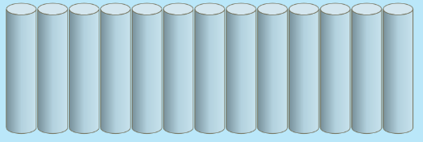
Start on the INTRO tab.
- Send 10 balls through the Plinko Machine. Draw where they land. This is called a dot plot and each dot represents one occurrence.

- Now compare with your partner, how are your dot plots different?

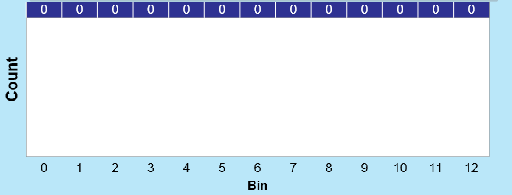
- Try switching back and forth between the “count” view, 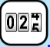, and the “container” view, . The count view presents what is called a histogram, a graph of the number of balls that fell in each bin. The container view shows a dot plot of the data. Draw a histogram representing the same data from your first trial.

- What is the mean, median, and mode bin number of these 10 Plinko tries?
  - Mean: b. Median c. Mode

- Now compare your mean median and mode with that of your partner. Were they different than yours? If so explain how come. If not, explain if you think they would be the same if you each did another trial.

- Now try 100 balls. Erase and retry several times. Discuss with your partner what you notice about the differences between each of your trials of 100 balls?

- Outliers are values that are either much greater or much less than the other data as a whole. Did any of your plots have any outliers? If so, what were they and how do you now they were outliers? If not, why do you think you didn’t see any outliers?

- Sketch the general shape of the pattern you see as a dot plot and as a histogram.

- What do you see as the advantage of the dot plot vs the histogram? Which is better when we want to find the median? Why? Which is better when we have 1000 data points? Why?

- Now go to the Lab part of the simulation and try running 1000 runs of a number of rows and binary probability (other than 1.00 or 0.00) of your choice. Draw the histogram below.
I set Binary probability to _____ I set number of rows to _____

- On our special edition of Plinko, all chips fall from the same location. We have recorded the chip landing places for 100 players in the graph below, using a dot plot.
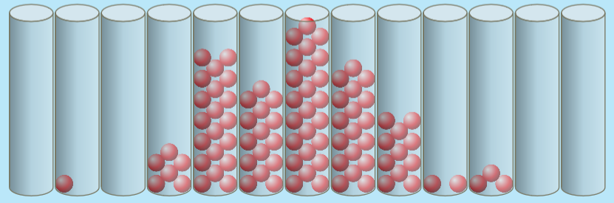

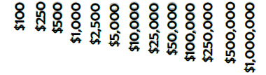

a. Which dollar amount was won the most?

b. What was the median amount of money won?

c. How many people won more than $25,000?

d. Does the data have any outliers? What are they? How do you know?

