

Using ratios and rates to solve problems
  - Author: Ian Whitacre, Sebnem Tekin

Pre-Planning
Students use given rate information to analyze a driving situation and make predictions. The teacher displays the sim and uses it to test students’ predictions, after they have completed their written work.

Curriculum Alignment
GoMath Grade 3, Lesson 6.3 (Explore Activity 2)

Materials
- Technology: 2:1 or 1:1 laptop, chromebook, or iPad
- PhET sim: Unit Rates
- Activity sheet

Lesson Plan (18 minutes)

launch
3 MINUTES | - Project the Racing Lab screen of the Unit Rates sim  - Using the default settings (50 miles, 2.0 hours), run the car to 150 miles. Ask students what they notice.  - Then slide the finish line to 100 miles, and ask students how long it will take the car to get there.  - After the class articulates a prediction with supporting argument, test their prediction with the sim.  - Feel free to ask for predictions for other distances, such as 50 miles, 75 miles, 125 miles, or 175 miles. Again, hear students’ reasons before testing their predictions with the sim.

Sim-based lesson
10 MINUTES | Introduce the Road Trip activity, and distribute the activity sheet  Instruct students (working individually or in pairs) to complete at least parts a and b prior to discussion.  - For part a,  - students might focus on relating the decimal 0.5 to the fraction ½  - students might focus on the fact that 35 and 0.5 are in the same place on the double number line  - students might focus on the distance from 0  - For part b,  - students might repeatedly add 35 miles and 0.5 hours  - students might use multiplication, especially to find the distances for 1 and 2 hours  - students might have difficulties working with the decimal numbers  As students work, eavesdrop on their work and conversations. How are they reasoning about equivalent rates and the way these are represented on the double number line?  Identify students with strategies or explanations to share with the class  In brief whole-class discussion:  - Call on one or more students to share answers to a. Discuss the point that the same line segment represents two related quantities.  - Call on a few students to share their predictions and explanations. As the class agrees on predictions, add the predictions to the double number line in the sim by writing the numbers in the text boxes.  - Once the predictions have been discussed and added to the double number line, test them by running the car. Slide the flag to each distance and click the green circular button to make the car go. Confirm (or refute) each prediction.  - Revisit the question of how rates are represented on the double number line. Identify both equal and proportional relationships (e.g., the length from 35 miles (0.5 hours) to 70 miles (1 hour) is the same as the length from 70 miles (1 hour) to 105 miles (1.5 hours); the length from 70 miles (1 hour) to 140 miles (2 hours) is twice the length from 35 miles (0.5 hours) to 70 miles (1 hour).  If students have not completed parts c and d, instruct them to do so  If time permits, discuss their answers to c and d

Name: ___________________________ Date: ___________ Class: _______________

road trip
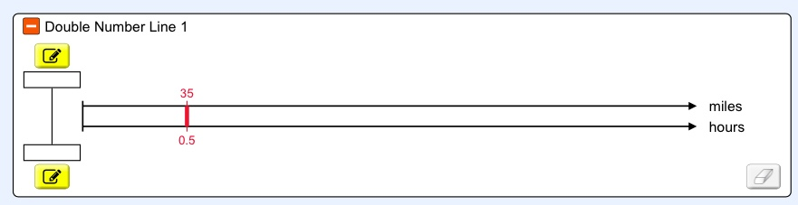

- Jennifer and Mikerra are on a road trip. They drive 35 miles in the first ½ hour. How is this rate represented on the double number line? Explain.

- At this rate, how far will they travel in 1 hour? 1.5 hours? 2 hours? 2.5 hours? Add your answers to the double number line above. Record any written work below. Be prepared to share and explain your predictions.

- What is the relationship between the initial rate of 35 miles in ½ hour and the other rates shown on the double number line?

- At the same rate, how long would it take Jennifer and Mikerra to travel 350 miles? Explain.

