

Ratios
  - Author: Ian Whitacre, Sebnem Tekin

Pre-Planning
Students use ratios to describe the relationship between two quantities. They use the matching patterns in the necklaces. They use ratio to solve problems involving proportional relationships.

LEARNING GOALS
- Students represent ratios with concrete models
- Students write ratios and generate equivalent ratios
- Applying multiplication and division to solve problems based on a given ratio
- Use three different ways to write ratio

Standards Addressed
- 6.RP.1.1 Understand the concept of a ratio and use ratio language to describe a ratio relationship between two quantities.
- 6.RP.1.3 Use ratio and rate reasoning to solve real-world and mathematical problems, e.g., by reasoning about tables of equivalent ratios, tape diagrams, double number line diagrams, or equations.
- 6.RP.1.3a Make tables of equivalent ratios relating quantities with whole-number measurements, find missing values in the tables, and plot the pairs of values on the coordinate plane. Use tables to compare ratios.
- MP.4

Curriculum Alignment
GoMath Grade 6, Lesson 6.1

Prior Knowledge
- Knowledge of basic multiplicative facts
- Recognition of patterns
- Real-world experiences with patterns
- Write equivalent fractions
- Make part to part comparisons by using fractions

Materials
- Technology: 2:1 or 1:1 laptop, chromebook, or iPad
- PhET sim: Proportion Playground
- Activity sheet

Lesson Plan (50 minutes)

Warm-up
7 MINUTES | Start the lesson with a discussion about patterns:  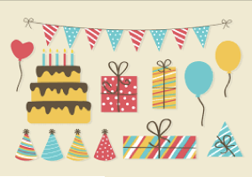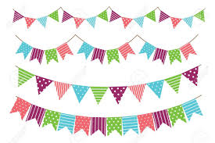  - Use one or more multiple bunting flags given in the following pictures  - How do the colors in the bunting flags repeat?  - How can we explain the rule in the pattern?  - In what ways might patterns be useful?  Call on a few students to share their ideas.

Sim-based lesson
10 MINUTES | Display the Proportion Playground sim on your screen or interactive whiteboard.  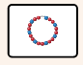  Instruct students to go to Proportion Playground: choose Explore option and stay in the necklace scene.  Play for 3-5 minutes.  Students are exploring and the teacher is focusing on how students are exploring the sim and what they notice.  While students play, circulate and interact with them. Ask open-ended questions about what they notice about the sim, how it works, and what they think about the relationship between the number of red beads and blue beads and the pattern (e.g. why do you think those patterns match or do not match?)  Lead a brief discussion on what students discover or their questions about the sim or patterns.  Begin to focus the discussion on what they are going to figure out with the tasks:  - How to the number of blue and red beads relate to matching patterns.  - How to find matching patterns with keeping the ratio between blue and red beads  Use “ratio” terminology to express the relationship between the number of blue and read beads.  Define ratio in terms of student ideas and the whole-class discussion.
12 MINUTES | TASK 1  Relate what is discussed about ratio in the introduction part to the task.  Instruct students to get started with Task 1, which involves finding the number of blue and red beads by keeping the pattern rule in a necklace.  Instruct students to stay in Proportion Playground: Explore - the necklace  As students work, notice the strategies that they are using to make the same pattern and to find the matches. Look especially for which number pair they are using:  - between relation: comparing the number of red beads in the first necklace with the second necklace to decide the number of blue beads to be used.  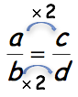  (e.g. in the given example, students may multiply (or divide) “a” by 2 to get the value of “c” and do the same thing to get “d” by using the value of “b”.)  - within relation: using the relation between red and blue beads in the first necklace to decide the number of beads in the second necklace) that students use.  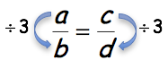  (e.g. in the given example, students may divide (multiply) “a” by 3 to get the value of “c” and do the same thing to get “d” by using the value of “b”.)  - Repeated addition by following the pattern  (e.g. if there is a 1:3 ratio between # of red beads to # of blue beads, the students may add 1 red bead for every 3 blue beads to the pattern)  Select one or more students to share their solution strategies.  Focus on writing each ratio in three different ways. the possible .
12 MINUTES | 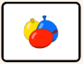  Display the Proportion Playground sim on your screen or interactive whiteboard. Instruct students to go to Proportion Playground: Balloons and play for 1-2 minutes.  - While students play, circulate and interact with them. Ask open-ended questions about what they notice about the sim, how it works, and what they think about the relationship between the amount of blue and yellow paints.  - Lead a brief discussion on what students discover or their questions about the sim or mixture.  - Begin to focus the discussion on how matching patterns relate to the amount of blue and yellow paints.  TASK 2  - Instruct students to get started on Task 2, which is to find the amount of yellow and blue colors for making the same color mixture.  - Lead a whole class discussion about the different meanings of the ratio in necklace and paint context.  - Lead a whole discussion about the possible methods to find the missing number in the equation while keeping the ratio the same.  - Discuss their methods to find the missing number in a ratio. Are they using between strategy, within strategy, or repeated addition? Why do they prefer to use this strategy and why not other strategies?  The teacher may ask the following questions for the discussion.  - When do we use ratio?  - Why are ratios good tools to use for comparing quantities?  - Why do we use multiplication and division while working on ratios?  - How can you relate fractions and ratio? In what ways are they similar or different?

Summary
5 minutes | Assign students to complete “Guided Practice.”

Name: ___________________________ Date: ___________ Class: _______________

Ratios

Warm-up
- How does the pattern including the shapes and colors in the bunting flags repeat?
.
- How can you explain the rule in the pattern?

- In what ways, patterns might be useful?

A ratio is _____________________________________________________________.

Exploration Phase
Go to the Explore screen in the Proportional Playground sim. Play with the sim for 5 minutes. Write down 3 discoveries that you make or questions that you have.

- 1)
- 2)
- 3)

Task 1
- I used to have a necklace having 2 red beads and 6 blue beads when I was I child. Now, it is too small for my neck. I want to have a larger one with the same pattern.
  - What is the ratio red beads to blue beads in the small necklace?

  - How many red and blue beads can you use to make a necklace with the same pattern?

- In the table below, you have some blanks to fill in based on the given ratio between the number of red and blue beads.
Number of Red Beads | 3 | 6 |  | 18
Number of Blue Beads | 1 | 2 | 4

- What do you notice about the numbers in the table that show a matching?

- Find the biggest necklaces you can make with the same pattern. How many different ratios can you write with the number of blue beads, red beads, or the total number of beads you use?

- What are the three different ways to write a ratio?

- Here you have another necklace with a different pattern! In this necklace, there are 3 red beads for every 5 blue beads. Based on this information find other matching patterns and fill in the table. You may / may not be able to use the sim to find the missing numbers in the table.
Number of Red Beads | 3 |  | 12 |  | 36
Number of Blue Beads | 5 | 10 |  | 40

Explain your strategy (or strategies) you used to find the missing numbers in the table.

Exploration phase
Go to the Explore screen in the Proportional Playground sim. Play with the sim for 2 minutes. Write down the differences or similarities you see with the necklace screen you worked previously.

- 1)
- 2)
- 3)

Task 2
- I mix 3 galloons of blue paint and 2 galloons of yellow paint to make my favorite color. But I need to have more of this color to paint the fences. I want to keep mixing my favorite color.
- Use the sim and fill in the blanks of the following table to make the same color.
Blue Color (gal) | 3 | 6 | 12 |  | 36
Yellow Color (gal) | 2 |  |  | 10

- What do you notice about the numbers in the table that show a match?

- What if we want to have different color tones as given below and we do not have the sim? How can we find the amount of each color missing in the following equations?
  blue paint |  | 27  balloons of blue paint  =
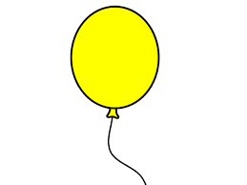  yellow paint |  | …………  balloons of yellow paint
yellow paint  = |  | ……….  balloons of yellow paint
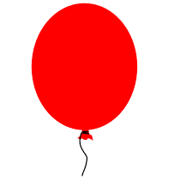  red paint |  | 24  balloons of red paint

Explain your thinking:

Discussion
- When do we use ratio?

- Why are ratios good tools to use for comparing quantities?

- Why do we use multiplication and division while working on ratios?

- How can you relate fractions and ratio? In what ways are they similar or different?

