Name: ___________________________________________________ Date:____________________________________ Hour: ______________

Molecular Polarity Lab
https://goo.gl/zQkLwf

Go to the website listed above. Click the play symbol on the simulation.

Part 1: Two Atom Investigation
- Click the keep the box for bond dipole checked and check the boxes to show the partial charges and the bond character
- Keep the electronegativity of A at low and increase and decrease the electronegativity of atom B. Observe the arrow, partial charge and bond character. Fill in the following observation
As the electronegativity of atom B increases the...
arrow _____________________________________________________________________________________
partial charges ___________________________________________________________________________
bond character ___________________________________________________________________________
- Now put the electronegativity for A to the middle and vary the electronegativity of B and observe the results.
Fill in the following information.
- The polarity arrow always points to the ________________________________ electronegative atom.
- The partial positive charge is always on the _____________________________ electronegative atom.
- The larger the electronegativity difference the more __________________________________ the bond character.
Part 2: Three atom Investigation
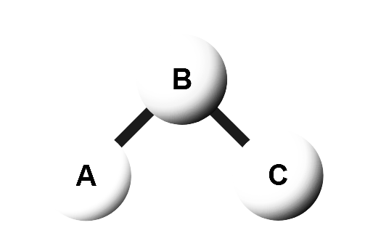
- Keep the original “bent” arrangement of atoms and set the electronegativities of A and C to low and B to middle. Click to show the bond dipoles, molecular dipoles and partial charges.
  - Draw the bond dipoles on the bonds in the diagram
  - In a different color show the overall molecular dipole in the diagram
  - Draw the partial charge symbols in another color in the diagram.
  - Click the electric field on. Describe what happened to the molecule - be very specific.

- Click the reset button.  Keep the “bent” arrangement of atoms and set the electronegativities of A and C to high and B to middle. Click to show the bond dipoles, molecular dipoles and partial charges.
  - Draw the bond dipoles on the bonds in the diagram
  - In a different color show the overall molecular dipole in the diagram
  - Draw the partial charge symbols in another color in the diagram.
  - Click the electric field on. Describe what happened to the molecule - be very specific.

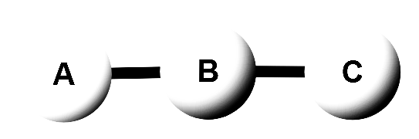
- Click the reset button. Change the arrangement of atoms to a “linear” arrangement (see below) and set the electronegativities of A and C to high and keep B to middle. Click to show the bond dipoles, molecular dipoles and partial charges.
  - Draw the bond dipoles on the bonds in the diagram
  - In a different color show the overall molecular dipole in the diagram
  - Draw the partial charge symbols in another color in the diagram.
  - Click the electric field on. Describe what happened to the molecule - be very specific.

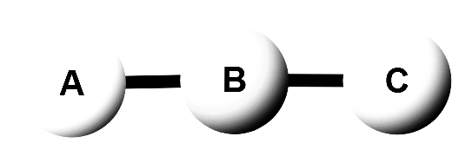
- Take off the electric field. Rotate the molecule to keep the “linear” arrangement (see below) and set the electronegativities of A to high, keep B to middle and set C to low. Click to show the bond dipoles, molecular dipoles and partial charges.
  - Draw the bond dipoles on the bonds in the diagram
  - In a different color show the overall molecular dipole in the diagram
  - Draw the partial charge symbols in another color in the diagram.
  - Click the electric field on. Describe what happened to the molecule - be very specific.

- Take off the electric field. Rotate the molecule to keep the “linear” arrangement (see below) and set the electronegativities of A and C to low and keep B to middle and set C to low. Click to show the bond dipoles, molecular dipoles and partial charges.
  - Draw the bond dipoles on the bonds in the diagram
  - In a different color show the overall molecular dipole in the diagram
  - Draw the partial charge symbols in another color in the diagram.
  - Click the electric field on. Describe what happened to the molecule - be very specific.

- Take off the electric field. Rotate the molecule to keep the “linear” arrangement (see below) and set the electronegativities of A, Band C to middle. Click to show the bond dipoles, molecular dipoles and partial charges.
  - Draw the bond dipoles on the bonds in the diagram
  - In a different color show the overall molecular dipole in the diagram
  - Draw the partial charge symbols in another color in the diagram.
  - Click the electric field on. Describe what happened to the molecule - be very specific.

Summary
Summarize what you learned by answering the following questions.
- Which way do the bond arrows point?
- Can a molecule have bond dipoles but not have a molecular dipole? Explain.
- What happens when a molecule with a dipole is put in an electric field? Be specific.
Part 3: Real Examples
You will now apply what you learned to real molecules. The real molecules does not work on the simulation so just apply what you know.

HF - The ball and stick structure for HF is shown. Answer the following and do what is asked
- Which atom is more electronegative? _______________
- Draw a bond polarity arrow (bond dipole)
- Draw the partial charges on the molecule
- Would you expect this to move in an electric field? Draw it in the field provided.
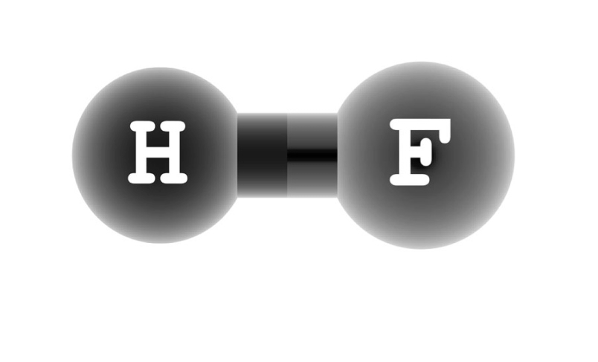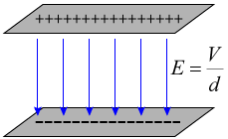

H₂O - The ball and stick structure for H₂O is given. Answer the following and do what is asked.
- Which atom is more electronegative? _______________
- Draw a bond polarity arrow (bond dipole)
- Place partial charges on the molecule
- In a different color draw a molecular dipole arrow.
- Would you expect this to move in an electric field? Draw it in the field provided.
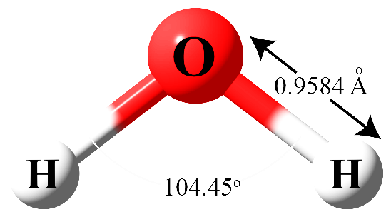

CO₂ - The ball and stick structure for CO₂ is given. Answer the following and do what is asked.
- Which atom is more electronegative? _______________
- Draw a bond polarity arrow (bond dipole)
- Place partial charges on the molecule
- In a different color draw a molecular dipole arrow.
- Would you expect this to move in an electric field? Draw it in the field provided.
