Name:
Objective: Explore transverse and longitudinal waves as well as examples of each.
Part 1: exploring amplitude and pulse waves
Background video: https://www.youtube.com/watch?v=RVyHkV3wIyk

Vocab | definition | image
Amplitude: | energy a wave has. | 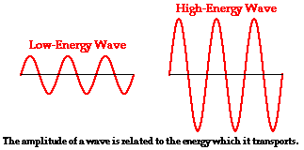
Frequency: | number of waves that pass by per second. | 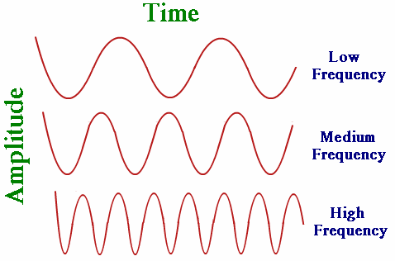
Periods: | Length of time for a save to complete. | 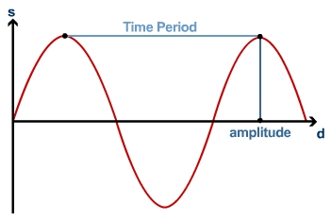
Wavelength: | distance between two crests. | 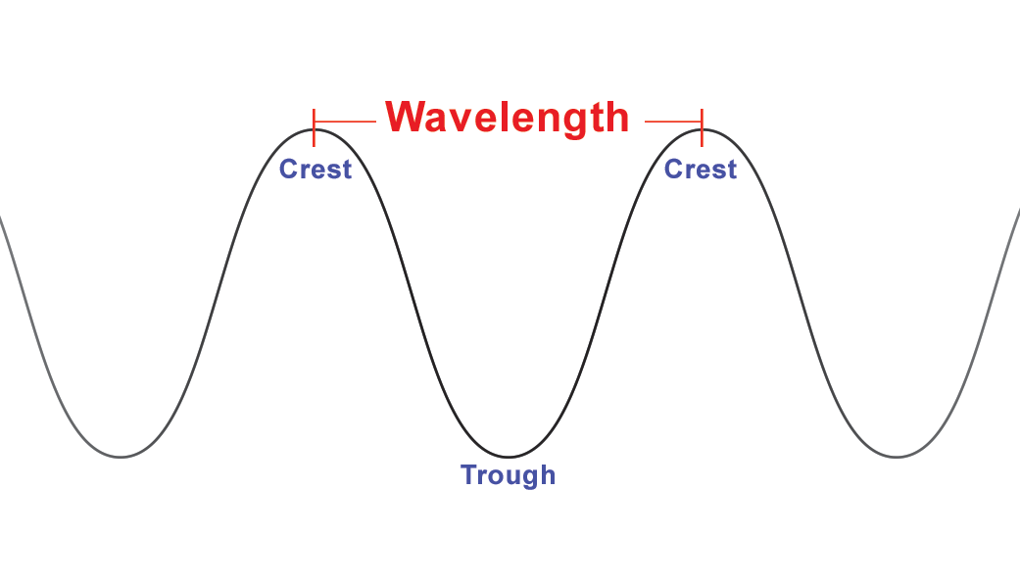
Crest/Trough: | Crest=the highest point on a wavelength  Trough=the lowest point on a wavelength | 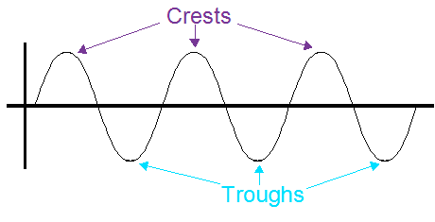

Instructions for measuring frequency, periods, and wavelength in a simulation:
(click the link to open the simulation)
https://phet.colorado.edu/sims/html/wave-on-a-string/latest/wave-on-a-string_en.html

Use the demonstrations below to help you measure the “period” and “wavelength”.
Demonstration: Measuring the period. https://www.youtube.com/watch?v=QRzSha78gPc
Demonstration: Measuring the Wavelength: https://www.youtube.com/watch?v=P-3PEbpIsww

- Select oscillate, slow motion, timer, and rulers.
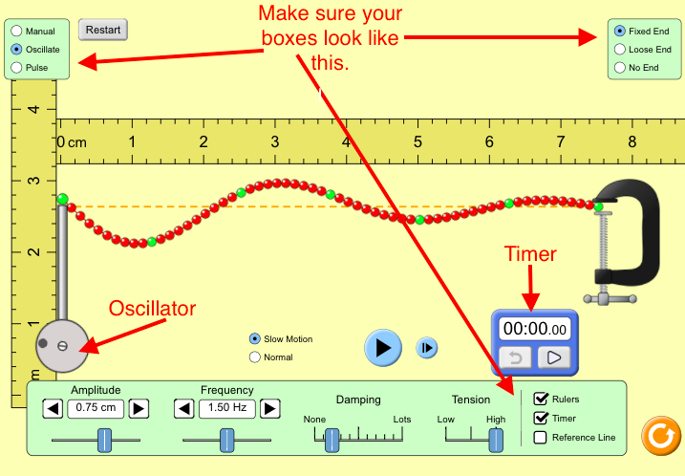
- Set the amplitude to 1 cm (This will stay the same).
- Set frequency to .5Hz.
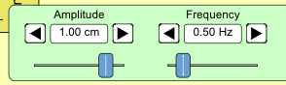
- Pause ()the simulation when the oscillator is at the bottom of it’s cycle.
- Click play ()on your timer . It should not start yet.
- Click play () to start the simulation. The waves and the timer will start.
- Click pause () when the oscillator is back at the bottom of the cycle . This means you have made one wave. 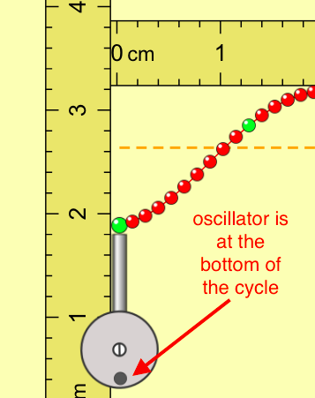
- Use the ruler (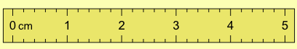) to measure wavelengths.
- Record your data in the table below (a period is how long it takes to make one wave).

***Repeat steps 1 - 9 for 1Hz, 2Hz, and 3 Hz (change the frequency ONLY/do NOT change the amplitude).***

Frequency | Period (Unit=S) | Wavelength (Unit=Cm)
1 Hz
2 Hz
3 Hz

- Based on observations, What is wavelength?

- Based on observations, What is a period?

- Based on observations, what is frequency?

- Based on observations, What is the relationship between frequency in period. (compare and contrast). Give an example to defend your answer.

- Based on observations, what is a question you still have about waves?

