Fraction Matching: Proper and Improper Fractions
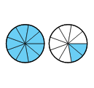
This lesson serves as either an introduction to part to whole fraction models or an intervention activity in later grades. More difficult levels of the activity extend to equivalent fraction practice. For example, students may be asked to match $\frac{22}{18}$to Students will informally experiment with matching fractions in both proper and improper form, pie chart models, and bar chart diagrams. Students will confirm their answers using the PhET simulation. This lesson plan uses the PhET Fractions Activity. Materials are included in both .docx and .pdf files. If available, teachers may find the most success uploading the .docx files to Google Drive, converting the files to Google Docs, and sharing with classes via a Google Classroom type platform to allow students access to electronic worksheets.

Content Objectives:
- Students will interpret a fraction denominator as a whole partitioned into equal parts and a numerator as the quantity of equal parts.
- Students will match fractions in proper or improper form, pie chart representations, and bar model diagrams.
- Students will be exposed to number line equivalents for fractions.

Common Core Standards:
3.NF.A.1 - Understand a fraction 1/b as the quantity formed by 1 part when a whole is partitioned into b equal parts;
understand a fraction a/b as the quantity formed by parts of size 1/b. (Please note that parts of this lesson go beyond
the grade 3 expectations limited to fractions with denominators 2, 3, 4, 6, and 8.)
4.NF.A.13.NF.A.1 - Explain why a fraction a/b is equivalent to a fraction (n x a)/(n x b) by using visual fraction models, with attention to how the number and size of the parts differ even though the two fractions themselves are the same size. Use this principle to recognize and generate equivalent fractions. (Please note that parts of this lesson go beyond
the grade 4 expectations limited to fractions with denominators 2, 3, 4, 5, 6, 8, 10, 12, and 100.)

CCSS Math Practices:
MP1: Make sense of problems and persevere in solving them.
MP4: Model with mathematics.
MP5: Use appropriate tools strategically.
MP6: Attend to precision.
MP8: Look for and make use of structure.

Materials:
- Chromebooks (class set or partners) - Please note that provided directions for the activity are written for Chromebooks and this activity will need to be modified if you are using other devices.
- Access to PhET Fraction Matching simulation. (You may want to link this to your class website for easy access for students)
- Fraction Matching - Warm Up
- Fraction Matching - Student Page (This is best used as a digital copy. It could be a paper copy as well, but the answer boxes may need to be formatted to allow for written answers.)
- Fraction Matching - Exit Ticket (There are two exit ticket versions. The first is a leveled quiz where students may select which question level they would like to answer. Levels on the exit ticket correspond to gradual difficulty rather than levels from the sim.) The maximum number of points awarded is 10 points. Students who answer the Level 3 question correct earn 5/5, students who answer the Level 2 question correct earn 4.5/5, and students who answer the Level 1 question correct can 4/5. Points could be omitted from the exit ticket for student information to be used anecdotally.
- Fraction Matching - Sample Student Work

The Plan
Time | Activity | Notes
0:00-0:10 | Fraction Matching Warm Up | Project or display Fraction Matching - Warm Up to the front of the room. Students should work for 5 minutes silently and independently. They should talk to their table partner for three minutes. Then, use equity cards (or other randomization technique) to choose students to show/discuss their solutions with the whole class.
0:15-0:40 | PhET Fraction Matching | Using Google Classroom or some other method, share the Finding Unit Rates - Student Page so that each student has a digital copy.  Have each student pick up their assigned chromebooks.  Guide students to the PhET Fraction Matching activity using directions 1-3 of the Fractions Matching - Student Page. Allow students a few minutes to explore the sim.  Once students have logged in and have explored for a couple of minutes, project the sim on the front screen, and briefly guide the class in a discussion:  *What did you notice?  *What patterns did you see?  *What information are you using to help match fractions to diagrams?  *What do you suppose the number on the bottom of the fraction tells you? Do you you know what it is called?  *What do you suppose the number on the top of the fraction tells you? Do you you know what it is called?  *What mistakes have you made that have allowed you to understand fractions better?  (Depending on your class, you may choose to do Level 1 as a whole class with students taking turns matching fractions to diagrams or diagrams to diagrams and using the suggested questions above.)  Show students how to enter their answers into their digital worksheet and also how to take a screenshot using  Students may work through the digital worksheet and levels at their own pace.
0:40-0:50 | Closure and Exit Ticket | Students log out and return Chromebooks.  Provide a Fraction Matching - Exit Ticket to each student.

Follow-up:
After grading students’ exit tickets, you may want to provide them with the opportunity to clear any misconceptions by allowing them to make corrections using the module and then asking them to identify their mistake. The questions from the assessment can be found in the following place of the module:

1) $\frac{1}{3}$compared to $\frac{1}{4}$ (Level 1)
2) Model equivalent for $1\frac{1}{4}$ (Level 3)
3) Equivalent fraction for $\frac{9}{7}$ (Level 6)

FRACTION MATCHING - Warm Up
Today you are going to complete a fraction matching activity. Below are three possible matches. Identify a match you agree with and explain why. Identify a match you disagree with and explain why.

1. Match #1
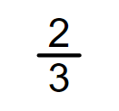

2. Match #2

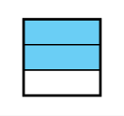

3. Match #3
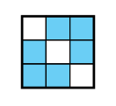

Name:______________________________ Date:__________ Period:__________

Fraction Matching- Student Page
Directions | Questions
1. Visit the PhET Fraction Matching activity.  2. Click on 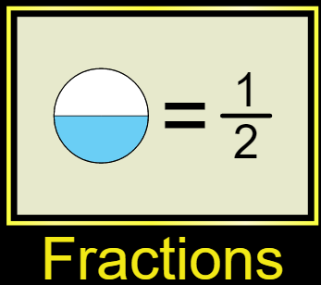  3. Click on 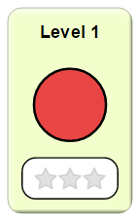  4. Use the scales to match a fraction to a diagram or a diagram to a diagram. When you think you have a match, click 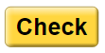 to check your match. If you are incorrect, find your mistake and then click 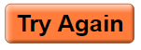.  5. When you finish, answer the questions to the right BEFORE moving on. | Screenshot your score and paste it in the box below.  Click Copy to clipboard then to PASTE  What is the fraction representation for 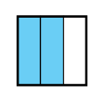. How do you know? (Write your answer in the box below. It will expand as you type.)
6. Click 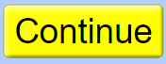on your score report.  7. Click 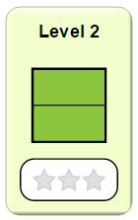  8. Use the scales to match fractions.  9. Answer the questions to the right. | Screenshot your score and paste it in the box below.  Click Copy to clipboard then to PASTE  Look at the vertical number line. What information can you gain by looking at the number line?  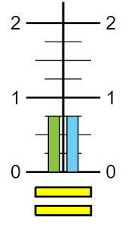  Look at the vertical number line. What do you think the inequality sign, 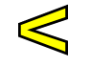, represents?
10. Click on your score report.  11. Go to the next level. As you work the levels, take screenshots of your score reports and paste them on the screen to the right.
  Level | Screenshot
  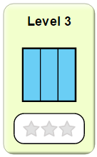
  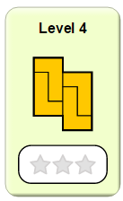
  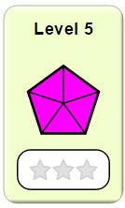
  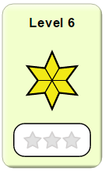
  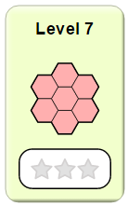
  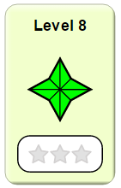

Name:______________________________ Date:__________ Period:__________

FRACTION MATCHING - Leveled Exit Ticket

Directions: Pick one problem below to solve. If you do more, only one will count for your grade.
Level 1 (4 points) | Level 2 (4.5 points) | Level 3 (5 points)
What advice do you have for the person who made the mistake below?  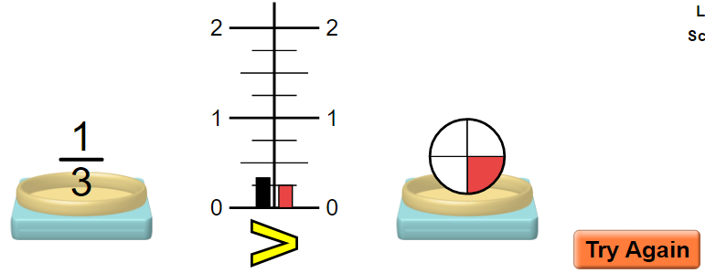 | 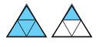  What advice do you have for the person who made the mistake below?  $=\frac{5}{8}$ | What advice do you have for the person who made the mistake below?  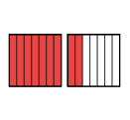  $=\frac{9}{7}=\frac{27}{14}$

Name:______________________________ Date:__________ Period:__________

FRACTION MATCHING - Exit Ticket

What advice do you have for the student who made the mistake below?

$=\frac{5}{8}$

Name:______________________________ Date:__________ Period:__________

Fraction Matching- Sample Student Work
Directions | Questions
1. Visit the PhET Fraction Matching activity.  2. Click on  3. Click on  4. Use the scales to match a fraction to a diagram or a diagram to a diagram. When you think you have a match, click to check your match. If you are incorrect, find your mistake and then click .  5. When you finish, answer the questions to the right BEFORE moving on. | Screenshot your score and paste it in the box below.  Click Copy to clipboard then to PASTE  What is the fraction representation for . How do you know? (Write your answer in the box below. It will expand as you type.)
  12 points possible
  Look for students to mention a whole divided into three parts and two shaded parts for a fraction of $\frac{2}{3}$.
6. Click on your score report.  7. Click  8. Use the scales to match fractions.  9. Answer the questions to the right. | Screenshot your score and paste it in the box below.  Click Copy to clipboard then to PASTE  Look at the vertical number line. What information can you gain by looking at the number line?  Look at the vertical number line. What do you think the inequality sign, , represents?
  12 points possible
  Look for students to mention two equal line less than one whole. Students may also read the number line and notice the lines are equivalent to $\frac{3}{4}$.
  Look for students to mention that one side of the number line shows a value larger than the other. Students may also incorporate “greater than” and “less than” vocabulary.
10. Click on your score report.  11. Go to the next level. As you work the levels, take screenshots of your score reports and paste them on the screen to the right.
  Level | Screenshot
   | 12 points possible
   | 12 points possible
   | 12 points possible
   | 12 points possible
   | 12 points possible
   | 12 points possible

Name:______________________________ Date:__________ Period:__________

FRACTION MATCHING - Leveled Exit Ticket - ANSWERS

Directions: Pick one problem below to solve. If you do more, only one will count for your grade.
Level 1 (4 points) | Level 2 (4.5 points) | Level 3 (5 points)
What advice do you have for the person who made the mistake below?  The pie chart has been split into 4 equal parts with one piece shaded which represents the fraction $\frac{1}{4}$. The student’s mistake is writing a fraction that compares the shade portion to the unshaded portion. | What advice do you have for the person who made the mistake below?  $=\frac{5}{8}$  The shaded model represents the fraction $1\frac{1}{4}$. This student may have thought that the whole was 8 instead of 4 and written a fraction on the shaded portion compared to the small triangles. | What advice do you have for the person who made the mistake below?  $=\frac{9}{7}=\frac{27}{14}$  The student accurately represented the model using the fraction $\frac{9}{7}$. However, when the student found the equivalent fraction, they multiplied 9 by 3 and 7 by 2 creating a fraction that is not equivalent.

Name:______________________________ Date:__________ Period:__________

FRACTION MATCHING - Exit Ticket

What advice do you have for the student who made the mistake below?

$=\frac{5}{8}$

The shaded model represents the fraction $1\frac{1}{4}$. This student may have thought that the whole was 8 instead of 4 and written a fraction on the shaded portion compared to the small triangles.

