6th Grade Math Lesson: Finding Unit Rates
This lesson serves as an introduction to finding unit rates. It may be helpful if students have covered Common Core Standard 6.RP.A.1 - (Understand the concept of a ratio and use ratio language to describe a ratio relationship between two quantities) prior to this lesson. Students will informally experiment with finding unit rates using addition, subtraction, multiplication, and division. Students will be able to confirm their answers using the PhET simulation.

Content Objectives:
- Students will interpret values on a number line.
- Students will use addition, subtraction, multiplication, and division strategies to determine unit rate.

Common Core Standards:
6.RP.A.2 - Understand the concept of a unit rate a/b associated with a ratio a:b with b $≠$0, and use rate language in
the context of a ratio relationship.
6.RP.A.3 - Use ratio and rate reasoning to solve real-world and mathematical problems, e.g., by reasoning about tables
of equivalent ratios, tape diagrams, double number line diagrams, or equations.

CCSS Math Practices:
MP1: Make sense of problems and persevere in solving them.
MP4: Model with mathematics.
MP5: Use appropriate tools strategically.
MP6: Attend to precision.
MP8: Look for and make use of structure.

Materials:
- Chromebooks (class set) - Please note that provided directions for the activity are written for Chromebooks and this activity will need to be modified if you are using other devices. Materials for this activity may be uploaded to Google Drive in order for students to use electronically.
- Access to PhET Unit Rates Shopping simulation (You may want to link this to your class website for easy access for students)
- Finding Unit Rates - Warm Up
- Finding Unit Rates - Student Page (This is best used as a digital copy. It could be a paper copy as well, but the answer boxes may need to be formatted to allow for written answers. You may also choose to differentiate this activity and assign different sections to students based on ability. In this case, the exit ticket could be used prior to the activity in order to assign tasks to students.)
- Finding Unit Rates - Exit Ticket (There are two exit ticket versions. The first is a leveled quiz where students may select which level of question they would like to answer. Questions are designed to have gradual difficulty.) The maximum number of points awarded is 10 points. Students who answer the Level 3 question completely correct can earn 10/10, students who answer the Level 2 question completely correct can earn 9/10, and students who answer the Level 1 question completely correct can earn 8/10)
- Finding Unit Rates - Sample Student Work

The Plan - Day 1
Time | Activity | Notes
0:00-0:10 | Cookie Sharing Warm Up | Project or display Finding Unit Rates - Warm Up to the front of the room. Students should work for 5 minutes silently and independently. They should talk to their table partner for three minutes. Then, use equity cards (or other randomization technique) to choose students to show/discuss their solutions with the whole class.
0:15-0:40 | PhET Unit Rates Shopping - Apples  (Using Addition and Subtraction to Find Unit Rates) | Using Google Classroom or some other method, share the Finding Unit Rates - Student Page so that each student has a digital copy.  Have each student pick up their assigned chromebooks.  Guide students to the PhET Unit Rates Shopping activity using directions 1-4 of the Finding Unit Rates - Student Page. Allow students a few minutes to explore the sim.  Once students have logged in and have explored for a couple of minutes, project the sim on the front screen, and briefly guide the class in a discussion:  *What did you notice?  *What patterns did you see?  *What happened to the price on the scale when you added bags of fruit?  *What happened to the price when you took one piece of fruit off the scale?  *What happened to the price when you took a second piece of fruit off the scale?  *Could you use the scale to find the price of one piece of fruit? How?  Show students how to enter their answers into their digital worksheet and also how to take a screenshot using  Fifteen minutes before class ends, give students a five minute warning. At the end of the day they will be discussing answers to the questions:  *Write your own definition for the vocabulary word unit rate.  *How can you use addition and subtraction to find a unit rate?
0:40-0:50 | Closure and Clean Up | Have students share answers to the last questions:  *Write your own definition for the vocabulary word unit rate.  *How can you use addition and subtraction to find a unit rate?  Have students log out and return Chromebooks.

The Plan - Day 2/3
Time | Activity | Notes
0:00-0:10 | Warm Up and Student Exemplars | Direct students to pick up Chromebooks and go to the PhET Unit Rates Shopping activity.  Before students get started for the day, select exceptional short answer responses from yesterday’s Apple activity. You can use the Student Sample Worksheet as well. Note how to make sure to fully answer the question and also explain your process.
0:15-0:40  (this may take longer and can stretch into a third day) | PhET Unit Rates Shopping - Lemons  (Using Multiplication to Find Unit Rates)  PhET Unit Rates Shopping - Pears  (Using Division to Find Unit Rates) | Using Google Classroom or some other method, share the Finding Unit Rates - Student Page so that each student has a digital copy.  Have each student pick up their assigned chromebooks.  Students will continue to work on the Lemon and Pear sims focusing on how to use multiplication and division to find unit rates.  Questions to ask students as they are working:  *If you know the unit rate of an item, how can you use it to determine the cost of a group of items?  *How can you use multiplication to find a unit rate?  *How can you use division to find a unit rate?  *How are you using the double number line to find a unit rate?  *What other types of unit rate in addition to price per item could you find using this sim?  *How has your understanding of unit rate changed as you have been working on this project?
0:40-0:50 | Exit Ticket and Clean Up | Students will complete exit ticket. You can either use this as a closing activity, or before the last day to gather formative information about how to help students on the last day.  Have students log out and return Chromebooks.

Follow-up:

After grading students’ exit tickets, you may want to provide them with the opportunity to clear any misconceptions by allowing them to make corrections using the module and then asking them to identify their mistake. The questions from the assessment can be found in the following place of the module:

1) If 4 carrots cost $0.60, what is the unit rate for one carrot? Explain your process below. (button #2, carrots sim)
2) If 5 oranges cost $3.75, what is the unit rate for one orange? Explain your process below. (button #1, oranges sim)
3) If .4 pounds of purple candy cost $2.16, what is the unit rate for 1 pound of purple candy? Explain your process below. (button #3, purple candy sim)

After this lesson students may also benefit from using more formal ratio table notation. The Math in Context Models You Can Count On book provides thorough direct instruction and practice problems for how to use a ratio table.

FINDING UNIT RATES - Warm Up
1. Imagine you have a box of one dozen chocolate chip cookies. (That’s 12 to be exact!) You and your best friend decide to share the cookies.

A. What operation (addition, subtraction, multiplication, division) will you use to solve this problem? Why does this operation make sense?

B. If you fairly share the cookies with your best friend, how many will you each get?

2. Before you could eat your cookies, two more of your friends show up and you decide to share the cookies with them as well. (That makes four people total.) If you fairly share the cookies, how many will you each get?

3. You are interrupted from your delicious dessert one more time as your friend suggests that you share the cookies with your class that has 24 people.

A. How many cookies will each person get?

B. How many people will share each cookie?

Name:______________________________ Date:__________ Period:__________

FINDING UNIT RATES - Student Page
Apples
Directions | Questions
1. Visit the PhET Unit Rates Shopping activity  2. Click on   3. Click on in the bottom left corner, then select Apples in the menu  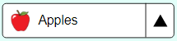  4. Place one set of apples on the scale.  | Look at the price on the scale. What is the cost for 5 apples? (Write your answer in the box below. It will expand as you type.)
5. Take one apple off the scale.  | Using the double number line, report below how the price changed when you removed one apple.  Assuming the price of each apple is the same, how do you think the price will change when you remove one more apple from the scale?
6. Remove a second apple from the scale. | Was your above prediction correct? Why or why not?  Assuming the price of each apple is the same, what do you think the price of one apple will be? Explain how you determined the price.
7. Remove all but one apple from the scale.   | Using the double number line, determine the cost of apple. This is called a unit rate.  Was your prediction in step 5 correct? How could you find the cost of one apple without taking the other apples off the scale?
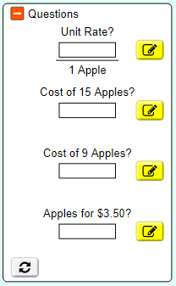  8. Using the scale, double number line, and apples, complete the challenge problems on the right side of the page. Click on the yellow button to input your answers. Once you have a smiley face, you have the correct answer. | Write your own definition for the vocabulary word unit rate.  Screenshot your completed and accurate table and paste it in the box below.  Click Copy to clipboard then to PASTE  How can you use addition and subtraction to find a unit rate?

Lemons
Directions | Questions
1. Click on   in the lower left hand corner.  2. Place a set of lemons on the scale.  | Look at the price on the scale. What is the cost for 5 lemons?  What do you predict will be the cost when you double the number of lemons on the scale? Explain how you made your prediction.
3. Place a second set of lemons on the scale. | Using the double number line, report below how the price changed when you added a second set of lemons. Was your prediction correct? Why or why not?  What do you predict will be the cost when you triple the original number of lemons on the scale? Explain how you made your prediction.
4. Place a third set of lemons on the scale. | Using the double number line, report below how the price changed when you added a third set of lemons. Was your prediction correct? Why or why not?
5. Remove one lemon from the scale. | Using the double number line, report below how the price changed when you removed one lemon.
6. Remove all but one lemon from the scale.  | What is the unit rate for one lemon?  What do you notice about your answers in steps 5 and 6? Why did this happen?
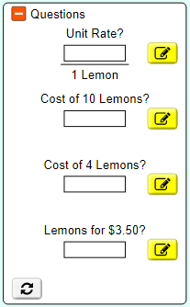  7. Using the scale, double number line, and lemons, complete the challenge problems on the right side of the page. Click on the yellow button to input your answers. Once you have a smiley face, you have the correct answer. (See if you can find the cost for ten and four lemons by using what you know about the unit rates rather than just getting your answer from the scale.) | Screenshot your completed and accurate table and paste it in the box below.  Click Copy to clipboard then to PASTE  If you know the cost of ten lemons is $2.50, how could you use the unit rate to find the price for 11 lemons?  If you know the unit rate of an item, how can you use it to determine the cost of a group of items?

Pears
Directions | Questions
1. Click on    in the lower left hand corner.  2. Place a set of pears on the scale.  | Look at the price on the scale. What is the cost for 5 pears?  What do you predict will be the unit rate for a pear? (You are just making a prediction at this point.)
3. Remove one pear from the scale.   | What is the price for 4 pears?  What do you predict will be the cost when you divide the number of pears in half? Explain how you made your prediction.
4. Remove two pears from the scale so you have two left on the scale.   | Using the double number line, report below how the price changed when you divided the number of pears in half. Was your prediction correct? Why or why not?  Think about dividing the number of pears in half again. What do you predict will be the unit rate for one pear?
5. Remove one more pear from the scale so you have only one pear left.  | Using the double number line, report below how the price changed when you divided the number of pears in half..  What is the unit rate for one pear?  How does the answer above compare to your previous predictions?
6. Multiply the number of pears on the scale by 10 so you now have 10 pears.   | What happened to the price on the scale?  What do you notice about your answers in steps 5 and 6? Why did this happen?  What will happen to the price if you divide the number of pears by 10?
7. Use mental math to divide the number of pears on the scale by 10. Next, find the unit rate for one pear. | What is the unit rate for one pear?
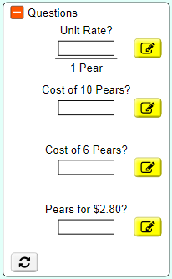  8. Using the scale, double number line, and lemons, complete the challenge problems on the right side of the page. Click on the yellow button to input your answers. Once you have a smiley face, you have the correct answer. (See if you can find the cost for ten and six pears by using what you know about the unit rates rather than just getting your answer from the scale.) | Screenshot your completed and accurate table and paste it in the box below.  Click Copy to clipboard then to PASTE  How can you use division to find a unit rate?

Finished Early?
Directions | Questions
1. Click on

in the lower left corner. This will take you to some questions about vegetables.

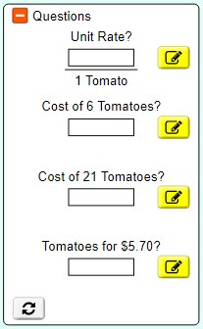
2. Complete the Challenges for each of the vegetables.

3. As you work, use
to take pictures of your work. Paste your pictures in the boxes in the right column

Name:______________________________ Date:__________ Period:__________

FINDING UNIT RATES - Leveled Exit Ticket
Directions: Pick one problem below to solve. If you do more, only one will count for your grade.
Level 1 (8 points) | Level 2 (9 points) | Level 3 (10 points)
If 4 carrots cost $0.60, what is the unit rate for one carrot? Explain your process below.  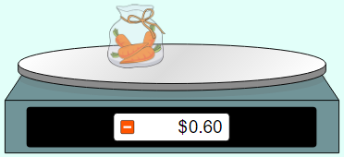 | If 5 oranges cost $3.75, what is the unit rate for one orange? Explain your process below.  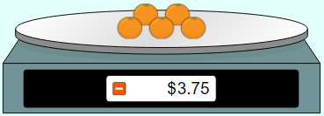 | If .4 pounds of purple candy cost $2.16, what is the unit rate for 1 pound of purple candy? Explain your process below.  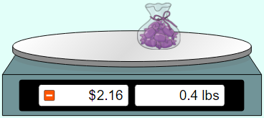

Name:______________________________ Date:__________ Period:__________

FINDING UNIT RATES - Exit Ticket
If 5 oranges cost $3.75, what is the unit rate for one orange? Explain your process below.

Name:______________________________ Date:__________ Period:__________

FINDING UNIT RATES - Sample Student Work
Apples
Directions | Questions
1. Visit the PhET Unit Rates Shopping activity  2. Click on  3. Click on in the bottom left corner, then select Apples in the menu  4. Place one set of apples on the scale. | Look at the price on the scale. What is the cost for 5 apples? (Write your answer in the box below. It will expand as you type.)
  $2.50
5. Take one apple off the scale. | Using the double number line, report below how the price changed when you removed one apple.  Assuming the price of each apple is the same, how do you think the price will change when you remove one more apple from the scale?
  When I removed one apple, the price decreased by $0.50 to show a price of $2.00 for four apples.
  I think the price will decrease another $0.50 to show a price of $1.50 for three apples.
6. Remove a second apple from the scale. | Was your above prediction correct? Why or why not?  Assuming the price of each apple is the same, what do you think the price of one apple will be? Explain how you determined the price.
  Yes! When I removed a second apple the price decreased $0.50 to show a price of $1.50 for three apples.
  When I removed each apple, the cost decreased by $0.50, so if I remove two more apples the cost will go down by $0.50 two times which is also $1. $1.50 for three apples minus $1 to remove two apples will show a cost of $0.50 for one apple.
7. Remove all but one apple from the scale. | Using the double number line, determine the cost of apple. This is called a unit rate.  Was your prediction in step 5 correct? How could you find the cost of one apple without taking the other apples off the scale?
  One apple is $0.50
  Yes! I followed my steps from step 6 and found that one apple if $0.50. Explanation will vary.
8. Using the scale, double number line, and apples, complete the challenge problems on the right side of the page. Click on the yellow button to input your answers. Once you have a smiley face, you have the correct answer. | Write your own definition for the vocabulary word unit rate.  Screenshot your completed and accurate table and paste it in the box below.  Click Copy to clipboard then to PASTE  How can you use addition and subtraction to find a unit rate?
  In this context, a unit rate is the price for one of an item. (Answers will vary.)
  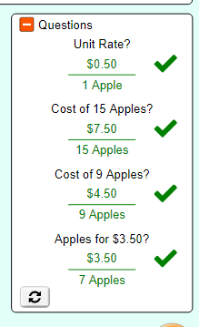
  Every time I took away one apple, that was the unit rate. You could also just keep subtracting until you got to one apple, which would also be your unit rate.

Lemons
Directions | Questions
1. Click on  in the lower left hand corner.  2. Place a set of lemons on the scale. | Look at the price on the scale. What is the cost for 5 lemons?  What do you predict will be the cost when you double the number of lemons on the scale? Explain how you made your prediction.
  $1.25
  I think the cost will be $2.50 because if I double the number of lemons, the price should also double.
3. Place a second set of lemons on the scale. | Using the double number line, report below how the price changed when you added a second set of lemons. Was your prediction correct? Why or why not?  What do you predict will be the cost when you triple the original number of lemons on the scale? Explain how you made your prediction.
  Yes! The price did doubled to $2.50 when I put a second set of lemons on the scale and doubled the number of lemons.
  I think the original price of $1.25 will triple to $3.75 since I have three times as many lemons. I could also think of this as adding one more set of lemons at $1.25 and add that to the price for two sets of lemons which was $2.50 to get $3.75.
4. Place a third set of lemons on the scale. | Using the double number line, report below how the price changed when you added a third set of lemons. Was your prediction correct? Why or why not?
  Yes! The price for three sets of lemons is $3.75. This makes sense because I have three groups at $1.25. 3 x $1.25 is $3.75.
5. Remove one lemon from the scale. | Using the double number line, report below how the price changed when you removed one lemon.
  When I removed one lemon, the price decreased to $3.50.
6. Remove all but one lemon from the scale. | What is the unit rate for one lemon?  What do you notice about your answers in steps 5 and 6? Why did this happen?
  $0.25
  Since the price dropped by $0.25 when I removed one lemon, I think the price, or unit rate, for one lemon is $0.25.
7. Using the scale, double number line, and lemons, complete the challenge problems on the right side of the page. Click on the yellow button to input your answers. Once you have a smiley face, you have the correct answer. (See if you can find the cost for eight lemons by using what you know about the unit rate and the cost for ten lemons.) | Screenshot your completed and accurate table and paste it in the box below.  Click Copy to clipboard then to PASTE  If you know the cost of ten lemons is $2.50, how could you use the unit rate to find the price for 11 lemons?  If you know the unit rate of an item, how can you use it to determine the cost of a group of items?
  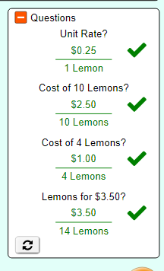
  Once you have the price for ten lemons, which is two groups of five lemons at $1.25 per group, you can just add the unit rate of $0.25 to get $2.75 for 11 lemons.
  Whatever number you multiply the number of items by also needs to be used to multiply the unit rate.

Pears
Directions | Questions
1. Click on  in the lower left hand corner.  2. Place a set of pears on the scale. | Look at the price on the scale. What is the cost for 5 pears?  What do you predict will be the unit rate for a pear? (You are just making a prediction at this point.)
  $2.00
  I think it will be less than $0.50 because there are five pears and each pear would have to be less than $0.50 for the total to be $2.00.
3. Remove one pear from the scale. | What is the price for 4 pears?  What do you predict will be the cost when you divide the number of pears in half? Explain how you made your prediction.
  $1.60
  I think the cost for two pears, or half four, I think the price will be $0.80 because there are half the number of pears, so the price should be half the cost for four pears.
4. Remove two pears from the scale so you have two left on the scale. | Using the double number line, report below how the price changed when you divided the number of pears in half. Was your prediction correct? Why or why not?  Think about dividing the number of pears in half again. What do you predict will be the unit rate for one pear?
  Yes! When I divided the number of pears in half, the price was half the original price. This makes sense because half the number of items should cost half as much.
  I think the unit rate will be $0.40 because that is half the cost of two pears.
5. Remove one more pear from the scale so you have only one pear left. | Using the double number line, report below how the price changed when you divided the number of pears in half..  What is the unit rate for one pear?  How does the answer above compare to your previous predictions?
  The price was cut in half to $0.40.
  $0.40
  I was right on!
6. Multiply the number of pears on the scale by 10 so you now have 10 pears. | What happened to the price on the scale?  What do you notice about your answers in steps 5 and 6? Why did this happen?  What will happen to the price if you divide the number of pears by 10?
  The price on the scale increased to $4.00.
  If the number of pears is multiplied by ten, then the price will also get multiplied by 10.
  It will go back down to the unit rate price of $0.40.
7. Use mental math to divide the number of pears on the scale by 10. Next, find the unit rate for one pear. | What is the unit rate for one pear?
  It is still $0.40.
8. Using the scale, double number line, and lemons, complete the challenge problems on the right side of the page. Click on the yellow button to input your answers. Once you have a smiley face, you have the correct answer. (See if you can find the cost for ten and six pears by using what you know about the unit rates rather than just getting your answer from the scale.) | Screenshot your completed and accurate table and paste it in the box below.  Click Copy to clipboard then to PASTE  How can you use division to find a unit rate?
  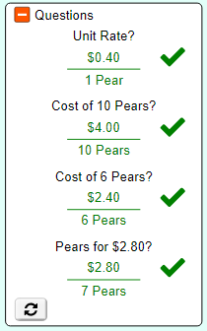
  To get to a unit rate, you can divide both the number of items and the price until you get to one item. The price for one item is the unit rate.

Name:______________________________ Date:__________ Period:__________

FINDING UNIT RATES - Leveled Exit Ticket (ANSWERS)
Directions: Pick one problem below to solve. If you do more, only one will count for your grade.
If 4 carrots cost $0.60, what is the unit rate for one carrot? Explain your process below.  $0.15 per carrot - explanation will vary | If 5 oranges cost $3.75, what is the unit rate for one orange? Explain your process below.  $0.75 per carrot - explanation will vary | If .4 pounds of purple candy cost $2.16, what is the unit rate for 1 pound of purple candy? Explain your process below.  $5.40 per carrot - explanation will vary

Name:______________________________ Date:__________ Period:__________

FINDING UNIT RATES - Exit Ticket (ANSWERS)
If 5 oranges cost $3.75, what is the unit rate for one orange? Explain your process below.

$0.75 per orange - explanation will vary

