Energy Skate Park
APP1 Lab #1
Version 1.1

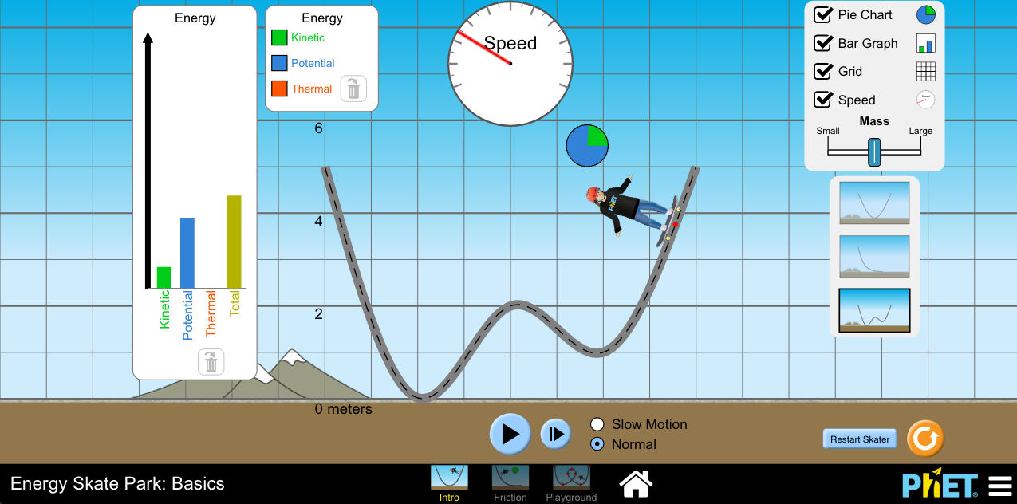

Before you begin the lab:

- Open the Energy Skate Park PhET simulation on your device.
(Link is on Edmodo)
- Make sure you have LoggerPro 3.0 on downloaded onto your computer.
(It’s free because you are my student. Link is on Edmodo.)

- Grab a timer.

Purpose

You are investigating the relationship between kinetic energy, potential energy, and total energy when only conservative forces are present and then again when non-conservative forces are present. The data will be analyzed graphically in order to provide a clear trend.

Directions

Part 1- Conservative Forces

- Open Energy Skate Park. Choose Intro.
- Take time to play around with the simulation. Make sure all boxes are checked.
- What do you notice about the total energy, kinetic energy, and potential energy in the bar graph?

- What do you notice about the pie graph? What must you do in order to get the pie graph to be larger?

- You are measuring the changes in energy- total, kinetic, and potential over time. To do this, we need to define our system. This is a skater-earth system.

- We also need to establish numbers for mass and speed.
0-m/s
2-m/s
4-m/s
6-m/s
8-m/s
10-m/s
12-m/s
14-m/s
16-m/s
18-m/s
20-m/s

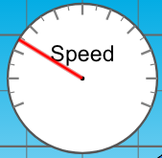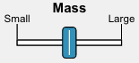
10-kg
20-kg

30-kg

- Choose “Slow Motion.” Place the 20-kg skater at 6-m and start the timer when you hit play. Pause both timer and sim when the skater is at 4-m, 2-m, 0-m, and 6-m. Record the height, speed, and time in the table below. Continue recording until you’ve reached 30-s.
Time | Height | Velocity
0-s | 6-m | 0-m/s

- Calculate the potential energy, kinetic energy, and total energy of the system using the data from #4.
Be sure to use 10 m/s² for g.

Time  (x-axis) | Potential Energy  (y-axis) | Kinetic Energy  (y-axis) | Total Energy  (y-axis)

- Graph the three data sets in #5 using Logger Pro. I have attached an instructional video to the assignment to help with this step.

Part 2- Non-conservative Forces

- Click “Friction” at the bottom of the simulation.
- Take time to play around with this simulation. Make sure all boxes are checked.
- What do you notice about the total energy, kinetic energy, and potential energy in the bar graph?

- What do you notice about the final thermal energy & the total energy once the skater has stopped?

- You are measuring the changes in energy- total, kinetic, and potential over time. To do this, we need to establish numbers for mass and speed as well as our system: This is a skater-earth system.

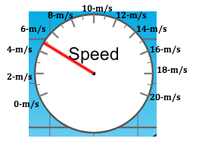
10-kg
20-kg

30-kg

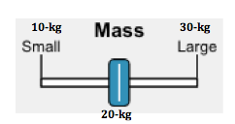

- Choose “Slow Motion.” Place the 20-kg skater at 6-m and start the timer when you hit play. Pause both timer and sim when the skater is at 4-m, 2-m, 0-m, and 6-m. Record the height, speed, and time in the table below. Continue recording until you’ve reached 30-s.
Time | Height | Velocity
0-s | 6-m | 0-m/s

- Calculate the potential energy, kinetic energy, and total energy of the system using the data from #10. Be sure to use 10-m/s² for g.

Time  (x-axis) | Potential Energy  (y-axis) | Kinetic Energy  (y-axis) | Thermal Energy  (y-axis) | Total Energy  (y-axis)

- Graph the four data sets in #11 using Logger Pro. Follow the same procedure as before. Make the thermal energy a linear fit.

- You are now finished with the experiment itself. Now type a formal lab report to present this information. Be sure to follow the rubric for the lab report attached to this assignment.

