Title: Tell Me How to Function

Important Questions:
- What is the difference between the input and output?

What is a function? How does it affect the input and output?

Instructions:

In this activity, the above questions are investigated. Complete this document by filling in data tables and writing complete responses. This investigation has three phases: Exploration, Explanation and Application. Work between this document and the simulation (sim).

1. Click this screen shot below to open the “Function Builder” simulation.

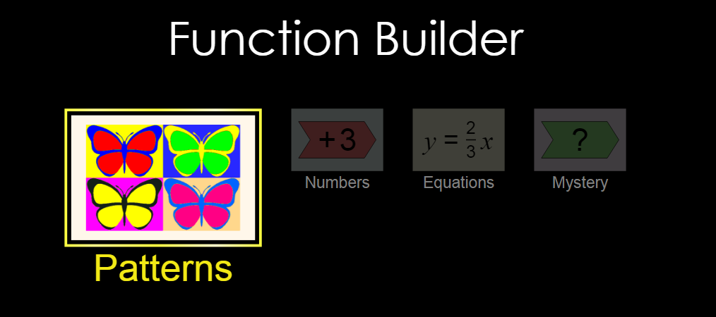

Exploration Phase:
- Briefly explore what will happen to the four pictures on the left, when the “mirror” 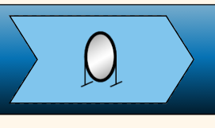image is placed in the “builder”. 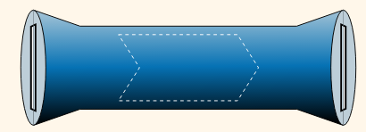

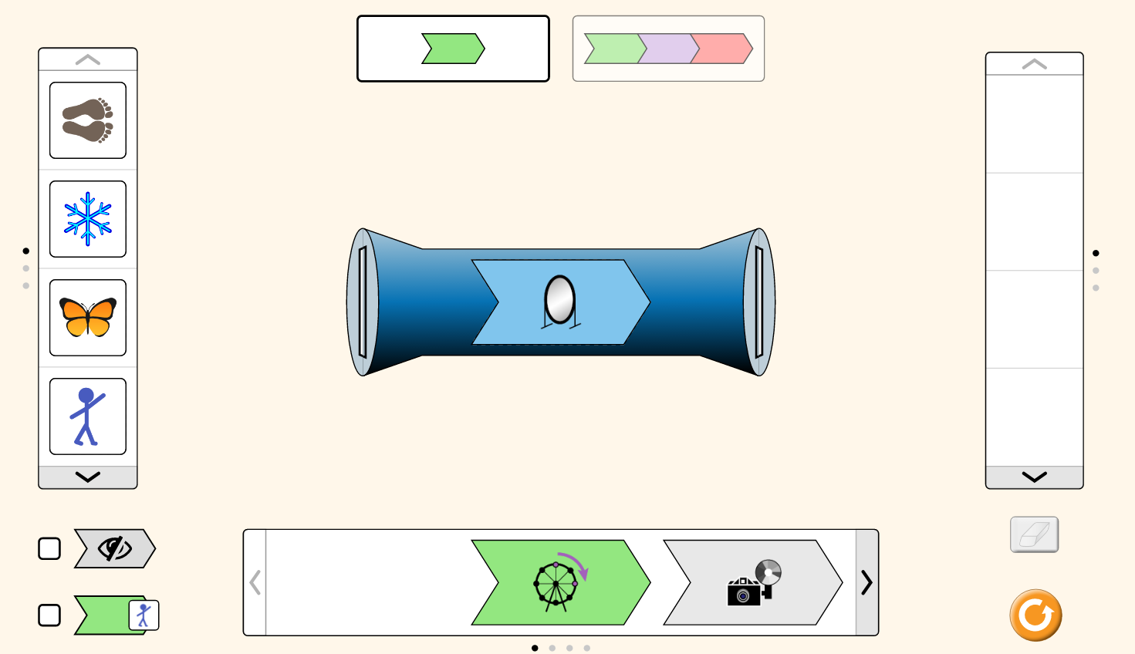

- Briefly explore what will happen to the four pictures on the left, when the “rotating wheel” 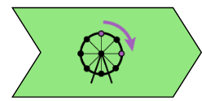image is placed in the “builder”.

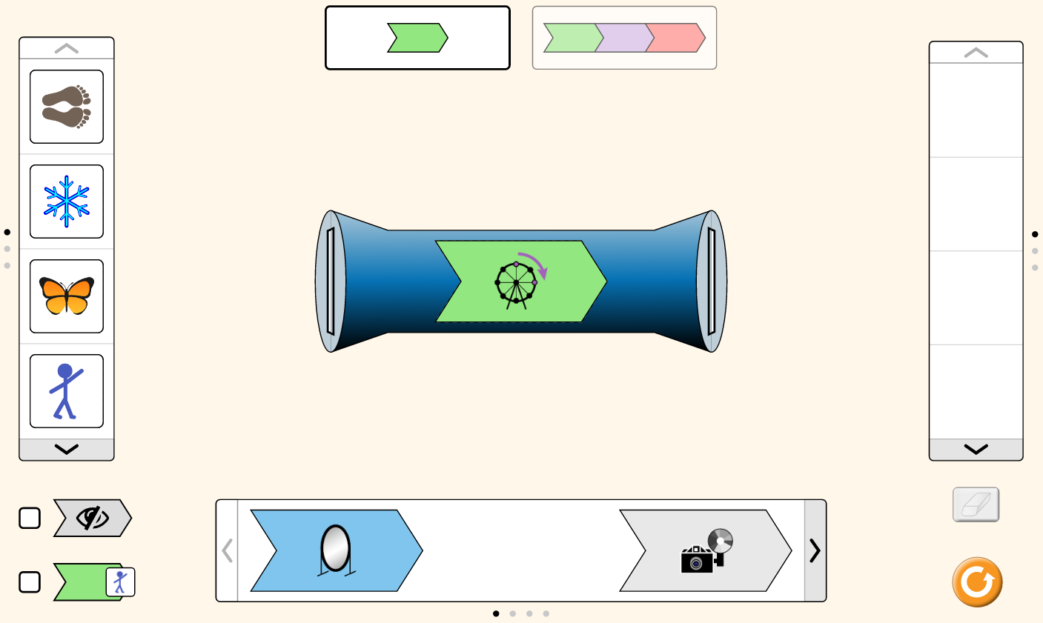
Questions
- What happens to the images on the left when it is put through the “builder”?

- Based on your exploration, match the parts of the stimulation to the word bank:

 | Word Bank
- Left images _____________________  - Right images____________________  - Builder___________________________ | - Function  - Output  - Input

- Why are the images on the left different from the images on the right?

Explanation Phase:
This Phase has an investigative goal.

- Click on the “Numbers” tab. This screen appears:
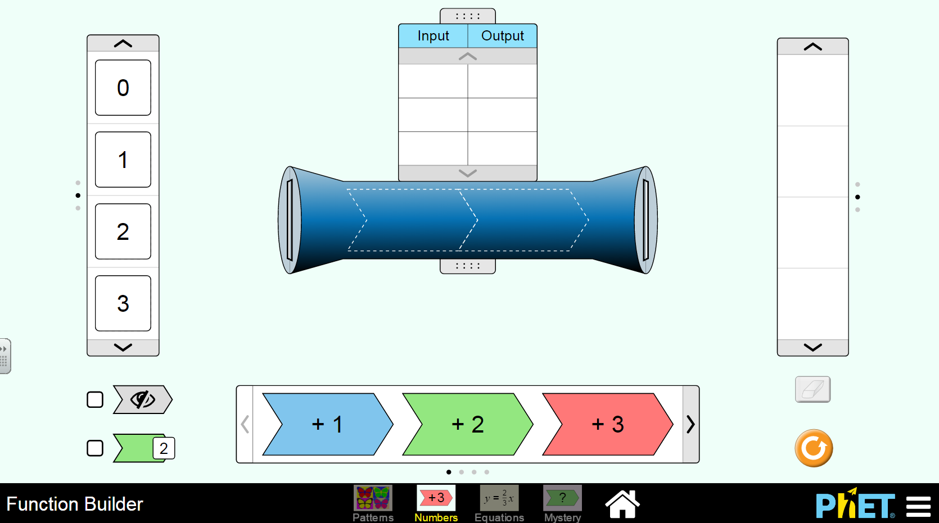2. Determine the values of the “right” side (output) based on the “left” side (input) and “builder” (function).
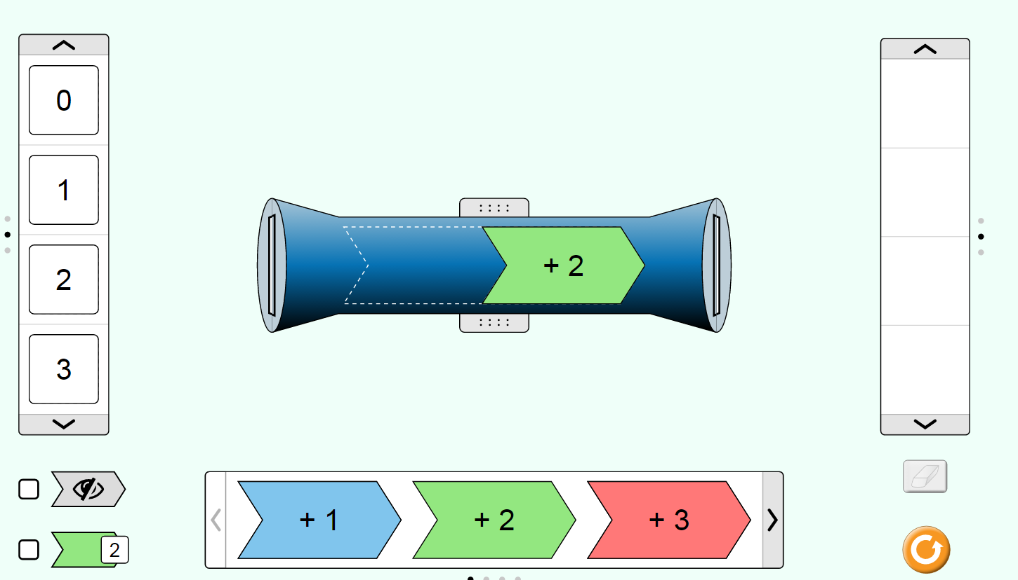

- Determine what the function is based on the input and out values.

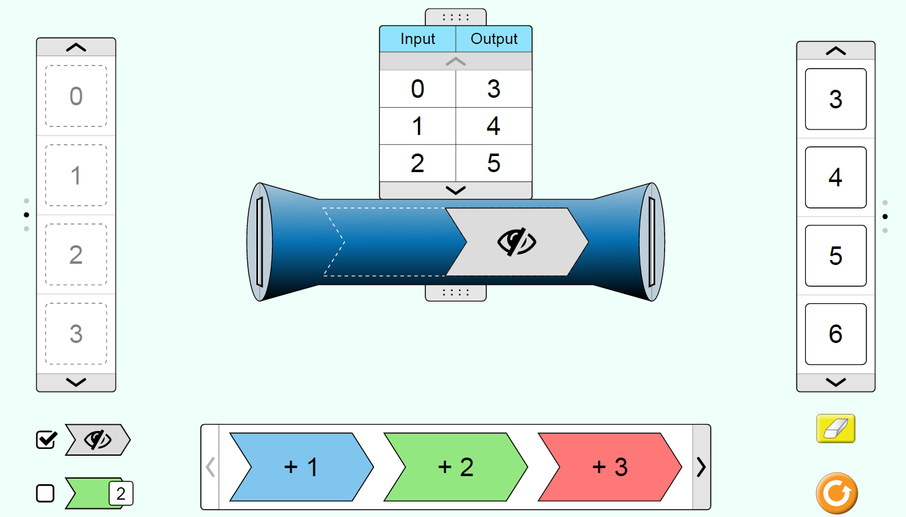
HELP: Use this tab!

 Function =________________________

Application Phase

- Click the “Mystery” tab. The screen below appears.
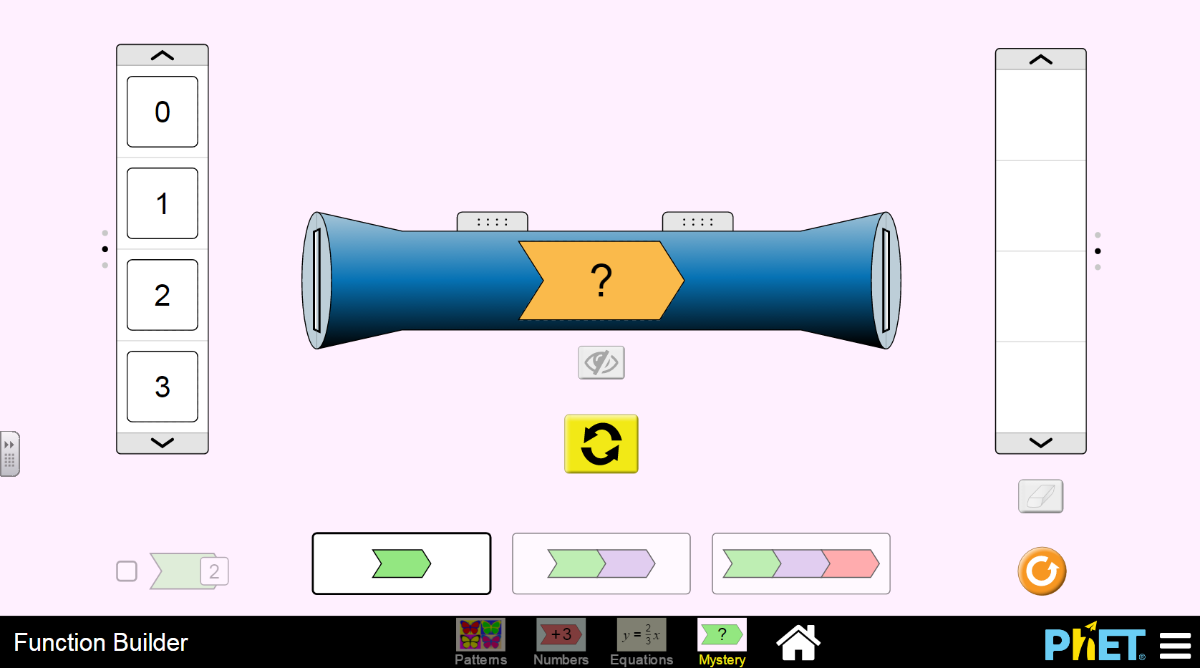
- Put the input values into the function to find the output values with one mystery function. Determine what the function is based on the input and output values.

- Put the input values into the function to find the output values with two mystery functions. Determine what the function is based on the input and output values.

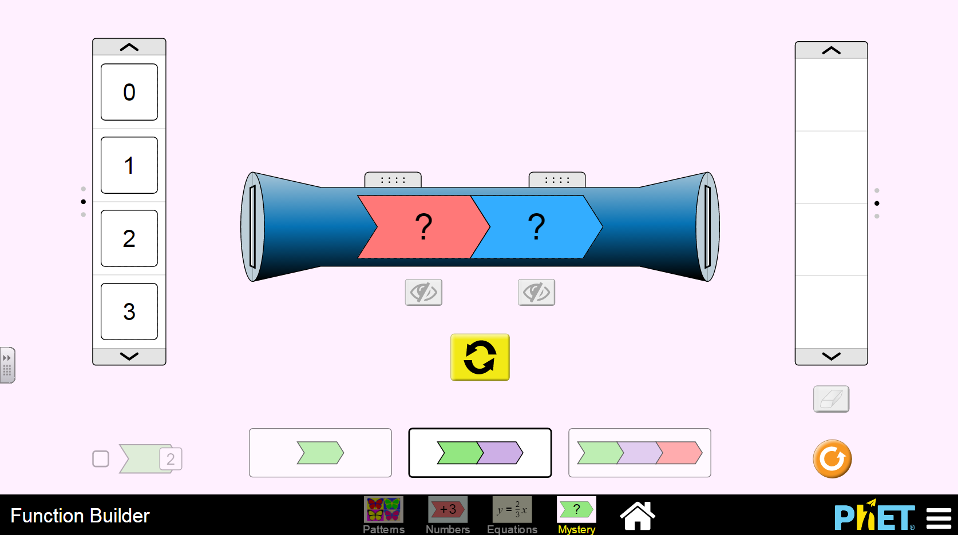
HELP: Use this tab!

Questions:
- What is the pattern between the inputs and outputs when given a function?

- How would you determine what the input is, if you were only given the output and function?

Congratulations: You’re finished!

