HSA Brownsville Science Department
Name:
Class:
Circuits Virtual Lab
Fatih Gozuacik, M.Ed, M.Phys
Goal of the experiment: To understand & explore circuit elements, equivalent resistance, current and voltage calculations.
Needed materials: A laptop or desktop with Java software, PhEt Circuits Lab simulation, and a calculator.
Download the simulation: https://phet.colorado.edu/en/simulation/legacy/circuit-construction-kit-ac

Step 1: Series Circuit. Create a series circuit by pulling resistors from the side, and then right click on the resistor.
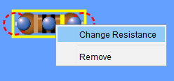  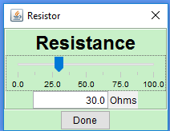  Change the resistance. | 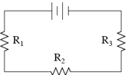  Pick any three different value of your choice. And set  the voltage by right clicking to any value of desire. Build  a circuit as in above, you can use your imagination and  alter the diagram. You can replace one resistor with a  light bulb and change the resistance. A switch can also  be added. | 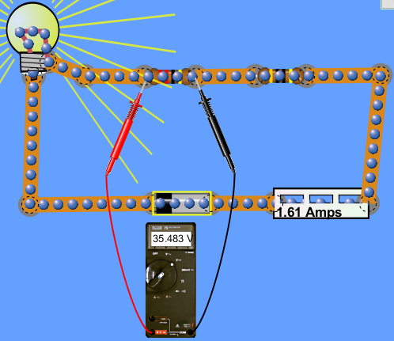

 |  |  |  |  |  | Theoretical Value |  |  |  | Experimental Value |  |  |  | Pull a volt meter from the  side to check individual  voltages. Connect ampere  meter to measure current.
 | R₁ | R₂ | R₃ | R_{eq} | V | I | V₁ | V₂ | V₃ | I | V₁ | V₂ | V₃
Set 1
Set 2

Step 2: Parallel circuit. Use above steps to build a three resistor system of any choice and desired voltage.

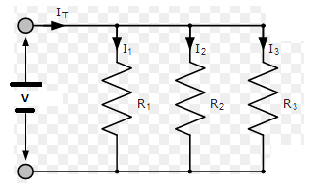 | Build a circuit similar to the  one left. Change resistors and  voltage and calculate  theoretical values.  Then use a voltmeter and  ampere meter to have  experimental values to  compare.  A sample set up can be seen on  the right. | 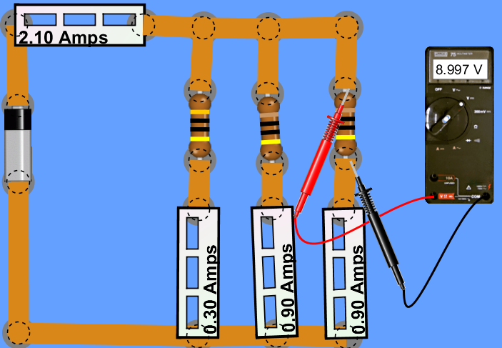

 |  |  |  |  |  | Theoretical Value |  |  |  |  |  |  | Experimental Value
 | R₁ | R₂ | R₃ | R_{eq} | V | I_{m} | I₁ | I₂ | I₃ | V₁ | V₂ | V₃ | I_{m} | I₁ | I₂ | I₃ | V₁ | V₂ | V₃
Set 1
Set 2

Use back side for result and commentary

Step 3: Result and commentary:
Explain the experiment step by step what you did. Did your theoretical and experimental calculations match?
If not, explain why. Add improvements if any.

Question 1: Is the equivalent resistance always lower than any resistor in parallel connection?

Question 2: Which connection should be chosen for Christmas lights? Series or parallel? Why?

Question 3: What type of connections do we use in our homes, offices and daily life? Why?

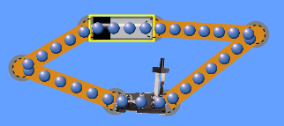
Question 4: Build a short circuit and explain what happens.

