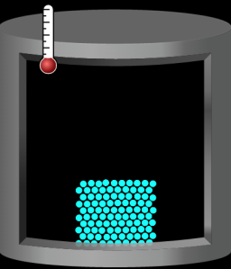


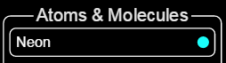

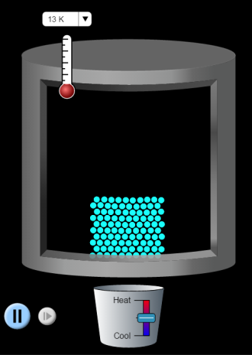
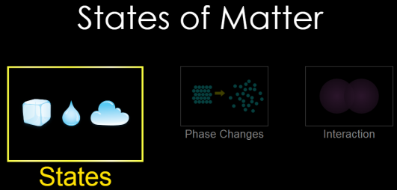

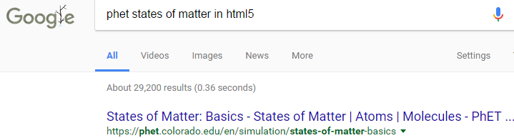
Click on
K
K
K
Click Play. 
Describe the motion of dots in a word or two.

Describe the motion of dots in a word or two.

Describe the motion of dots in a word or two.

˚C
˚C
˚C
Select “States”. Neon should be selected.
Click on Click on liquid
PhET States of Matter html5
Click the “5” shield
CLICK!
Write T and draw what you see here
and

Write T and draw what you see here
and




- Which of these 3 drawings shows the MOST order in the dots?
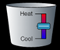
2. Click on solid, add heat (use slider to add heat) until you reach a temperature of about 26˚C. What changed?
- Keep adding heat until you reach about 55˚C. What changed?
- Based on your observations, what can you say about the motion of the dots as heat is added?

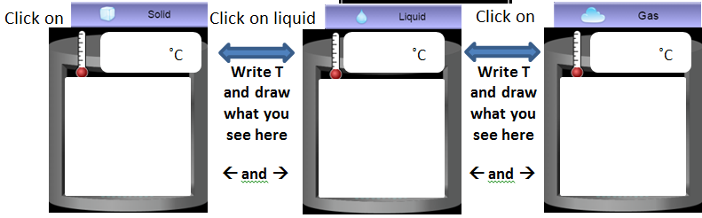
Select :
How do the words you chose to describe the motion of the dots change?
K
K
K
Describe the motion of dots in a word or two.

Describe the motion of dots in a word or two.

Describe the motion of dots in a word or two.

Select:  Click on solid liquid and gas. Heat it. Cool it. Is oxygen’s motion more closely related to the motion of neon/argon or water? Why?

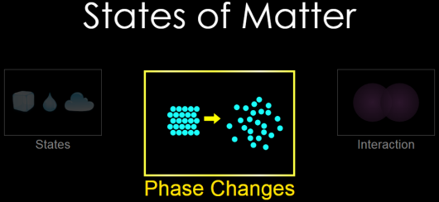
Select “Phase Changes”. Neon should be selected.
Click on Click on liquid
In what state is the neon? ______________________________
What are the temperature and pressure? _________˚C, _________atm
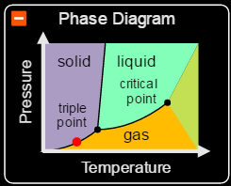
Look at the Phase Diagram. What happens to the red dot as you add heat?
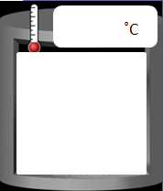
What happens to the red dot as you remove heat?
K
RESET: Add heat until the pressure reading changes from zero. What is the temperature? Draw dots! How are they moving? _________________________________________

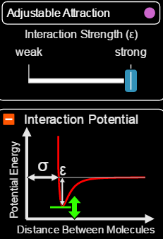
Select :
RESET: Select “Adjustable Attraction”. Move the interaction strength slider between “weak” and “strong”. What happens to the motion of the dots?
RESET: Select water. Give the bicycle pump 4 or 5 good pumps.
Draw what you see here
Before resetting the water example you drew (right), move the finger down about ½ way. What happens to the temperature (rises/falls/stays same) and pressure (rises/falls/stays same)?
Play with the sim and try to make the lid fly off. Can you make the lid fly off and have NO dots escape? In the boxes, below, give 4 different things you tried that made the lid fly off.
Which atom or molecule?  How did you do it?  What happened to the dots? | Which atom or molecule?  How did you do it?  What happened to the dots?
Which atom or molecule?  How did you do it?  What happened to the dots? | Which atom or molecule?  How did you do it?  What happened to the dots?

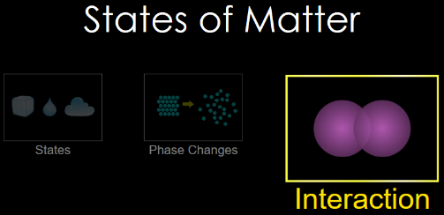
Expand the forces window  click
Select “Interaction”. Neon should be selected.
Click on Click on liquid
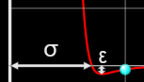

- Slide the finger to the right to the first vertical line. Let go of the finger. What happens to the Neon atom you dragged?

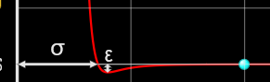
- RESET: Slide the finger to the right to the second vertical line. Let go of the finger. What happens to the Neon atom you dragged?

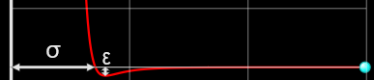
- RESET: Slide the finger to the right to the third vertical line. Let go of the finger. What happens to the Neon atom you dragged? (You may have to wait 45 seconds or so…)

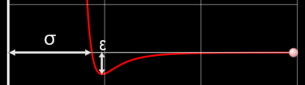
- RESET: select  Repeat steps 1 and 2 with argon. What differences are there with argon and neon?

- RESET: select  Move the interaction strength slider 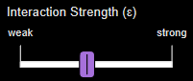. What happens to the graph?

- In all cases, which way are the forces pointing when the atoms get too close together?
- In all cases, which way are the forces pointing when the atoms get too far apart?
- What kind of motion does this represent (think big picture as the atom nuclei move – it might help to ignore the graph and look at atoms?)

- What is your favorite thing about these 3 sims?

