Funky Functions! Name:_____________
Learning Goals:
- Describe properties of transformations(changes in size, shape, orientation).
- Relate functions to transformations.
- Create definitions/working understanding of input, output, function rule, reflection, rotation, dilation.

1. Explore the Function Builder simulation for a few minutes, building whatever functions you choose. Write down 1-3 observations you have about building a function.

2. Label the parts of this function: input, output, function rule.
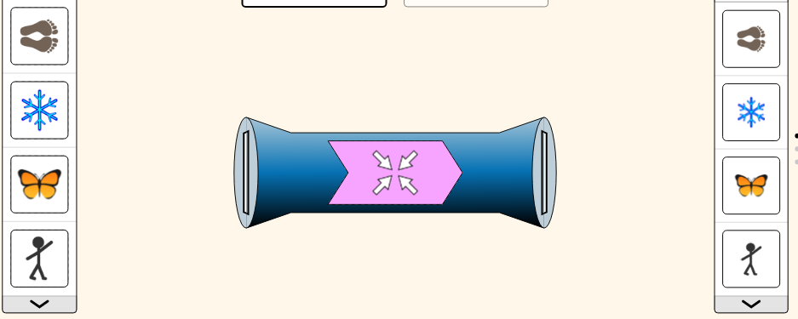

3. Describe how each function rule transforms the shapes.

Function rule | What happens? Check any that apply. | Describe/name the function in your own words.
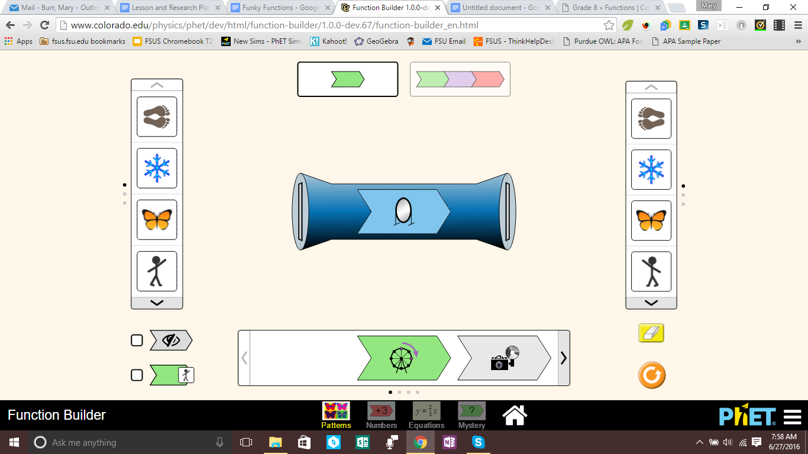 | [ ]Changes size [ ]Changes direction  [ ]Changes shape [ ]Changes color
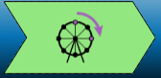 | [ ]Changes size [ ]Changes direction  [ ]Changes shape [ ]Changes color
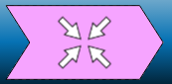 | [ ]Changes size [ ]Changes direction  [ ]Changes shape [ ]Changes color
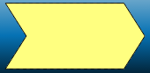 | [ ]Changes size [ ]Changes direction  [ ]Changes shape [ ]Changes color
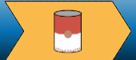 | [ ]Changes size [ ]Changes direction  [ ]Changes shape [ ]Changes color

4. Perform the transformation, and check yes or no in the table.
Input Shape | Function Rule | Output shape changes?
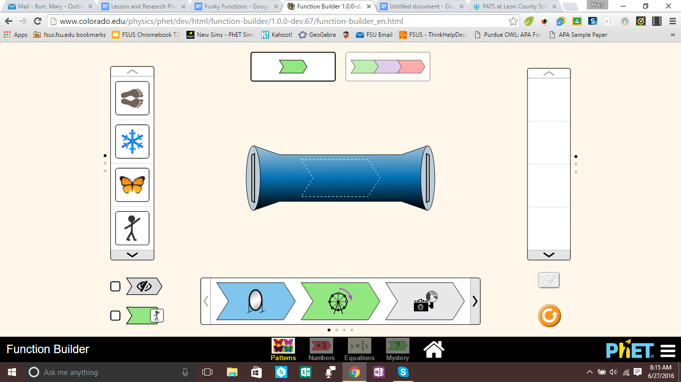 |  | [ ] Yes [ ] No
 |  | [ ] Yes [ ] No
 |  | [ ] Yes [ ] No
 |  | [ ] Yes [ ] No

5. Explain why some shapes change when reflected by the mirror and others do not.

6. Perform the transformation, and check yes or no in the table.
Input Shape | Function Rule | Output shape changes?
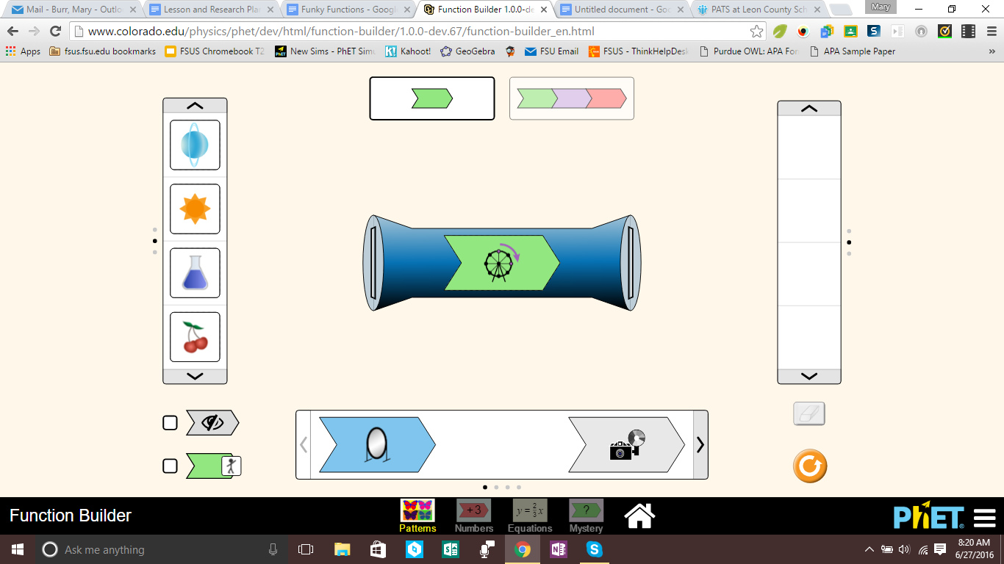 | 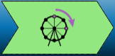 | - Yes  - No
- Yes
- No
- Yes
- No
- Yes
- No

7. Explain why you think some shapes change when rotated by the Ferris wheel and others do not.

8. What do you think the difference is between these two transformations?
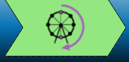

9. Describe what happens to the shape when you use this sequence of transformations.

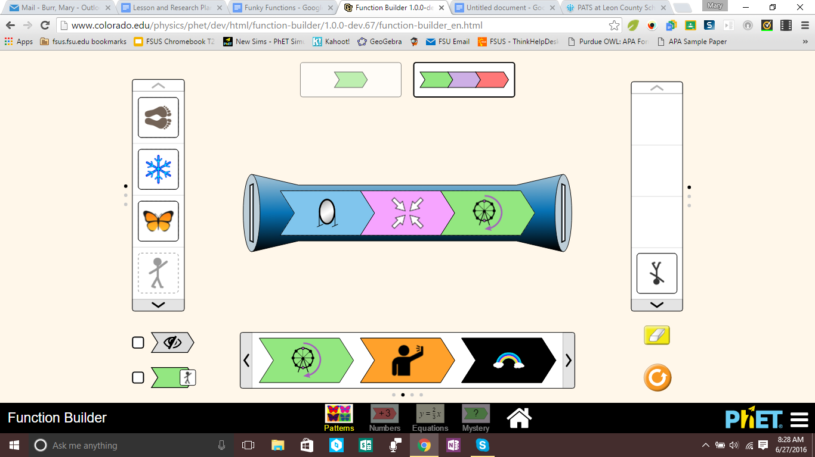
1.___________________________________________
2.___________________________________________
3.___________________________________________
(Hint: Use this button for step-by-step help: )

10. Is the output shape from #9 completely different than the input shape? How are they alike?

11. Early Finisher Challenge: What happens with each of the mystery functions?!

Mystery A
Mystery B
Mystery C

