Funky Functions by Mary Burr
Overview
Prerequisite Skills:
- Understand symmetry, lines of symmetry.
- Identify congruent shapes.
Learning Goals:
- Describe properties of transformations(changes in size, shape, orientation).
- Relate functions to transformations.
- Create definitions/working understanding of input, output, function rule, reflection, rotation, dilation (reduction).
Common Core Standards:
CCSS.MATH.CONTENT.8.G.A.1: Verify experimentally the properties of rotations, reflections, and translations.

CCSS.MATH.CONTENT.8.G.A.2: Understand that a two-dimensional figure is congruent to another if the second can be obtained from the first by a sequence of rotations, reflections, and translations; given two congruent figures, describe a sequence that exhibits the congruence between them.
CCSS.MATH.CONTENT.8.G.A.4: Understand that a two-dimensional figure is similar to another if the second can be obtained from the first by a sequence of rotations, reflections, translations, and dilations; given two similar two-dimensional figures, describe a sequence that exhibits the similarity between them.
CCSS.MATH.CONTENT.8.F.A.1: Understand that a function is a rule that assigns to each input exactly one output. The graph of a function is the set of ordered pairs consisting of an input and the corresponding output.
Mathematical Practices:
MP1: Make sense of problems and persevere in solving them.
MP2: Reason abstractly and quantitatively.
MP4: Model with mathematics.
MP5: Use appropriate tools strategically.
Materials:
- PhET Function Builder simulation: http://www.colorado.edu/physics/phet/dev/html/function-builder/1.0.0-dev.72/function-builder_en.html
- Computers/tablets for each student or pair of students
- Funky Functions Activity Sheet (1 per student)
Estimated Time: Approximately 50 minutes
Funky Functions
Simulation Introduction & Open Play | 3-5 minutes
Teacher will… | Students will…
● Encourage students to take a few minutes to explore the Function Builder simulation, letting them know they will be looking at the patterns function builder for today’s activity.  ● Distribute the activity sheet as students begin open play.  ● Circulate the room and ask students:  - What does this simulation do?  - What is the strip on the right?  - What is the strip on the left?  - What are the buttons at the bottom?  - What happens when you put a shape in the tube?  - Does the same thing happen to all shapes?  - Why do some shapes not change?  - What do the mystery functions do to the shapes?  - What could we call each of the buttons at the bottom? (mirror, ferris wheel, four arrows, yellow card, soup can)  - Are there any findings/discoveries you would like to share with me or the class? | ● Explore the simulation, building whatever functions they choose.  ● Respond to teachers’ informal questioning.  ● Jot down discoveries as #1 on the activity worksheet.
Guided Exploration & Discussion Part 1 | 15-20 minutes
Teacher will… | Students will…
● Encourage students to begin working on #2-3 in pairs. Try to give them at least 5 minutes where the teacher is silent before probing/aiding. Let students know they can and should discuss their answers with a partner.  ● After most students complete 2 & 3, facilitate a class discussion around the following questions (may want to ask students to close/cover devices):  1. What happened with the mirror? What did you name the mirror function? (Summarize: “Those are all really great ideas! This mirror image is a type of transformation that is called a reflection in mathematics. Because a reflection changes the direction a shape faces, it changes its orientation.”) Why does it make sense for a mirror to represent a reflection?  2. What happened with the ferris wheel? What did you name the ferris wheel function? (Summarize: “Those are all really great ideas! This ferris wheel is a type of transformation that is called a rotation in mathematics.Because a rotation changes the direction a shape faces, it changes its orientation. ”) Why does it make sense for a ferris wheel to represent a rotation?  3. How is a reflection different from a rotation, even though they both change the orientation? Could one or multiple rotations ever be the same as a reflections? Give an example if you can.  4. What happened with the four arrows? What did you name the four arrows function? (Summarize: “Those are all really great ideas! This four arrows is a type of transformation that is called a dilation in mathematics. Notice that dilations change size but not orientation.”) Why does it make sense for these four arrows to represent a dilation?  5. A dilation can be classified as either an enlargement or a reduction, which type of dilation is the four arrows?  6. What happened with the yellow arrow card? What did you name the yellow arrow function? (Summarize: “Those are all really great ideas! This yellow card is a kind of like a type of transformation that is called a translation in mathematics. In a translation, the shape moves but does not change size or orientation.” Depending on students’ level/experience, it may be worthwhile to point out that it is possible for a dilation to stay the same size, if the scale factor is 1 (just like the identity property).  6. What happened with the soup can? What did you name the soup can function? (Summarize: “Those are all really great ideas! This is actually multiple transformations in one function rule. In mathematics, we could say there was some duplication and reduction, but there is not a formal name for this type of transformation, except the one you made up! There is also no mathematical transformation that recognizes color change.”)  7. Can you think of any transformations in real life? (Cheer/dance/band routines involve translations, reflections, and rotations...getting your eyes dilated at the optometrist...pictures being arranged in a symmetrical way...gym/dance instructor having to reflect motions when facing class...hands of a clock rotating, etc.) | - Complete #2&3 on the activity sheet.  - Respond to teacher questions.  - Ask questions or ask for help as needed.  - Revise or add detail to answers to activity sheet as desired during discussion.
Guided Exploration & Discussion Part 2 | 15-20 minutes
Teacher will… | Students will…
● Encourage students to begin working on #4-11 in pairs. Try to give them at least 5 minutes where the teacher is silent before probing/aiding.  ● As students are working, circulate the room and ask the following probing/guiding questions:  - Why are the input and output sometimes the same in a reflection or rotation?  - Can you predict when the input and output will be the same?  - Does the size of the shape ever change in a reflection or a rotation?  - What is symmetry? What is a line of symmetry? Which shapes have no lines of symmetry?  - What is rotational symmetry? How can you tell when a shape has rotational symmetry? Which shapes have rotational symmetry?  - What do you think would happen if you rotate a shape completely around the ferris wheel?  - What would happen if we used both of the ferris wheel functions?  - What do you think would happen if you rotate a shape multiple times?  - What do you think would happen if you reflected a shape more than once?  ● After most students have finished #4-10, facilitate a class discussion around the following questions:  - Why do some shapes appear to change when reflected or rotated and some shapes do not?  - If the input and output look the same, did a transformation occur or not? Why do you think so?  - Which transformations or function rules preserve a shape’s orientation?  - Which transformations or function rules preserve a shape’s size?  - Even after multiple transformations or a sequence of transformations (any transformation except the eraser), what stays the same? (Transformations should make either congruent shapes or similar shapes).  - What does similar mean?  - Did anyone figure out the mystery transformations? What do you think happened?  - Where there any other discoveries or things you noticed that we have not discussed?  - Are there any lingering questions or frustrations?  - Could we graph shapes and transformations on coordinate plane? What would it be like? | - Complete #4-11 on the activity sheet.  - Respond to teacher questions.  - Ask questions or ask for help as needed.  - Revise or add detail to answers to activity sheet as desired during discussion.  - Answer questions and question answers: students should be able to determine if they agree/disagree with others’ claims and justify their own responses.
Informal Assessment | 5 minutes
Teacher will… | Student will…
Exit Ticket: Describe what you learned today, including as many of the following terms as possible: function, function rule, input, output, transformation, translation, reflection, rotation, dilation, reduction, enlargement, orientation. (Make sure your explanation shows what you understand and what the words mean, not just aimlessly using the words. You may want to define each word, which is okay)  OR  Complete the following sentences using the bolded vocabulary words above:  A _____________ is a transformation that changes a figure’s size. If the figure gets larger, it is a(n)________________. If the figure gets smaller it is a(n) _______________.  A ______________is a transformation that changes a figure’s orientation, but not size. (more than one acceptable answer).  A_________________is a transformation that is like a mirror image.  In a function, each __________ undergoes a function rule and creates an __________. | Complete exit ticket using complete sentences.
Going forward…
- Teacher should try to make connections between Funky Functions activity sim and graphing transformations in the coordinate plane (CCSS.MATH.CONTENT.8.G.A.3: Describe the effect of dilations, translations, rotations, and reflections on two-dimensional figures using coordinates.).
- Teachers can refer to the Function Builder when creating linear functions, and describe how transformations are a type of function.

Funky Functions! Name:_____________
Learning Goals:
- Describe properties of transformations(changes in size, shape, orientation).
- Relate functions to transformations.
- Create definitions/working understanding of input, output, function rule, reflection, rotation, dilation.

1. Explore the Function Builder simulation for a few minutes, building whatever functions you choose. Write down 1-3 observations you have about building a function.

2. Label the parts of this function: input, output, function rule.
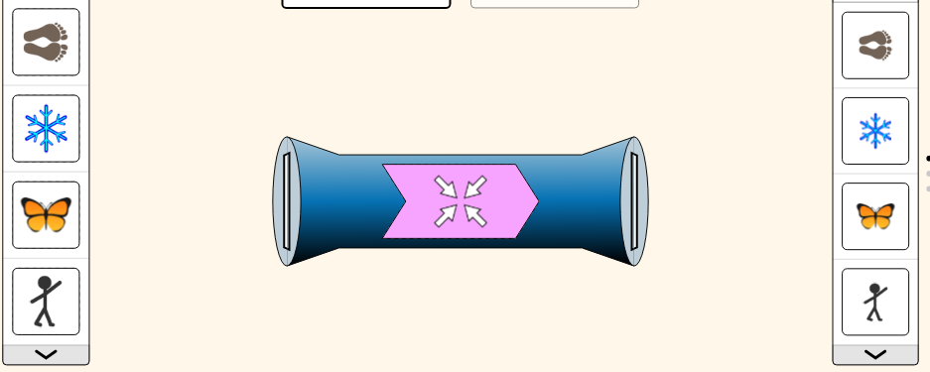

3. Describe how each function rule transforms the shapes.

Function rule | What happens? Check any that apply. | Describe/name the function in your own words.
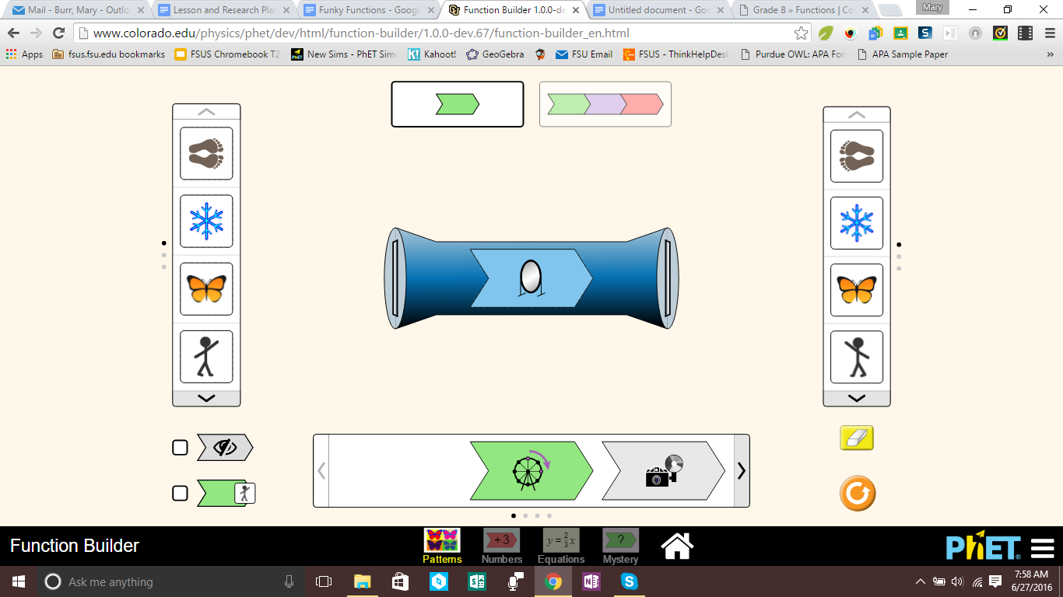 | [ ]Changes size [ ]Changes direction  [ ]Changes shape [ ]Changes color
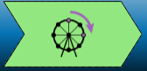 | [ ]Changes size [ ]Changes direction  [ ]Changes shape [ ]Changes color
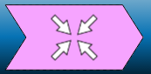 | [ ]Changes size [ ]Changes direction  [ ]Changes shape [ ]Changes color
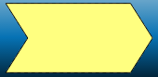 | [ ]Changes size [ ]Changes direction  [ ]Changes shape [ ]Changes color
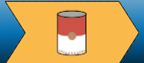 | [ ]Changes size [ ]Changes direction  [ ]Changes shape [ ]Changes color

4. Perform the transformation, and check yes or no in the table.
Input Shape | Function Rule | Output shape changes?
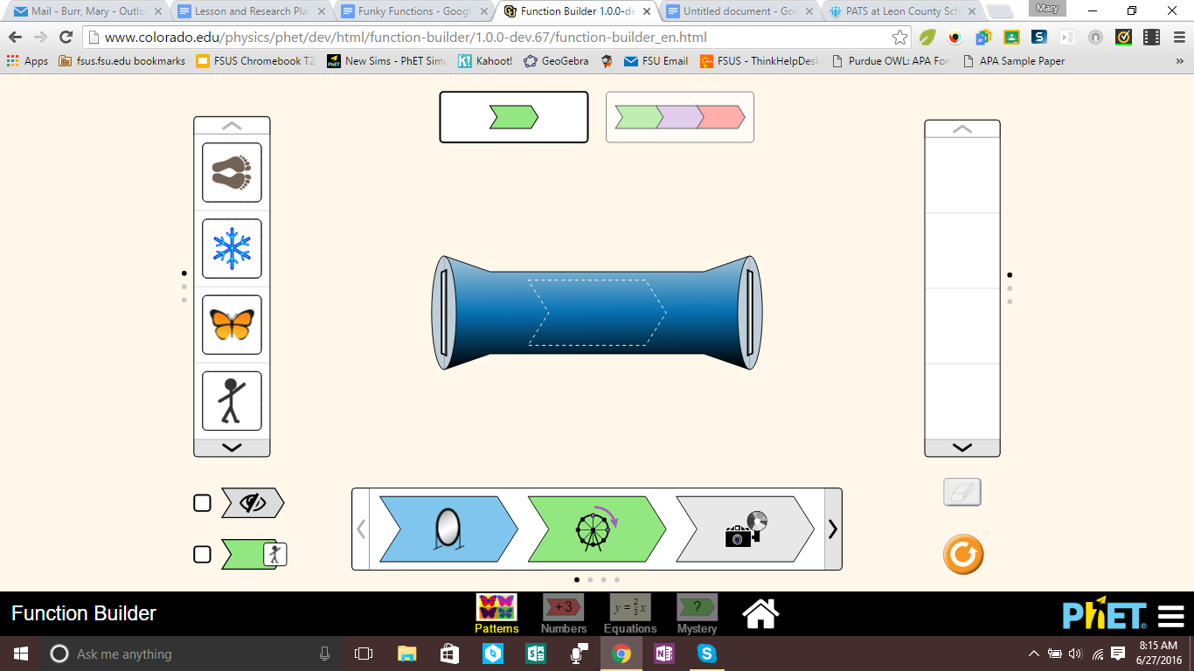 |  | [ ] Yes [ ] No
 |  | [ ] Yes [ ] No
 |  | [ ] Yes [ ] No
 |  | [ ] Yes [ ] No

5. Explain why some shapes change when reflected by the mirror and others do not.

6. Perform the transformation, and check yes or no in the table.
Input Shape | Function Rule | Output shape changes?
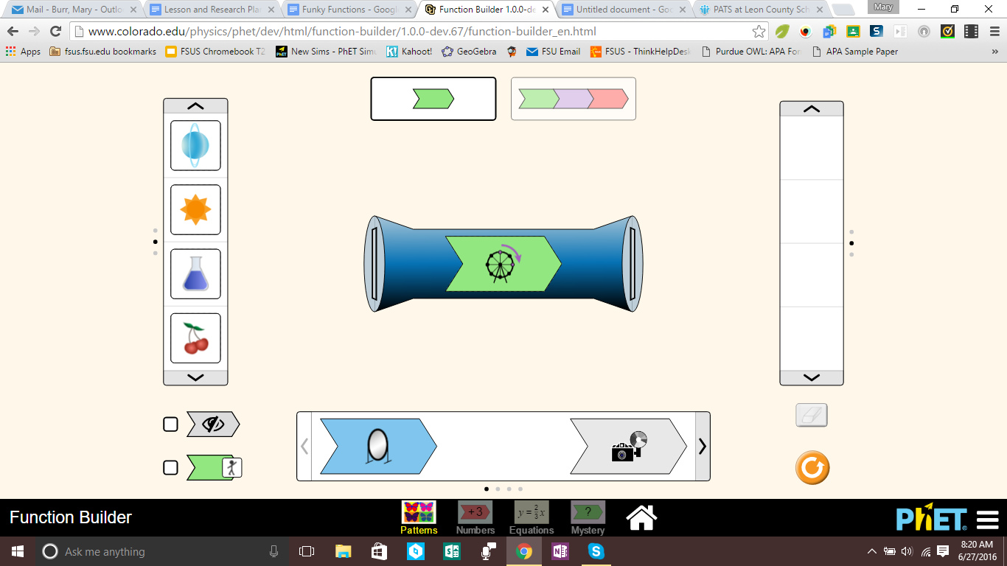 | 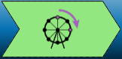 | - Yes  - No
- Yes
- No
- Yes
- No
- Yes
- No

7. Explain why you think some shapes change when rotated by the Ferris wheel and others do not.

8. What do you think the difference is between these two transformations?
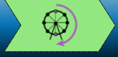

9. Describe what happens to the shape when you use this sequence of transformations.

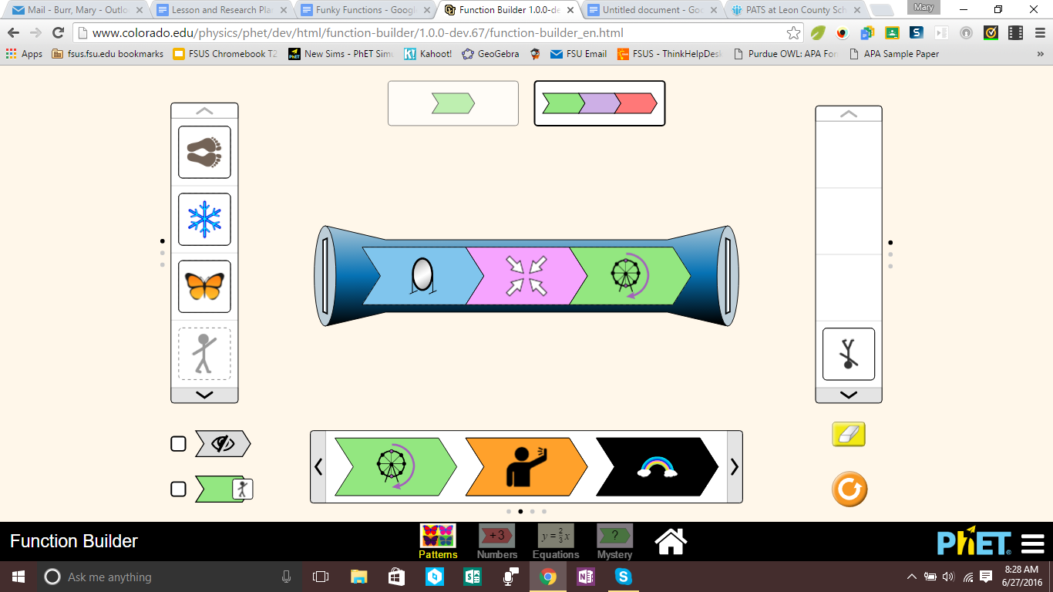
1.___________________________________________
2.___________________________________________
3.___________________________________________
(Hint: Use this button for step-by-step help: )

10. Is the output shape from #9 completely different than the input shape? How are they alike?

11. Early Finisher Challenge: What happens with each of the mystery functions?!

Mystery A
Mystery B
Mystery C

