PhET Interactive Simulations on Balancing Chemical Equations
Student Worksheet
Instructions:
- On computer, access the internet and go to: https://phet.colorado.edu/sims/html/balancing-chemical-equations/latest/balancing-chemical-equations_en.html
- On iPad or tablet, use PhET Simulations app; search for balancing chemical equations.
- Begin with INTRODUCTION activity to complete the chart.
- Select balance scale from TOOLS in top-right pull down menu to complete last column in chart.
Balancing chemical equations for the following reactions: | Chemical Equation  ** with correct number for the coefficients** | Draw molecular model of balanced chemical equation – Color the atoms for each element in compounds | Draw a balanced scale with correct number and color of atoms for each element.
Make Ammonia | __ N₂ + __H₂ __NH₃ | Reactants  Products | 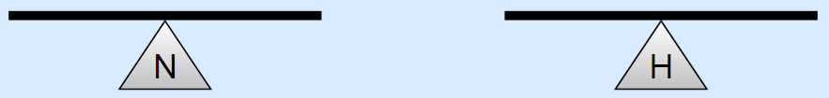
Separate Water | __ H₂O __ H₂ + __ O₂ | Reactants  Products | 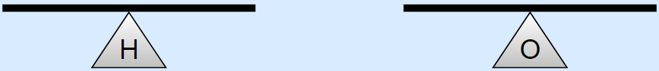
Combust Methane | __ CH₄ + __ O₂ __ CO₂ + __ H₂O | Reactants  Products

Extension – Part Two: Game
- To access game, go to same website or PhET app for Balancing Chemical Equations, and select GAME (happy face icon).
- Begin with Level 1, to balance chemical equations. As you improve your ability to balance chemical equations, you can advance to Level 2, then Level 3. Levels become more challenging.
- Use the chart below to fill in equations you have successfully balanced at each level, underlining the coefficients in each chemical equation.

Level 1 | Level 2 | Level 3

