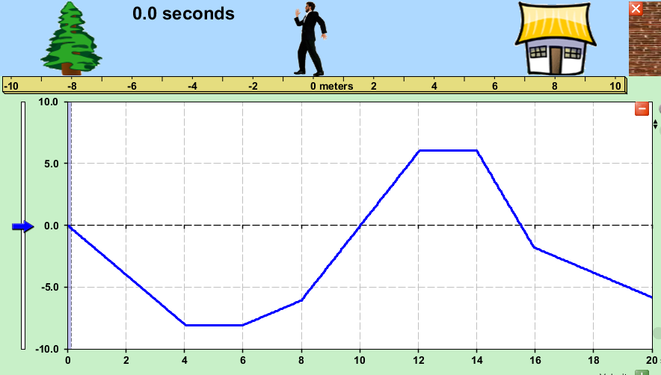
- The Position vs. Time graph to the right displays the motion of Awesome Ambrose.

- Describe in detail Awesome Ambrose’s motion. No calculations are necessary here.
___________________________________________
___________________________________________
___________________________________________
___________________________________________
___________________________________________
___________________________________________
___________________________________________
_______________________________________________________________________________________________________________________________________________________________________________________________________________________________________________________________________________________________________________________________________________________________________________________________________________________________________________________________________________________________________________
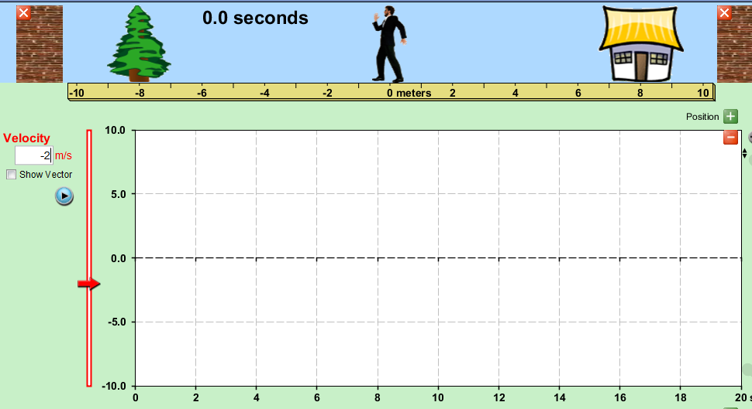
- Draw a Velocity vs. Time graph for Awesome Ambrose’s motion. Use the space below for calculations.

- Draw a motion diagram for Awesome Ambrose’s actions. Clearly indicate your chosen time interval.
x (m)
–10 –8 –6 –4 –2 0 2 4 6 8 10

- Calculate Awesome Ambrose’s average speed and average velocity for the entire trip. Show your work below.

- Make Ambrose’s Velocity vs. Time graph precisely as described and shown. Click “Playback” to see how you did!
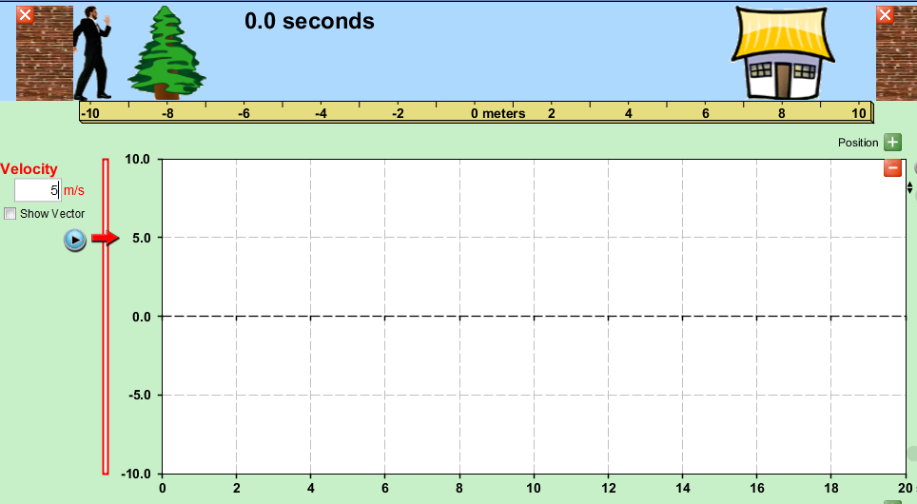
- Cool Carl begins at the left wall (–10 m) and moves to the right at 5.0 m/s for 2.0 seconds. Then he stops for 2.0 seconds to evaluate his life decisions. Unsatisfied with the choices he’s made, he moves to the left at 1.0 m/s for 4.0 seconds. Now at 8.0 seconds into his adventure, he immediately turns around and moves to the right at 2.0 m/s for 2.0 seconds, and then turns back around and goes the same speed to the left for 4.0 seconds. He pauses for 2.0 seconds to contemplate time travel, and then moves back to the right for the last 4.0 seconds at a speed of 3.0 m/s.

- Draw Cool Carl’s Velocity vs. Time graph and use it to predict his final position. Show your work below.

- Calculate Cool Carl’s average speed and average velocity for the entire trip. Show your work below.

- Draw the Position vs. Time graph for Cool Carl’s adventure. Show his average velocity as well.
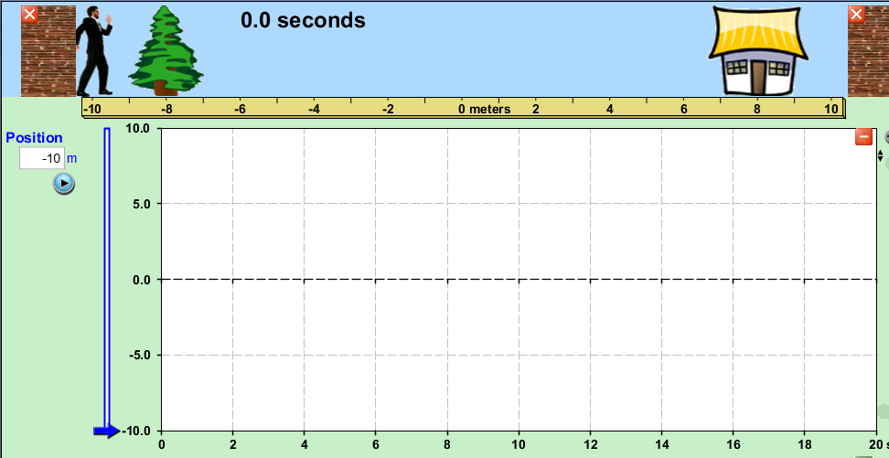

- Draw a motion diagram for Cool Carl’s actions. Clearly indicate your chosen time interval.
x (m)
–10 –8 –6 –4 –2 0 2 4 6 8 10

- Create Joe’s Velocity vs. Time graph precisely as described and shown. Click “Playback” to see how you did!

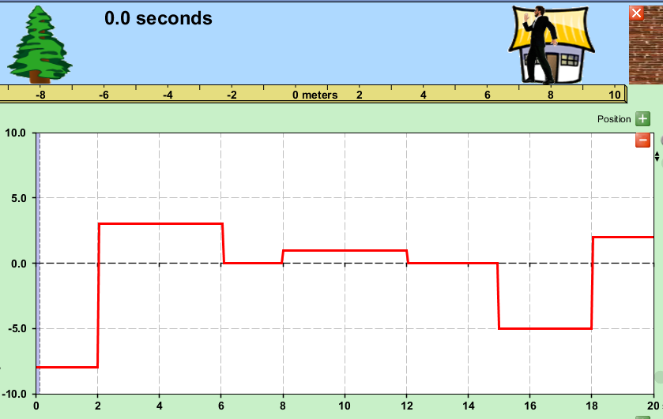
- The Velocity vs. Time graph to the right shows the motion of Excellent Ephraim. All velocities are whole numbers.

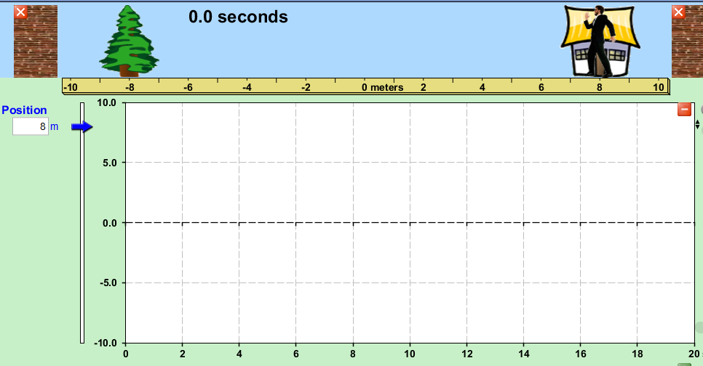
- Draw Excellent Ephraim’s Position vs. Time graph if he has an initial position of 8.0 m.

- Describe Ephraim’s motion in detail. No calculations are necessary for this part.
________________________________________________________________________________________________________________________________________________________________________________________________________________________________________________________________________________________________________________________________________________________________________________________________________________________________________________________________________________________________________________________________________________________________________________________________________________________________________________________________________________________________________________________________________________________________________________________________________________
- Calculate Excellent Ephraim’s average speed and average velocity. Show your work below.

- Create Ephraim’s Velocity vs. Time graph precisely as described and shown. Click “Playback” to see how you did!
- The motion diagram below shows the motion of Jazzy Jerome.
x (m)
–10 –8 –6 –4 –2 0 2 4 6 8 10
2 s

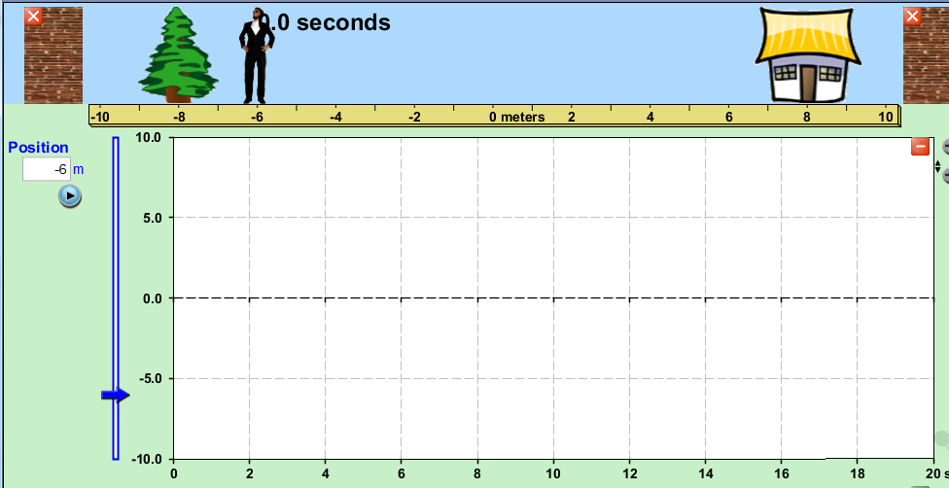
- Draw the Position vs. Time graph for Jazzy Jerome’s motion.

- Draw the Velocity vs. Time graph for Jazzy Jerome’s motion. Use the spaces below for calculations.
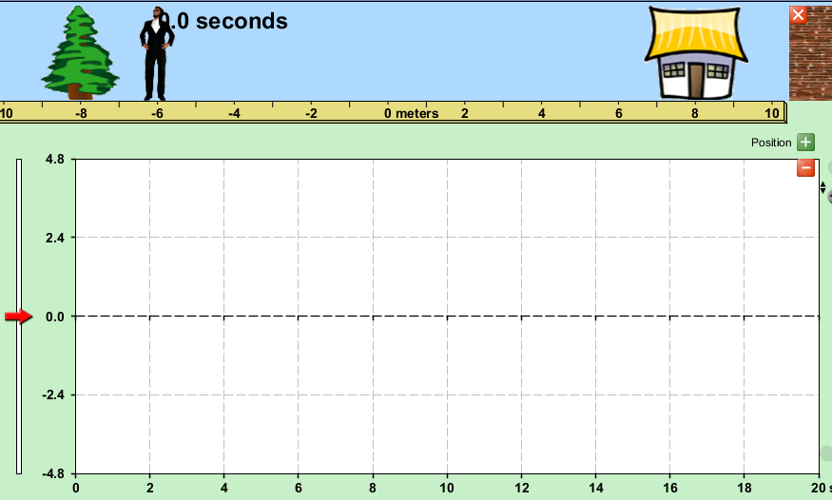

- Calculate Jazzy Jerome’s displacement from the Velocity vs. Time graph you drew and compare it to the motion diagram. What are his average speed and average velocity?

- Create Jerome’s Velocity vs. Time graph precisely as described and shown. Click “Playback” to see how you did!

