Plate Tectonics Simulator! Name: _______________________
Date: _____________ Period: ___
Directions:

*Go to the following website and click on “Run Now” http://phet.colorado.edu/en/simulation/plate-tectonics
*On the bottom right-hand corner of the simulator click on “Both and “Show Labels”.

Part A: Oceanic vs. Continental Crust

- Observe the Oceanic Crust on your left and the continental crust on your right. Which type of crust is thicker? ________________________.

- You can change the crust in the middle of the simulator by adjusting the temperature, composition and thickness. Adjust each of the variables ONE AT A TIME by sliding the dials. Describe what happens to the plate when you adjust each variable.

Variable | Less | More
Temperature

Composition

Thickness

3. Use the information you just collected in the table above to answer the following questions:
- Which type of crust has a higher temperature? ______________________
- Which type of crust has a higher composition of silica? ______________________
- Which type of crust has a higher composition of iron? ______________________
- Which type of crust is thicker? ______________________
- Which type of crust has a lower temperature? ____________________

- Why type of crust do geologists most typically drill when trying to reach the mantle? Explain why they do this.
_______________________________________________________________________________________________________________________________________________________________________.
- On the top right corner of your screen, drag the Zoom bar all the way to the bottom. You can actually click on and drag the Desnity dial into each layer of the Earth to see how dense that layer is. Drag the dial into each layer and fill out the table below.
Name of Layer | 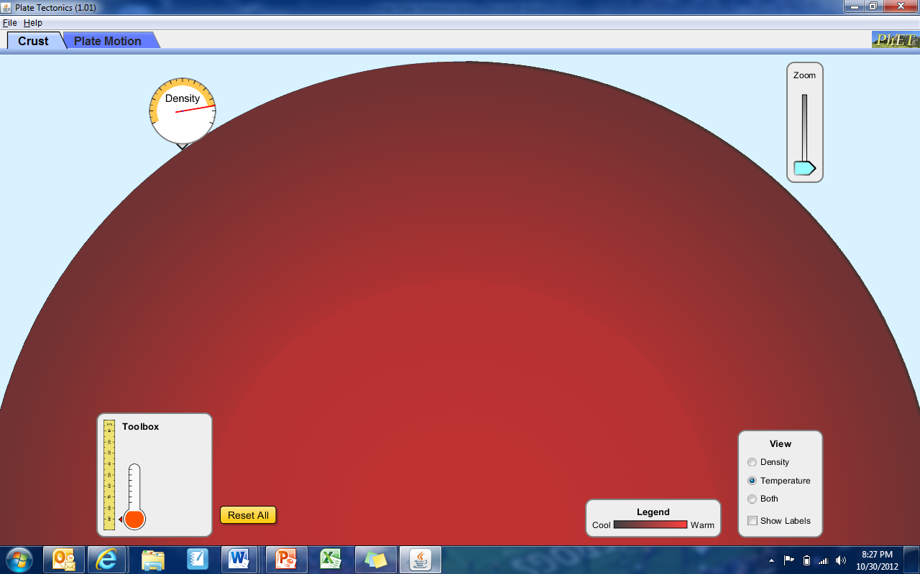  How does this layer’s density compare to the picture? | Why do you think this is?
- Greater Than
- Less Than
- Equal to
- Greater Than
- Less Than
- Equal to
- Greater Than
- Less Than
- Equal to

Part B: Plate Motion

- At the top of the simulator, click on the Plate Motion tab. At the top click on “Manual Mode”. At the bottom, click on “Both” and “Show labels” and “Show Seawater” WHENEVER possible!

Drag the Continental Crust Icon to both sides of the plate boundary. Two red knobs should appear. Drag one of the knobs towards the middle (convergent) and watch what happens! Then create a divergent boundary by pulling it away from the other. Finally, pull the knob toward you to create a transform fault. Fill out the table below. To reset the simulator each time click “New Crust”. To see the same thing happen again click “Rewind”.

A: Continental vs. Continental Plate Boundaries

Two types of plates | Type of boundary | Describe what happens! | Land features formed? | Time Elapsed
Continental vs. Continental | - Convergent  - Divergent  - Transform
Continental vs. Continental | - Convergent  - Divergent  - Transform
Continental vs. Continental | - Convergent  - Divergent  - Transform

B: Continental vs. Oceanic Plate Boundaries

Two types of plates | Type of boundary | Describe what happens! | Time Elapsed
Continental vs. Oceanic | - Convergent  - Divergent  - Transform

C: Old Oceanic vs. Young Oceanic Plate Boundaries

Two types of plates | Type of boundary | Describe what happens! | Time Elapsed
Old Oceanic vs.  Young Oceanic | - Convergent  - Divergent  - Transform
Old Oceanic vs.  Young Oceanic | - Convergent  - Divergent  - Transform
Old Oceanic vs.  Young Oceanic | - Convergent  - Divergent  - Transform

- Why does old oceanic crust subduct under young oceanic crust?
_______________________________________________________________________________________________________________________________________________________________________.

- Where does “new crust” come from? Where does “old crust”go?
_______________________________________________________________________________________________________________________________________________________________________.

- Why do you think you aren’t able to create a divergent oceanic/continental boundary?
_______________________________________________________________________________________________________________________________________________________________________.

- Click “Automatic Mode”. Create as many plate boundaries and timelines as you wish! Record any interesting observations here:

