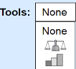
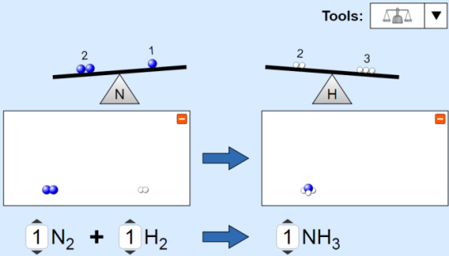
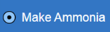
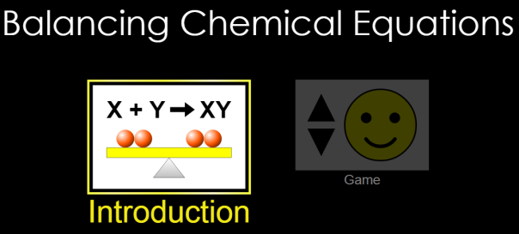
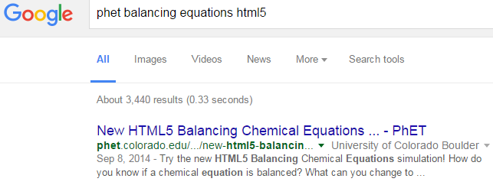
PhET Balancing Chemical Equations html5
Part 1 Directions: Choose “Introduction”
Select “Make Ammonia” and choose one of the balancing tools.
Make each coefficient “1” to see molecules.
Change coefficients until the reaction is balanced. Repeat for water and methane.
CLICK!

Draw pictures of balanced reactions and fill in the coefficients.
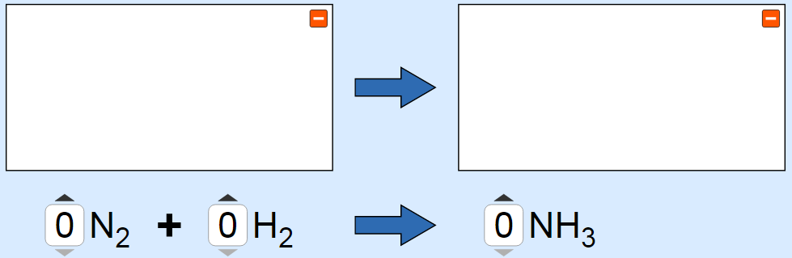
1.

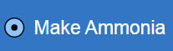
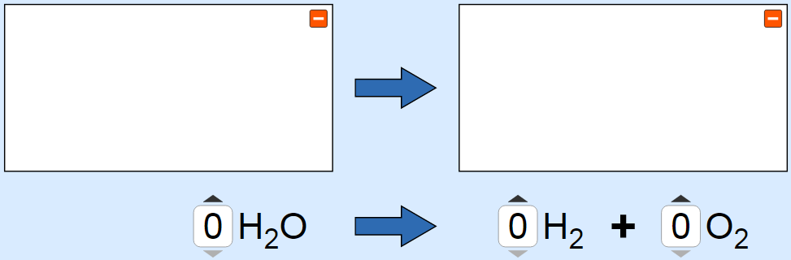
2.


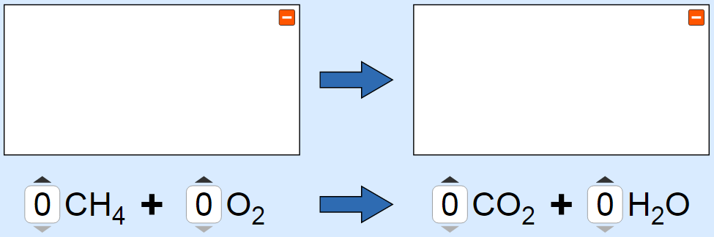
3.


AA31 Labs
AA31 Labs
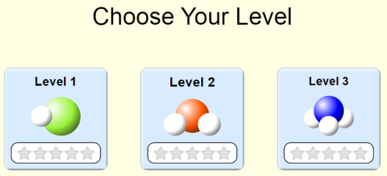
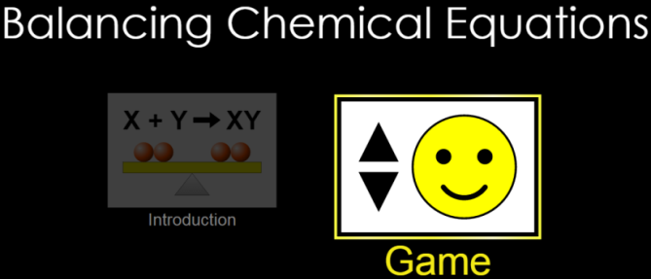
Part 2:

Directions: 2A 2B
Game: Level 1
Fill in the table and include the correct formulas. Play for time after first time.
 | Reactants |  | Products | Best time
#1 |  |  |  | 
#2
#3
#4

#5

Game: Level 2
Fill in the table and include the correct formulas. Play for time after first time.
 | Reactants |  | Products | Best time
#1
#2
#3
#4

#5

Game: Level 3
Fill in the table and include the correct formulas. Play for time after first time.
 | Reactants |  | Products | Best time
#1
#2
#3
#4

#5

