
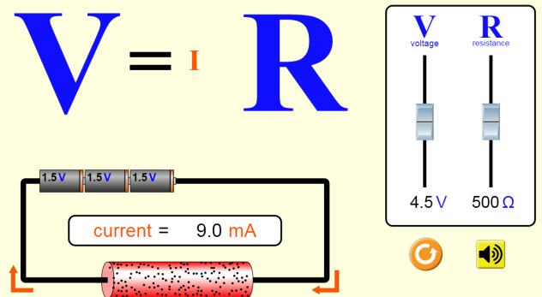
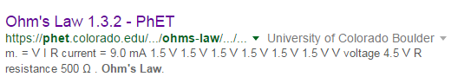
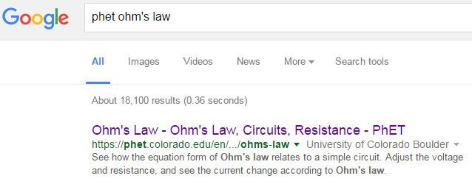
CLICK!
PhET Ohms Law html5

Set up: If asked to open app, click on the html5 logo:
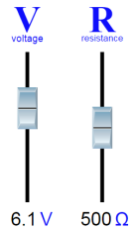
Part 1 Directions: Move the sliders up and down until the values in the table are achieved. Fill in the rest of the table, below.
Voltage | Current | Resistance
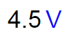 |   ÷1000A/mA = 0.009 A | 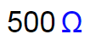
V |   ÷1000A/mA = A | Ω
V |   ÷1000A/mA = A | Ω
V | mA ÷1000A/mA = A | 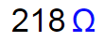
V | mA ÷1000A/mA = A | 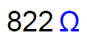
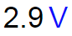 | mA ÷1000A/mA = A | Ω
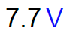 | mA ÷1000A/mA = A | Ω
Part 1 Questions:
- What happened to the letters V, I and R as you moved the sliders?

- There is a mathematical relationship (like multiply/divide/add/subtract) between V, I and R. Using the values in the table, can you find it? Circle the correct mathematical symbol in the table, below.
V |  | I |  | R
4.5 | 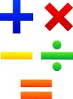 | 0.009 |  | 500
- How can you get current to be as large as possible?
AA31 Labs
AA31 Labs

