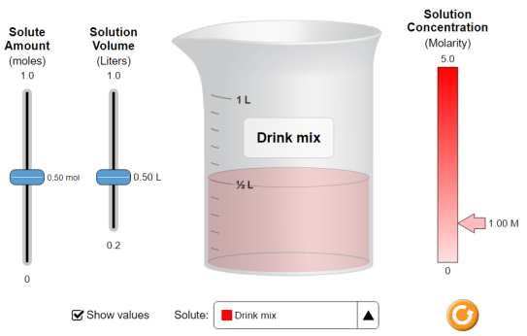
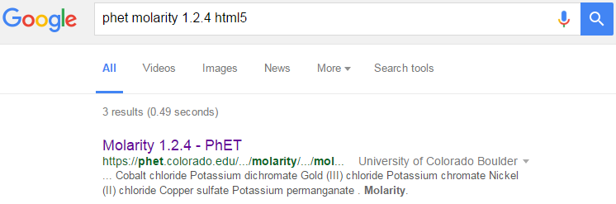
PhET Molarity html5
CLICK!


Part 1 Directions: Click “Show values”
Move the sliders up and down to see how they affect Molarity.
Molarity is moles per Liter, that is, how many moles of solute (entire salt) is dissolved per Liter of solution.
Part 1: Determining saturation concentration How concentrated can you get each solution before the solution is saturated? If you can’t saturate the solution, write the largest value you can make. Write the values in the table.
 | Put saturation concentration here |  | Put saturation concentration here
 | Put saturation concentration here |  | Put saturation concentration here
 | Put saturation concentration here |  | Put saturation concentration here
 | Put saturation concentration here |  | Put saturation concentration here
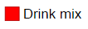
Part 2: Calculating Molarity - Drink Mix Using the simulation and the formula for Molarity above, complete the table below using Drink Mix.
Moles of Compound (mol) | Liters of Solution (L) | Molarity of Solution (M) | Moles of Compound (mol) | Liters of Solution (L) | Molarity of Solution (M)
.53 | .79 |  |  | .78 | .59
.86 | .34 |  | .88 |  | 1.8
1.0 | .20 |  | .35 | .84
.67 | .67 |  |  | .64 | .85
Post-lab Questions:
- Can you dissolve .35 moles of Potassium Permanganate (KMnO₄) into 500 mL of water? _________
Why? / Why not? (please show work)

- Can 750 mL of water dissolve 0.60 moles of gold (III) chloride, AuCl₃? _________ Why? / Why not? (please show work)

Going further – extrapolating results that you cannot test in the simulation.
- Can 1750 mL of water dissolve 4.6 moles of Copper Sulfate CuSO₄? _________ Why? / Why not? (please show work)

- What is the minimum amount of water is needed to dissolve 3mol potassium dichromate? (please show work)
AA31 Labs

