Phet: Photoelectric effect simulation http://phet.colorado.edu/en/simulation/photoelectric
Items you can change in the simulation include: target material, light intensity, light wavelength, battery polarity, and battery voltage.
Turn on all 3 graphs on the right.
Part I:
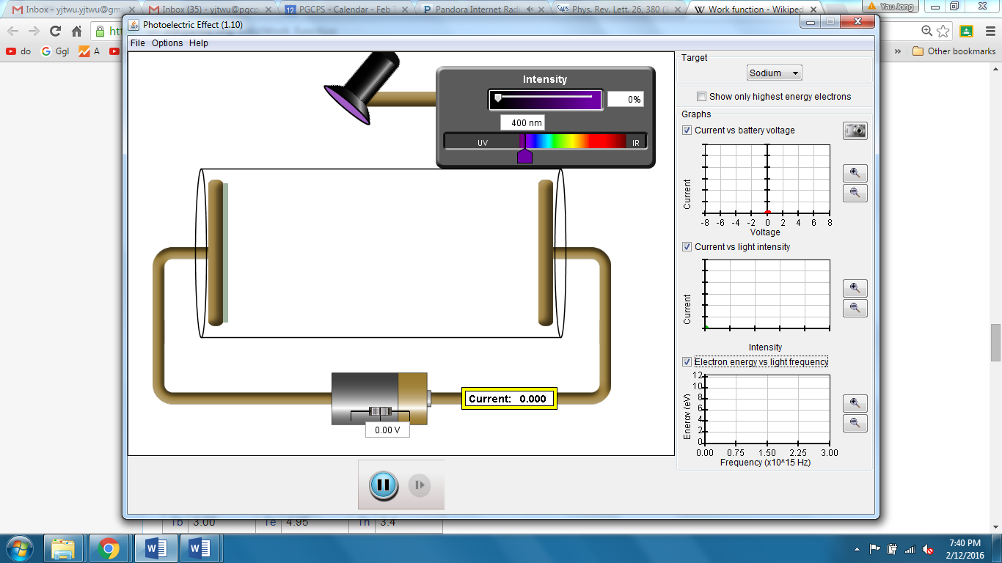
1. Start with sodium for target material. Keep voltage at 0. Change light intensity and/or light wavelength in different ways and observe how the current reading changes.
Record your observations and how they match photon model predictions:

2. Now let’s measure the work function (in eV) of sodium. Briefly describe what you would do, what data to take, and the calculations you would make to find the work function.

3. Select a wavelength and an intensity level so you get about 0.5 A of current. While you make adjustments to get to 0.5 A, please pay attention to how the wavelength and intensity affects the current. Record your wavelength: _____________ and intensity: _____________
a) Slowly change the battery voltage and battery polarity. Carefully observe how the current changes and how the motions of the electrons change. Record the current v.s. voltage graph. Explain why the graph looks so.

b) Now let’s find the stopping voltage under this setting. Describe what you would do to find the stopping voltage and record this voltage.

4. Use your stopping voltage to calculate the maximum kinetic energy of the electrons in eV. Then use the work function and the wavelength of the light to find the maximum kinetic energy. Do these two methods give you the same results? Find the % difference.

Part II: Now let’s try different target materials.
1. Which properties would change when target material is changed?

2. Record and compare 3 tests you carry out involving different target materials. Briefly explain what conclusion(s) you can draw from each of your test.
a) Test #1:

b) Test #2:

c) Test #3:

