Investigating the pH Scale
Guiding Question:
How does the pH scale qualitatively relate to acids, bases, hydronium ion and hydroxide ion concentrations?

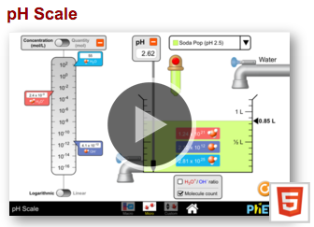
1. Navigate to the PhET “pH scale” Simulation.
- You can google “PhET pH scale”, go to the first link, then click on the play button in the center of the picture
- OR you can follow this link: https://phet.colorado.edu/sims/html/ph-scale/latest/ph-scale_en.html

Macro Investigation
2. Click on the “Macro” box.
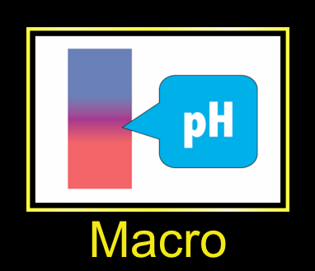

3. There is a pH scale on the left hand side of the screen. Label the pH scale below as acidic and basic. http://www.aquahealthproducts.com/sites/default/files/pH%20scale%20-%20EN.jpg
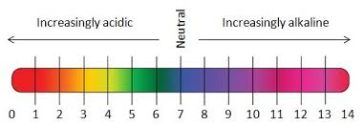
_______________
_______________

Lyric Portwood, South Paulding HS 2015
4. Investigate the pH of each of the following substances.
- Drag the pH sensor into the solution to see the pH reading. 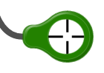
- Record the pH of the substance and whether the substance falls into the acid or base end of the pH scale.
- To change the substance simply select from the drop down menu. 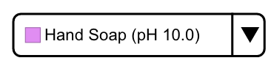
Substance | pH | acid/base
Drain cleaner
Hand soap
Blood
Spit
Milk
Chicken Soup
Coffee
Orange Juice
Soda Pop
Vomit
Battery Acid

5. Now add these substances below the pH scale on the previous page at the appropriate location based on their pH values.

6. Using the information from the chart and simulation answer the following questions.
  - What pH values correspond to acids?

  - What pH values correspond to bases?

Micro Investigation
7. Navigate to the “Micro” box.
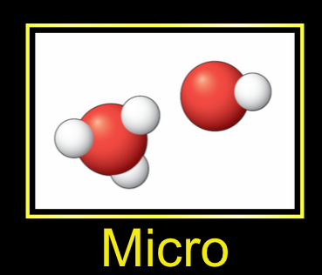
8. The same substances that were on the previous tab (Macro) are in this tab. However this tab gives you additional information. Click on the H₃O⁺/OH⁻ ratio box located below the beaker with the substance.
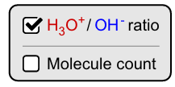
9. Fill in the chart below for each substance in the chart. (Note the first three columns of the chart you completed above)
Substance | pH | Acid or Base? | Concentration (mol/L) |  |  | Particulate Level View  (color coded)
Substance | pH | Acid or Base? | H₂O | H₃O⁺ | OH⁻ | Particulate Level View  (color coded)
Drain cleaner
Hand soap
Blood
Spit
Substance | pH | Acid or Base? | Concentration (mol/L) |  |  | Particulate Level View  (color coded)
Substance | pH | Acid or Base? | H₂O | H₃O⁺ | OH⁻ | Particulate Level View  (color coded)
Milk
Drain cleaner
Coffee
Orange Juice
Soda Pop
Vomit
Battery Acid

10. Using the information from the chart and simulation answer the following questions.
- As the pH approaches 0, what happens to the concentration of H₃O⁺ ions?

- As the pH approaches 0, what happens to the concentration of OH⁻ ions?

- As a solution becomes more acidic, the concentration of (H₃O⁺/OH⁻) ions increases and the concentration of (H₃O⁺/OH⁻) ions decreases.

- As the pH approaches 14, what happens to the concentration of H₃O⁺ ions?

- As the pH approaches 14, what happens to the concentration of OH⁻ ions?

- As a solution becomes more basic (aka alkaline), the concentration of (H₃O⁺/OH⁻) ions increases and the concentration of (H₃O⁺/OH⁻) ions decreases.

11. Can you predict what a solution with a pH of 7 will look like at the particulate level? Draw a particulate diagram of a neutral solution in the box.

12. Would you classify this solution as an acid or base? Explain your reasoning.

Lyric Portwood, South Paulding HS 2015
Further Investigations into the pH scale

Guiding Questions:
- How does adding water affect the pH of acid and base solutions?
- What are the outer limits of the pH scale? How low and high does it go and what does this mean?

My Solution Investigation
1. Navigate to the PhET “pH scale” Simulation.
- You can google “PhET pH scale”, go to the first link, then click on the play button in the center of the picture
- OR you can follow this link: https://phet.colorado.edu/sims/html/ph-scale/latest/ph-scale_en.html

2. Click on the “My Solution” box.
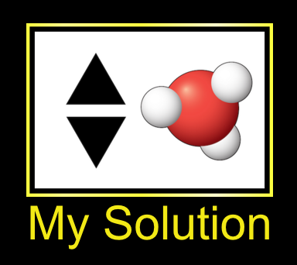
3. Click on the H₃O⁺/OH⁻ ratio box located below the beaker with the substance.
4. Determine the lowest the pH scale can go by adjusting the pH value. What is the lowest pH value you could achieve on the simulation?
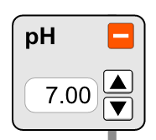

5. Draw a particulate diagram of this solution. Is this solution very acidic or very basic?

6. Determine the highest the pH scale can go by adjusting the pH value. What is the highest pH value you could achieve on the simulation?

7. Draw a particulate diagram of this solution. Is this solution very acidic or very basic?

8. Adjust the pH scale so that you have a solution with a pH of 7.00. Draw a particulate level diagram of this solution.

9. What are the concentrations of H₃O⁺ and OH⁻ ions?

10. Is this solution acidic or basic? Explain.

Micro Investigation
11. Navigate to the “Micro” box.
12. Click on the H₃O⁺/OH⁻ ratio box located below the beaker with the substance.
Lyric Portwood, South Paulding HS 2015
13. Investigate how adding more of the substance with the red button on the dropper changes the pH of the resulting solution.


14. Fill in the data table with data from 5 different solutions (make sure atleast two are acid and atleast two are base).
Substance | Volume (Liters) |  | pH
Substance | Initial | Final | Initial | Final

15. What happens to the pH of the solution as you add more of the substance to it?

16. Now you will investigate how adding water changes the pH of the solution. Reset the simulation page with the reset arrow.


17. Make sure to reclick on the H₃O⁺/OH⁻ ratio box located below the beaker with the substance.

18. Investigate the effect of adding water to a solution on the pH of that solution. Add enough water to the solution to bring the total volume of the beaker up to 1 L using the water knob.
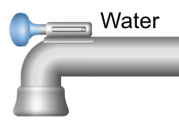

19. Fill in the chart below with data from five different solutions.
Substance | Acid or base? | pH |  | H₃O⁺ ion concentration (mol/L) |  | OH⁻ ion concentration (mol/L)
Substance | Acid or base? | Initial at 0.5 L | Final at 1 L | Initial at 0.5 L | Final at  1 L | Initial at 0.5 L | Final at 1 L

20. Use the simulation and information from the chart to answer the following questions.
- What happens to the pH of an acid as water is added?

- What happens to the concentration of both H₃O⁺ and OH⁻ ions as water is added to an acid?

- What happens to the pH of a base as water is added?

- What happens to the concentration of both H₃O⁺ and OH⁻ ions as water is added to a base?

21. Go back and answer the guiding questions from the beginning of this activity.
Lyric Portwood, South Paulding HS 2015
Determining pH

Guiding Question:
Substance | pH | H₃O⁺ concentration (mol/L)
Drain cleaner
Hand soap
Blood
Spit
Milk
Chicken Soup
Coffee
Orange Juice
Soda Pop
Vomit
Battery Acid
How is the pH quantitatively related to the hydronium ion concentration?

Mathematical Investigation
1. Navigate to the PhET “pH scale” Simulation.
- You can google “PhET pH scale”, go to the first link, then click on the play button in the center of the picture
- OR you can follow this link: https://phet.colorado.edu/sims/html/ph-scale/latest/ph-scale_en.html

2. Navigate to the “Micro” box.
3. Fill in the chart below using the simulation.

4. Now if you noticed, at the bottom of the left side of the screen you can change the view from Logarithmic to Linear and vice versa. The pH scale is a logarithmic scale. Therefore let’s apply some logarithm calculations to see if there is a correlation to pH. Determine the log of all of your H₃O⁺ ion concentrations from above. To do this simple press “log” then type in the concentration on your calculator and hit Enter. Record your data in the table below.
Substance | pH | H₃O⁺ concentration (mol/L)
Drain cleaner
Hand soap
Blood
Spit
Milk
Chicken Soup
Coffee
Orange Juice
Soda Pop
Vomit
Battery Acid
Substance | pH | H₃O⁺ concentration (mol/L) | Log of H₃O⁺ concentration
Drain cleaner
Hand soap
Blood
Spit
Milk
Chicken Soup
Coffee
Orange Juice
Soda Pop
Vomit
Battery Acid

5. Is there any relationship between the H₃O⁺ concentration and the pH?

Lyric Portwood, South Paulding HS 2015
6. Can you write an equation to describe this?

7. There is another scale that is complimentary to pH. It is called the pOH scale. Look at the pOH and pH scale below. What is the relationship between these two scales?
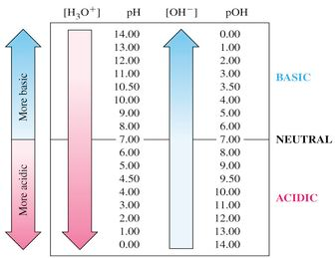https://baskinapchem.wikispaces.com/file/view/pH-pOH%20scales2.jpg/425149768/337x259/pH-pOH%20scales2.jpg

8. The pOH scale is also a logarithmic scale. Therefore let’s apply some logarithm calculations to see if there is a correlation to pOH. Determine the log of all of your OH⁻ ion concentrations from above. To do this simple press “log” then type in the concentration on your calculator and hit Enter. Record your data in the table below.
Substance | pH | pOH | OH⁻ concentration (mol/L) | Log of OH⁻ concentration
Drain cleaner
Hand soap
Blood
Spit
Milk
Chicken Soup
Coffee
Orange Juice
Soda Pop
Vomit
Battery Acid

9. Is there any relationship between the OH⁻ concentration and the pH (Hint* think of the pH scale as ending at 14(even though we know it can go beyond there))?

10. Can you write an equation to describe this?

11. Determine the pOH for all solutions in the chart above.

12. What is the relationship between pH, pOH, H₃O⁺ ions and OH⁻ ions?
Lyric Portwood, South Paulding HS 2015

