Simulation Lab: States of Matter and Kinetic Energy
Objectives:
- Explain the relationship between temperature of a substance, the state of matter of the substance, and the kinetic (motion) energy of the particles.
- Identify common characteristics of each state of matter related to particle motion, particle arrangement, and distance between particles.
Hypothesis:
What does heating atoms/ molecules do to their motion? Explain your prediction in 2-3 complete sentences.
______________________________________________________________________________________________________________________________________________________________________________________________________________________________________________________________________________________________________________________________________________________________________________________________________________________________________________________________________________________________________________________________________________________________________________________________________________________________
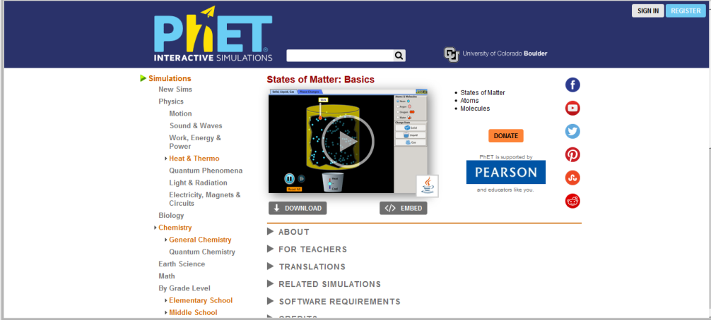
Setup Procedures:
- Go to google.com.
- In the search bar, type “phet states of matter basics”. Choose the very first result. You should see the page pictured at right.

- Click on the play button in the middle of the picture. It will take a minute for the program to load. Be patient!

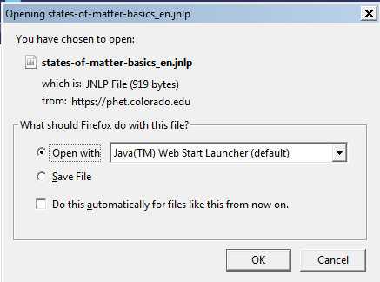
- If a dialogue box appears that looks the one shown to the right and asks which program to use, make sure the choice shown is “Open With” and then “Java”. Click OK. Again, the program will take a minute to load. Be patient! The page that opens should look like the picture below.
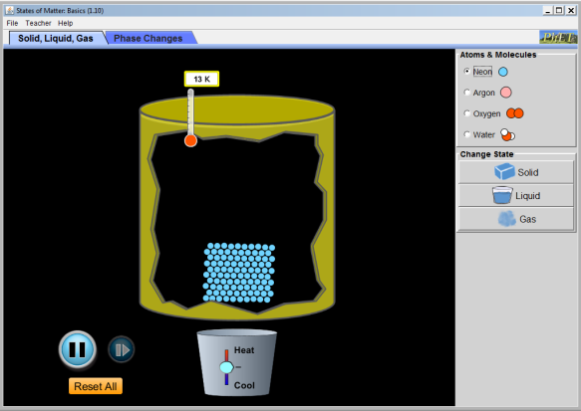

Simulation Lab: States of Matter and Kinetic Energy
Lab Procedures: Name: _________________________________
Explore:
- At the top of the page, click on the “Teacher” tab, then click on “Celsius.”
- Stay on the Solid, Liquid, Gas tab. We will look at the other tab, “Phase Changes,” in our next unit.
- For 5 minutes, play! Try different atoms and molecules. Click on the different states. Heat and cool the particles and watch what happens!
Experiment:
- Choose neon as the atom type.
- Complete the table below by clicking on the different states of matter.
State | Sketch 10 atoms the way they appear | Does the group of atoms have a fixed shape? YES/NO | Are the atoms touching each other? YES/NO | Are the atoms vibrating? YES/NO | Are the atoms changing location? (watch a single atoms for 30 seconds to determine) YES/NO | Rank the volume of the substance 1=least, 5 =most | Rank the speed of the particles  1=slowest, 5 =fastest
solid
liquid
gas

- Choose argon as the atom type, then choose solid as the state of matter.
- Record the temperature shown: _____________.
- Describe the motion of the atoms in complete sentences. What are they doing? How fast are they moving? How are the atoms arranged?
_________________________________________________________________________________________________________________________________________________________________________________________________________________________________________________________________________________________________________________________________________________________________________________________________________
- Heat the argon atoms until the temperature is around -200°C.
- How did this affect the motion of atoms? Explain in complete sentences.
____________________________________________________________________________________________________________________________________________________________________________________________________________________________________________________________________________________________________________________________________________________________________________________________________________________________________________________________________________________________________________________________________________
- Did the argon change state as you heated the atoms? Explain how you know in complete sentences.
_________________________________________________________________________________________________________________________________________________________________________________________________________________________________________________________________________________________________________________________________________________________________________________________________________
- Heat the argon atoms until the temperature is around -180°C.
- How did this affect the motion of atoms? Explain in complete sentences.
____________________________________________________________________________________________________________________________________________________________________________________________________________________________________________________________________________________________________________________________________________________________________________________________________________________________________________________________________________________________________________________________________________
- Did the argon change state as you heated the atoms? Explain how you know in complete sentences.
_________________________________________________________________________________________________________________________________________________________________________________________________________________________________________________________________________________________________________________________________________________________________________________________________________
- Heat the argon atoms until the temperature is around -80°C.
- How did this affect the motion of atoms? Explain in complete sentences.
____________________________________________________________________________________________________________________________________________________________________________________________________________________________________________________________________________________________________________________________________________________________________________________________________________________________________________________________________________________________________________________________________________
- Did the argon change state as you heated the atoms? Explain how you know in complete sentences.
_________________________________________________________________________________________________________________________________________________________________________________________________________________________________________________________________________________________________________________________________________________________________________________________________________
- Heat the argon atoms until the temperature is around 50°C.
- How did this affect the motion of atoms? Explain in complete sentences.
____________________________________________________________________________________________________________________________________________________________________________________________________________________________________________________________________________________________________________________________________________________________________________________________________________________________________________________________________________________________________________________________________________
- Did the argon change state as you heated the atoms? Explain how you know in complete sentences.
_________________________________________________________________________________________________________________________________________________________________________________________________________________________________________________________________________________________________________________________________________________________________________________________________________
- Heat the argon atoms until the temperature is around 500°C.
- How did this affect the motion of atoms? Explain in complete sentences.
____________________________________________________________________________________________________________________________________________________________________________________________________________________________________________________________________________________________________________________________________________________________________________________________________________________________________________________________________________________________________________________________________________
- Did the argon change state as you heated the atoms? Explain how you know in complete sentences.
_________________________________________________________________________________________________________________________________________________________________________________________________________________________________________________________________________________________________________________________________________________________________________________________________________
- Choose solid again.
- Cool the argon atoms until they reach a temperature of approximately -270°C.
- How did this affect the motion of atoms? Explain in complete sentences.
____________________________________________________________________________________________________________________________________________________________________________________________________________________________________________________________________________________________________________________________________________________________________________________________________________________________________________________________________________________________________________________________________________
- Did the argon change state as you cooled the atoms? Explain how you know in complete sentences.
_________________________________________________________________________________________________________________________________________________________________________________________________________________________________________________________________________________________________________________________________________________________________________________________________________

Conclusion
- For each state of matter, describe the particles. Make sure you include:
- the way the particles are arranged (1 point)
- the type of motion they are involved in (1 point)
- the distance between the particles (1 point)
- The particles in a solid… _____________________________________________________________________________________________________
___________________________________________________________________________________________________________________________________________________________________________________________________________________________________________________________________________________________________________________________________________________________________________The particles in a liquid…_____________________________________________________________________________________________________
___________________________________________________________________________________________________________________________________________________________________________________________________________________________________________________________________________________________________________________________________________________________________________
- The particles in a gas…_______________________________________________________________________________________________________
___________________________________________________________________________________________________________________________________________________________________________________________________________________________________________________________________________________________________________________________________________________________________________

- When you increased the temperature of the particles, did the speed of the particles increase, decrease, or stay the same? _________________________
- When you decreased the temperature of the particles, did the speed of the particles increase, decrease, or stay the same? ________________________

The temperature of a substance is really a measure of the thermal energy of the particles in that substance. The speed of the particles is determined by the kinetic energy of the particles. Based on this, complete the sentences below.

- As thermal energy of a substance increases, the kinetic energy of the particles ______________________ (increases, decreases, or stays the same).
- Therefore, we can say that temperature is really just a measure of the _______________________ energy of the particles in a substance.

