AP Physics 2 Name: ___________________
PHET: Charges and Fields Activity Part 1

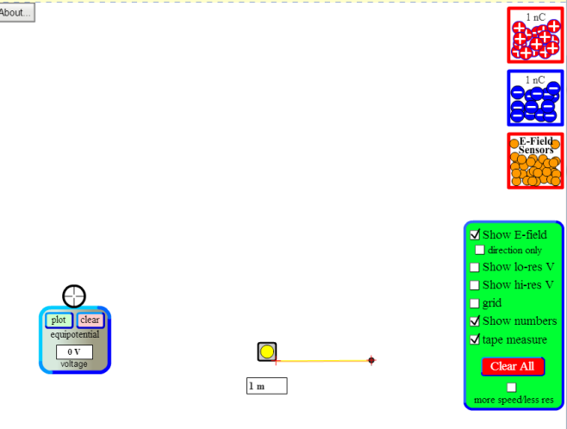
Objective: Your mission is to design a procedure in which you will collect data to discover the relationship between:
- Electric Field Strength and Distance (radius).
- Amount of charge and Electric Field Strength.

How Should I Start? I would start by playing around with the sim a bit.
- Click the boxes for “Show E-field”, “Show numbers”, and “tape measure”.
- Drag a charge onto the screen and observe what the E-field looks like.
- You can measure the strength of the E-field at any point by dragging the E-field sensor to whatever point you want.
- Add some more charges and observe what that does to the field.

Okay Now I know what the buttons do. What next?
- Decide what your independent and dependent variables will be to investigate the first objective.

Independent: ___________________________ Dependent: _____________________________

- Design a data table for your data. I want you to gather data for 15 points. Label the columns appropriately.

Point
1
2
3
4
5
6
7
8
9
10
11
12
13
14
15

- What things will you keep constant during this simulation?

- Open up Logger Pro and graph your data.
- Do a curve fit to find the relationship between your variables. Print out your graph with the equation and attach it to this lab. Describe the relationship in words here.

And now for Objective 2!!!

- Decide what your independent and dependent variables will be to investigate the SECOND objective.

Independent: ___________________________ Dependent: _____________________________

- Design a data table for your data. I want you to gather data for 15 points. Label the columns appropriately.

Point
1
2
3
4
5
6
7
8
9
10
11
12
13
14
15

- What things will you keep constant during this simulation?

- Open up Logger Pro and graph your data.
- Do a curve fit to find the relationship between your variables. Print out your graph with the equation and attach it to this lab. Describe the relationship in words here.

- Why would the Field strength vary inversely with the surface area of a sphere?

