Series and Parallel Circuits
Online Lab

Open the circuit constructor at the following URL:
http://phet.colorado.edu/sims/circuit-construction-kit/circuit-construction-kit-dc_en.jnlp
Create the circuit shown in figure 1.
Make the following modifications to the component properties by right-clicking on each component:
- Set the resistance of each light bulb to 5 ohms
- Set the battery voltage to 10 volts

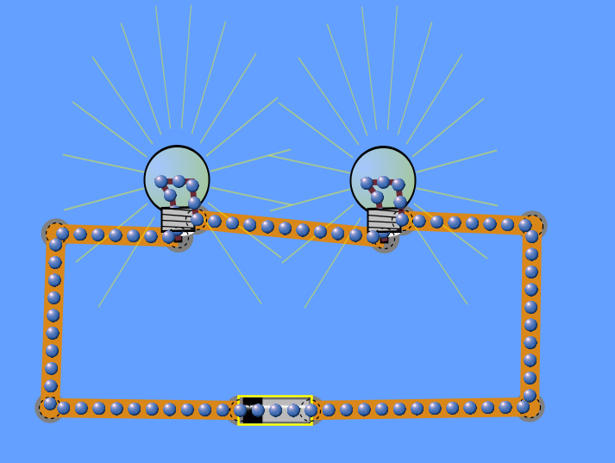
Figure 1

- What is the total resistance of these series-connected bulbs?
R =

- Use ohms law to calculate the circuit current (I):
Calculated current I = V/R where:
V=voltage in volts
R=Resistance in ohms
I = Current in amps (The letter “I” originally stood for Intensity)

I =


- Use the Non-Contact Ammeter to measure the current the circuit. Record the measured current.

I =

The bulbs in figure 1 are connected in series.
Connect another bulb in series with the first two. Change the properties of this bulb to have 5 ohms of resistance.
- Calculated the circuit current for the modified circuit and record this calculated current.
I =

- Use the Non-Contact Ammeter to measure the current in the circuit. Record the measured current.
I =

Connect the bulbs in the configuration shown below. Make sure each bulb is set for 5 ohms of resistance and the battery is set for 10 volts.
- What do you immediately notice about the bulbs and why?

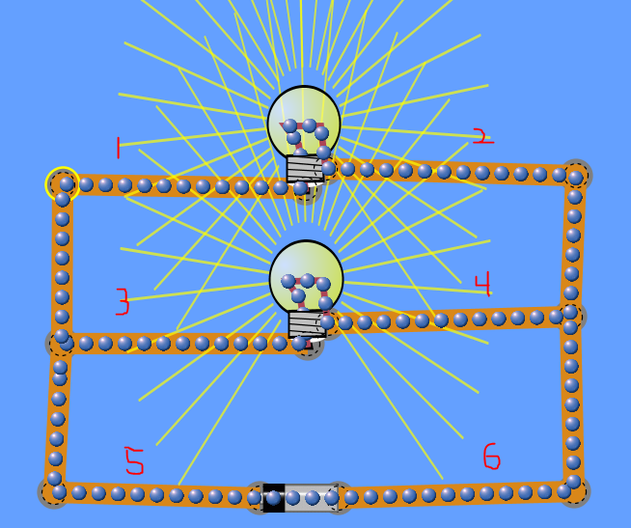
Figure 2

The bulbs in figure 3 are connected parallel.

Figure 3
- What is the total resistance of these parallel-connected bulbs?
R =

- Calculated the currents for the parallel circuit and record these calculated values.
I _{(point 1)} =
I _{(point 2)} =
I _{(point 3)} =
I _{(point 4)} =
I _{(point 5)} =
I _{(point 6)} =

- Use the Non-Contact Ammeter to measure the currents in the circuit. Record the measured currents.
I _{(point 1)} =
I _{(point 2)} =
I _{(point 3)} =
I _{(point 4)} =
I _{(point 5)} =
I _{(point 6)} =

If the calculated values of current don’t match the measured values of current read about parallel circuits in your text and recalculate the currents.
- As you add more bulbs (loads) in a series circuit what happens to the current in the series circuit and why?

- As you add more bulbs (loads) in a parallel circuit what happens to the current in the series circuit and why?

- Which one of these circuits represents the type of electrical connections found in your home?

Series (figure 4) and parallel (figure 5) connected loads.
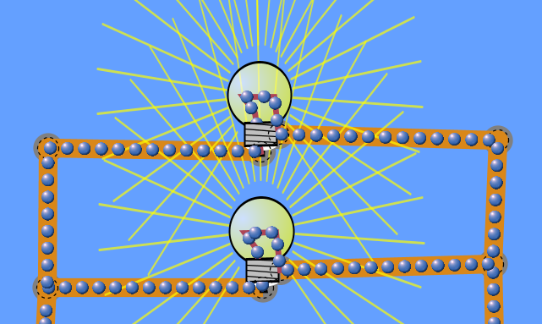
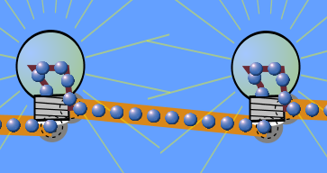
Just as loads like the light bulbs can be connected in series and parallel the power sources can also be connected in series and parallel.
Figure 5
Figure 4

- What is the advantage of connecting power supplies in series?

- What is the advantage of connecting power supplies in parallel?

