Lesson plan for Forces and Motion Basics: Net Force Activity 1 (Designed for second grade)
By Anne Mason
Prior Knowledge
Students need to have an understanding that an object needs a push or a pull (force) to get the object moving. A force can make an object move, make an object stop, change an object’s speed, change an object’s position or direction.
Learning goals or targets
Students will predict how a force will change an object’s motion or direction.
Students will understand the greater the force is, the greater the change in motion will be.
Standards
Standard 1: Physical Science
GLE 1: Changes in speed or direction of motion are caused by forces such as pushes and pulls
EOa: Identify and predict how the direction or speed of an object may change due to an outside force (Depth of Knowledge 1-2)
EOb: Analyze and interpret observable data about the impact of forces on the motion of objects (Depth of Knowledge 1-2)
Materials
- PhET Forces and Motion: Basics simulation:
https://phet.colorado.edu/en/simulation/forces-and-motion-basics
- Desktop/Laptop/Chromebook/tablet for each student or pair
- Activity Recording sheet (see page 3)
- Pencil and colored pencil
Pre-Lesson
Have simulation downloaded on the computers prior to lesson. Introduce students to the Forces and Motion: Basics simulation. Explain various tools to reset and movement of objects.
Lesson
Begin with stating the learning goals/targets. Pass out student activity recording sheet and ask students to predict what will happen in different scenarios. Students will also comment on how much force will be applied to the object. Give students about 15 to 20 minutes to run the simulations. Students will check their predictions and make any changes with a colored pencil.

Closure
Gather students up with their student activity sheets. Ask the following questions:
a) Does it matter that the people are red or blue? Explain your answer.
b) Does a large person always win each competition? Provide evidence to support your answer.
c) If two people are pulling on opposite sides, does the cart always stay still? Explain your ideas.
d) Does it matter what part of the rope a person holds? Provide evidence to support your answer.

Follow up Sims
Students can continue to explore forces and motion with the following Motions simulation.

Name ______________________ Student Activity Sheet: Net Force
1. Look at the pictures below of two people pulling on a cart of candy. Which way do you think the cart will move in each of the pictures below? Explain your predictions using drawings and words in the table below.
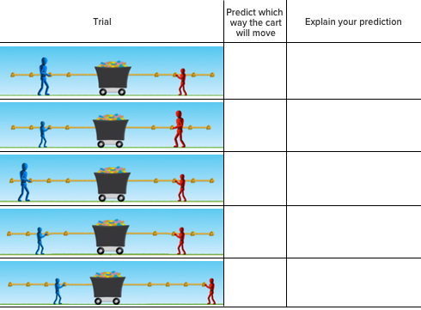
2. Compare the predictions that you made above to what happens to the cart of candy in each trial. If some of your predictions are not right, use a different color pencil to correct them.
3. Try more trials using different combinations of people from the red and blue teams. Draw or talk about what you discover. You can use the table below to keep track of your observations.
Trail Direction Explain why
cart moved
