 | Exploring Gravity

PRE-PLANNING | PRIOR KNOWLEDGE
PRE-PLANNING | - Know that a force is a push or a pull (PhET simulation “Forces and Motion Basics” https://phet.colorado.edu/en/simulation/forces-and-motion-basics for review/remediation)
PRE-PLANNING | LEARNING GOALS
PRE-PLANNING | - Understand that gravity is a force.  - Understand that the force of gravity is dependent on the mass and distance between objects.
PRE-PLANNING | Common Core Standards | Common Core Practices
PRE-PLANNING | MS-PS2-4-Construct and present arguments using evidence to support the claim that gravitational interactions are attractive and depend on the masses of interacting objects. | 1. Make sense of problems and persevere in solving them  2. Reason abstractly and quantitatively  5. Use appropriate tools strategically  7. Look for an make use of structure
PRE-PLANNING | MATERIALS
PRE-PLANNING | - PhET Gravity Force simulation:  - https://phet.colorado.edu/sims/html/gravity-force-lab/latest/gravity-force-lab_en.html  - Computers/tablets for each student  - Notecards for each student  - “Exploring Gravity” worksheet
LESSON CYCLE | WARM-UP 5 minutes
LESSON CYCLE | Activate prior knowledge by leading a discussion or having students journal about the following questions:  - What do you know about gravity?
LESSON CYCLE | INTRO 5 minutes
LESSON CYCLE | Teacher will… | Students will…  Check statements they believe are true.
LESSON CYCLE | - Project simulation/assist students with accessing simulation  - Distribute activity sheets.  - Read introduction
LESSON CYCLE | GUIDED EXPLORATION 30 minutes
LESSON CYCLE | Teacher will… | Students will…
LESSON CYCLE | - Circulate the room to be available for questions and ask probing/pushing questions, such as;  - What are variables? What is the difference between an independent and dependent variable?  - What is a force?  - What is gravity?  - What affects gravity?  Review of Variables  #2 Pair-Share: Have students turn and share with their partner their answers to questions 2. Call on some pairs to share their response with the class.  #3 Pair-Share: Have students turn and share with their partner their answers to questions #3. Call on some students to share with the class.  #4, 5 Pair Share: Have students turn and share with their partners what variables they manipulated and what they noticed.  True/False, Circle Correct Answer:  Assess student learning based on student answers. Some teachers might like to have the students justify their reasoning, but the main goal of this section is to get a quick formative assessment.  Review of Introduction, complete exit slip Pair Share:  Review introduction, have students discuss if gravity is a force. Have students go back to the questions in the introduction and revise answers as necessary.  Complete exit slip, turn in.  OPTIONAL CLAIM-EVIDENCE-REASONING EXTENSION: Additional opportunity for analysis and scientific writing for teachers/students who are familiar with writing CERs. | Work on the activity sheet while interacting with the Gravity Force screen of the sim.  Discuss #2–  Be attentive when sharing out #2. Update or modify answer to #2 based on class discussion.  Continue working on the activity sheet, discussing #5-6 with partners.  Discuss #5 and 6-  Discuss answers and modify answers based on class discussion.  Answer –  True/False, Circle Correct Answer based on observations.  Discuss-  Discuss revised answers, update or modify based on class discussion.  Complete exit slip, turn in for review.
LESSON CYCLE | DISCUSSION 5 minutes
LESSON CYCLE | Teacher will… | Students will…
LESSON CYCLE | - Facilitate a class discussion to bridge an understanding across representations. Remind students to close their laptops or turn around so that the sim does not distract them from listening. Use an established teaching strategy such as popcorn discussion (one student answers, calls on the next student to talk), think-pair-share (pose question, allow time to think, turn and talk to partner), or group discussions (print out questions and have groups talk to each other and write down consensus to share aloud with class). Sample questions include:  - Did anyone answer a question that they had at the beginning of the activity? What was it?  - Did anyone not answer a question? Share out and call on someone who can answer it. | Share responses to discussion questions.  Share out answered and unanswered questions and call on another student who can answer.

Name: ___________________________________ Class: __________________ Date: ____________________

Exploring Gravity
Learning Goals

- Students will investigate the variables that affect gravity.

QUESTION: How does gravity affect objects?

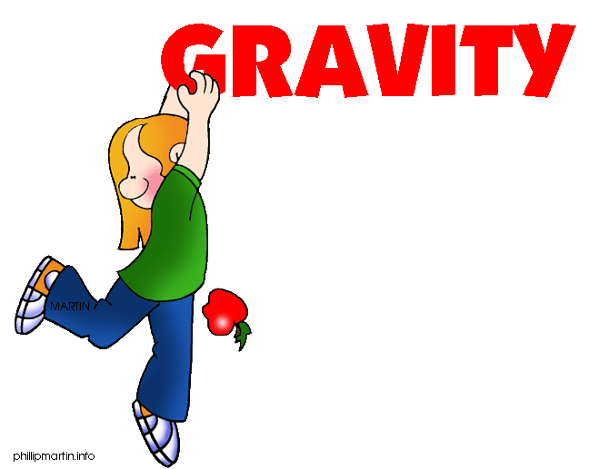

Jasmine and Emily were learning about forces in class. They learned that a force was either a push or a pull. Emily wondered if gravity was a force. She knew that when she dropped her book it was pulled down to the ground. Jasmine knew that the moon had less gravity than the earth, but she wasn’t sure why.

Check the circle containing the statement you agree with:

- Gravity depends on the material of the objects.
- Gravity is not a force because it can’t move objects.
- Gravity is a force because a force is a push or a pull.
- The moon has less gravity than the Earth because it has less mass than the Earth.
- The moon has less gravity than the Earth because it has no atmosphere.

Background information:

Variable-A variable is any factor that can be changed or controlled

Independent Variable – something that is changed by the scientist
- What is tested
- What is manipulated

Dependent Variable – something that might be affected by the change in the independent variable
- What is observed
- What is measured
- The data collected during the investigation

INSTRUCTIONS: Open up the Gravity simulation on the PhET website.
https://phet.colorado.edu/sims/html/gravity-force-lab/latest/gravity-force-lab_en.html

- Get familiar with the simulation by moving the figures back and forth as well as changing the mass of the spheres.

- Circle the different variables that can be found in this simulation.

Distance between figures Mass of the spheres
Force Size of the figures
Strength of the figures Size of the meter stick

- What do you think the size of the arrows on top of each sphere represent?

- Pick a variable to manipulate (the independent variable). Summarize what you changed and what happened in the table below:

Manipulated (Independent) Variable | Dependent Variable

- Change a different variable and summarize what happens in the table below:

Manipulated (Independent) Variable | Dependent Variable

True or False
Circle the correct answer.

1. Gravity is a force that can be changed. T/F

2. The bigger an object is, the smaller the force of gravity. T/F

3. As one object gets closer to another object, the force of gravity will increase. T/F

4. The Sun has a greater gravitational force than Jupiter. T/F

Circle the Correct Answer

Circle the pair with the greater gravitational force.

- 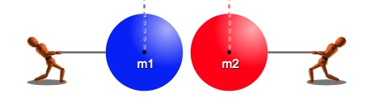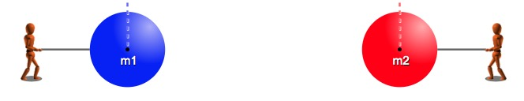

Explain why you chose the diagram you did.

2. 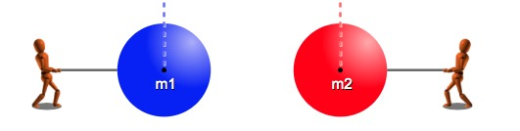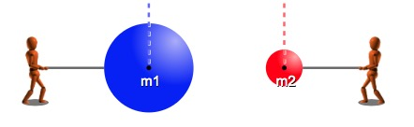

Explain why you chose the diagram you did.

Analysis Question: Why do you think Saturn and Jupiter have more moons than the other planets in our solar system?

Name____________________________________________________________________________________

Exit Slip

Question | Answer
Can gravity be considered a force? Why or why not?
What variable(s) affect gravity?
Questions I still have, things I am confused about

OPTIONAL CLAIM-EVIDENCE-REASONING/ANALYSIS

QUESTIONS:
1. Can gravity be considered a force?
CLAIM:

EVIDENCE:

SCIENTIFIC REASONING:

2. What variables affect gravity?
CLAIM:

EVIDENCE:

SCIENTIFIC REASONING:

