PhET Interactive Physics Simulations
Aligned to the AP Physics C Topic Outline

Alignment is based on the topics and subtopics addressed by each sim. Sims that directly address the topic area are in the second column; sims that relate to the topic area are in the “supplemental” columns.

Mechanics Topics and Sub-Topics | PhET Simulations | Supplemental PhET Simulations
Lab Work: Analyze Errors | Curve Fitting  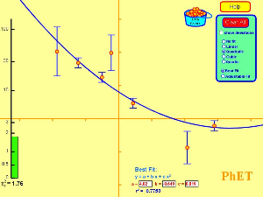  Linear, quadratic, cubic, quartic, best fit, adjustable fit, r², uncertainty. | Least-Squares Regression  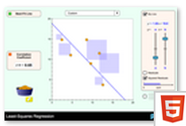  Least-Squares Regression, correlation coefficient, error analysis.
Kinematics  - Vectors, vector algebra, vector components | Vector Addition  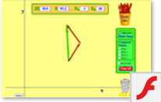  Vector algebra and components. | Ladybug Motion 2D  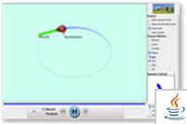  Interpret/differentiate velocity and acceleration vectors.
Kinematics in 1D  - Displacement, velocity, acceleration | The Moving Man  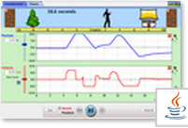  Position, displacement, velocity, acceleration, graphs. | Maze Game  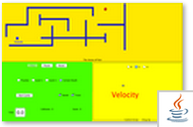  Displacement, velocity, acceleration, vectors.
Kinematics in 2D  - Displacement, velocity, acceleration, projectile motion | Motion in 2D  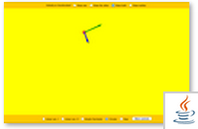  Velocity and acceleration vectors, linear, simple harmonic, circular motion.  Projectile motion  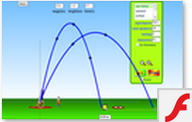  Range, height, time, initial speed, mass, air resistance, diameter. | Calculus Grapher  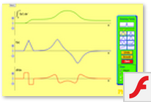  Integral and derivative graphs.  Graphing Lines  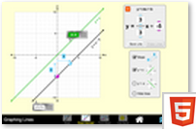  Slope, equation of a line.
Newton’s Laws of Motion  - Static Equilibrium (1st Law)  - Dynamics of a Single Particle (2nd Law)  - Dynamics of two or more objects (3rd Law) | Forces and Motion: Basics  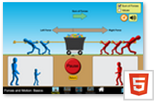  Net force (sum of forces), mass, speed, applied force, friction force, acceleration (1st and 2nd laws).  Forces and Motion  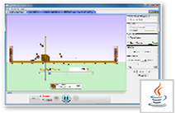  1D motion, FBDs, vectors, friction, gravity, normal, spring, and applied forces, sum of forces, position, friction coefficients, force/time graphs, game “Robot Moving Company”.  Ramp: Forces and Motion  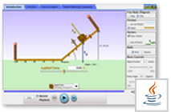  Same as Forces and motion above, but includes ramp with adjustable angle. | Friction  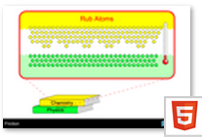  Molecular level, temperature.  Forces in 1 Dimension  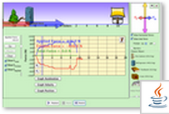  1D motion; graphs: applied force, acceleration, velocity, position; free body diagram, total force, horizontal force, vectors, friction, mass, friction coefficients.  The Ramp  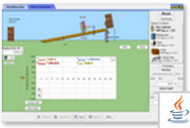  Similar to Ramp: Forces and Motion, includes energy and work graphs and bar charts.  Simulations that also fit with Newton’s Laws:  Masses and Springs (spring force)  Gravity Force Lab (3rd law vectors)  (See Oscillations and Gravity below)
Work, Energy, Power  - Work and work-energy theorem  - Forces and potential energy  - Conservation of energy  - (Power – no simulations) | Forces and Motion  (or Forces in 1 Dimension)  (See Newton’s Laws of Motion)  Could be used to calculate work done and compare with change in kinetic energy for work-energy theorem using force, distance, velocity measurements and graphs.  Energy Skate Park  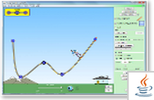  Quantitative energy and time graph, energy and position graph; qualitative energy bar graphs, pie chart; variable friction and gravity, moveable PE reference line, mass, slow motion option, student builds ramp shapes.  Other simulations with energy bar graphs:  Masses and Springs  Pendulum Lab  (See Oscillations & Gravity below) | The Ramp See above.  Quantitative energy and work graphs and qualitative bar charts. Might be able to use to show work done equals change in gravitational potential energy.  Energy Skate Park Basics  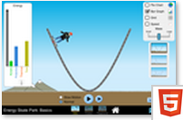  Similar to Energy Skate Park, but includes speed indicator. Limitations: no quantitative graphs (bar and pie only), friction coefficient adjustable only on student build screen, no adjustable PE reference line.  Energy Forms and Changes  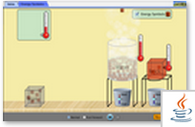  Qualitative introduction to conservation of energy principles.
Systems of Particles, Linear Momentum  - Center of mass  - (Impulse and momentum – no simulations)  - Conservation of linear momentum, collisions | Collision Lab  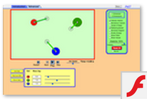  Elastic and inelastic collisions in 1D and 2D; center of mass; velocity and momentum vectors; momentum, mass, velocity, time and kinetic energy values; path tracing in 2D; 2 or more balls.
Circular Motion and Rotation  - Uniform circular motion  - Rotational kinematics and dynamics | Ladybug Revolution  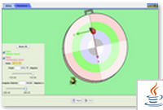  Quantitative angular and linear position, velocity, acceleration with time graphs and values for circular motion; can vary radius, radians and degrees, vectors are very small, may be hard to see. | Ladybug Motion 2D (See above)  Introductory to show velocity and acceleration vectors. May help students understand these vectors on Ladybug Revolution.
Circular Motion and Rotation  - Torque and rotational statics  - Angular momentum and its conservation | Torque  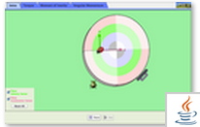  Torque (positive and negative), force, radius, braking force, mass, moment of inertia, angular acceleration, angular velocity, angular momentum. Velocity and acceleration vectors, degrees and radians, quantitative graphs. | Balancing Act  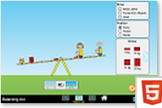  Balance masses at various positions on a beam. Pivot at center only. May cause a misconception that beams balance only horizontally.
Oscillations and Gravitation  - Simple harmonic motion (dynamics and energy relationships)  - Mass on a spring  - Pendulum and other oscillations  - Newton’s Law of gravity | Masses and Springs  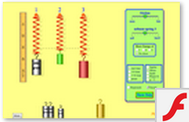  Vary masses, spring constants, friction, gravity force; use ruler, stopwatch, for quantitative measurements. Qualitative energy bar charts.  Pendulum Lab  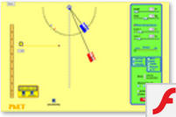  Quantitative ruler, stopwatch, photogate timer, length, mass, friction adjustments. Qualitative bar chart of kinetic, gravitational, thermal, and total energy. | Gravity Force Lab  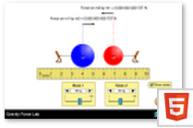  Two masses, force, distance, for quantitative measurements. Newton’s 3rd law vectors shown.  Calculus Grapher  (See Kinematics in 2D)
Oscillations and Gravitation  - Orbits of planets and satellites – circular and general | Gravity and Orbits  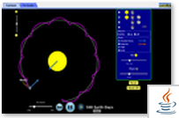  Conceptual only, gravity force and velocity vectors for orbital motion. Vary initial velocity, mass of satellite, observe changes in orbit.

E&M Topics and Sub-Topics | PhET Simulations | Supplemental PhET Simulations
Electrostatics  - Charge and Coulomb’s law (no simulation for Coulomb’s law) | Balloons and Static Electricity  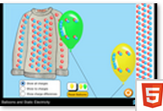  Static electricity, charges, forces, polarization, charging by friction, insulators, net charge. Conceptual. | John Travoltage  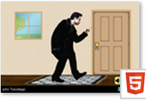  Charging by friction, discharge by contact, grounding, conductors. Conceptual.
Electrostatics  - Electric field and electric potential (including point charges)  - Gauss’s law  - Fields and potentials of other charge distributions | Charges and Fields  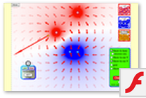  Electric field, field plots, voltage, equipotential lines, charge units, tape measure. Quantitative. | Electric Field Hockey (Must do!)  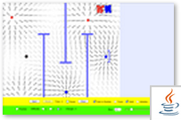  Game with electric field plots and charges. Students love this one. Qualitative.
Conductors, capacitors, dielectrics  - Electrostatics with conductors  - Capacitors (capacitance, parallel plate, spherical and cylindrical)  - Dielectrics | Capacitor Lab  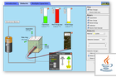  Quantitative. Vary area, distance, voltage, dielectrics. Measure capacitance, voltage, charge, E-field, stored energy. Connect/ disconnect battery, multiple capacitors. | Conductivity  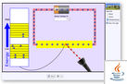  Conductivity in metals, plastics and photoconductors, electron energy levels. Vary applied voltage.
Electric Circuits  - Current, resistance, power  - Steady state direct current circuits with batteries and resistors only | Circuit Construction Kit (DC Only) Virtual Lab  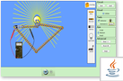  Quantitative. Circuits, light bulbs, resistors, voltmeter, ammeter, switches, batteries, series and parallel.
Electric Circuits  - Capacitors in circuits  - Transients in RC circuits | Circuit Construction Kit (AC+DC) Virtual Lab  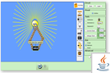  Quantitative. Similar to CCK DC only, but includes capacitors, inductors, AC, I and V graphs. | Capacitor Lab  (See above)  Ohm’s Law Lab  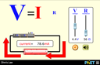  Quantitative. Voltage, Current, Resistance, Ohm’s Law.
Magnetic Fields  - Forces on charges in magnetic fields  - Forces on current-carrying wires in magnetic fields  - Fields of long current-carrying wires  - Biot–Savart law and Ampere’s law | These topics are not addressed in PhET simulations. | Faraday’s Electromagnetic Lab  (See below). Introduction to magnetic field of a bar magnet (bar magnet tab). Introduction to forces on charges in magnetic fields (pick up coil tab).
Electromagnetism  - Electromagnetic induction (including Faraday’s law – Lenz’s law is not addressed in PhET simulations) | Faraday’s Electromagnetic Lab  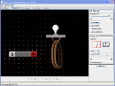  Electromagnetic induction, Faraday’s law, transformer, generator. Semi-quantitative (field strength, loop area, number of loops)
Electromagnetism  - Inductance (including LR and LC circuits)  - (Maxwell’s equations not addressed in simulations) | Circuit Construction Kit (AC+DC) Virtual Lab  Includes LR and LC circuits.

