Exploring Systems of Linear Equations
  - Overview
Prerequisite Skills:
- Identify slope and y-intercept from $y=mx+b$and from a graph.
- Graph a line using slope and y-intercept
- Write linear equations in slope-intercept form based on verbal descriptions/story problems or when given a graph.
Learning Goals:
- Describe a system of linear equations and a solution to a system of linear equations.
- Identify whether a system of linear equations has one solution, no solution, or infinitely many solutions based on the graph or equations.
- Create a rule that relates the slope of two lines and the number of solutions in the system.
Common Core State Standards:
CCSS.Math.Content.8.EE.C.8: Analyze and solve pairs of simultaneous linear equations.
CCSS.Math.Content.8.EE.C.8.a: Understand that solutions to a system of two linear equations in two variables correspond to points of intersection of their graphs, because points of intersection satisfy both equations simultaneously.
CCSS.Math.Content.8.EE.C.8.b: Solve systems of two linear equations in two variables algebraically, and estimate solutions by graphing the equations. Solve simple cases by inspection.
CCSS.Math.Content.8.EE.C.8.c: Solve real-world and mathematical problems leading to two linear equations in two variables.
Mathematical Practices:
1. Make sense of problems and persevere in solving them
2. Reason abstractly and quantitatively
4. Model with mathematics.
5. Use appropriate tools strategically
7. Look for and make use of structure
Materials:
- PhET Graphing Lines simulation:
https://phet.colorado.edu/sims/html/graphing-lines/latest/graphing-lines_en.html
- Computers/tablets for each student or pair of students
- Exploring Systems of Linear Equations Activity Sheets (1 per student)
- Index cards/exit tickets
Estimated Time:
Approximately 90 minutes, broken into two parts
  - Exploring Systems of Linear Equations, Part 1
Warm Up | 7-10 minutes
Activate prior knowledge using this problem as a warm-up:

Athletic Awesomeness charges $4 to enter, and $2 per game played. Sports Stars charges $3 per game, but only costs $1 to enter. Decide and justify which activity center you would encourage your sporty crush to attend with you this weekend.

Think-Ink-Pair-Share: Students should spend approximately 1-2 minutes examining the problem, completing scratch work, and writing down their argument. Then, students should turn to a partner and discuss their reasoning.
Simulation Introduction |  | 7-10 minutes
Teacher will… |  | Students will…
- Ask a student to distribute activity sheets.  - Encourage students to take a few minutes to explore the Graphing Lines simulation, letting them know they will be using the Slope-Intercept portion of the simulation for today’s lesson.  - Circulate the room and, somewhat as a review, ask students:  - What does this tool (point locator) do?  - What do the m and b represent again?  - What happens if you change the m and b?  - Can you graph more than one line at a time?  - Ask students to briefly share what they wrote down for #1 on the activity sheet to ensure all students remember how the tool works. |  | - Explore the simulation, graphing whatever lines they choose.  - Review slope and y-intercept by responding to teachers’ informal questioning.  - Jot down discoveries/reminders as #1 on the activity worksheet.
Guided Exploration |  | 15-20 minutes
Teacher will… |  | Students will…
- Encourage students to begin working on #2-11 in pairs. Try to give them at least 5 minutes where the teacher is silent before probing/aiding.  - Circulate the room to be available for questions and ask probing/pushing questions, such as:  - Why do these graphs intersect? (What makes them intersect?)  - Is it possible for two lines to intersect more than once?  - Why do you think those graphs will not intersect?  - What can be said about two lines that completely overlap?  - How does the slope affect whether the lines cross?  - What if both graphs have the same y-intercept but different slopes?  - If you are graphing a system of equations, what is a system of equations? What do you think the solution is? |  | - Complete #2-11 on the activity sheet.  - Respond to teacher questions.  - Ask questions or ask for help as needed.
Discussion and Summary |  | 10-15 minutes
Teacher will… |  | Students will…
When most students have gotten to the checkpoint on the worksheet…  - Facilitate a class discussion to bridge an understanding across representations. Remind students to cover their laptop screens with their worksheets so they are not distracted. Use an established teaching strategy such as pulling name sticks, or small group discussions (print out or display questions and have groups talk to each other and write down consensus for the “speaker” to share aloud with class). Students may want to present their worksheets using document camera as they make their points. The classroom whiteboard could have headings "one point of intersection", "never intersect", and "completely overlap" and a student volunteer records the main ideas of the class discussion. Sample questions include:  - What do you think a system of equations is?  - What is a solution to one line? What do you think the solution to a system of equations is?  - What did you notice about the first system where two lines intersect?  - What did you notice about the second system where the lines never cross? Are you positive even if the graph were expanded the lines would never cross? How do you know?  - Do you notice anything about the slopes? What if the slopes are different? What if the slopes are the same?  - What does it mean for two lines to be parallel?  - What about creating overlapping lines?  - What do you think it means for a system to have one solution? No solutions? Infinitely many solutions?  - Are there any other discoveries we haven’t yet discussed? |  | - Answer questions and question answers: students should be able to determine if they agree/disagree with others’ claims and justify their own responses.  - Some students may go to the board to share findings, then summarize and record main ideas.
  - Exploring Systems of Linear Equations, Part 2
Warm Up |  | 5-7 minutes
Teacher will… |  | Students will…
- Remind students of learning goals/ask students to read them aloud and quickly discuss or assess their own progress. Use the following questions to review:  - What did we discover yesterday?  - What were the possible ways you could graph more than one line on a coordinate plane?  - How did the slope of the lines impact whether or not the graphs intersect?  - To assess progress, use a stoplight or 1,2,3 method where students hold up a red, yellow, or green card or 1,2,3 to indicate whether they 1/red are stuck, 2/yellow a little confused, or 3/green ready to move on. Teacher should ask students who indicate that they are not ready to move on what is confusing for them, and allow the “green” students to help clarify the misconceptions. Once most issues are settled, move on. Monitor the “red/yellow” students closely during the remainder of the activity, paring with a “green” student if possible. |  | - Participate in class discussion.  - Assess and reflect upon their own progress.
Reinforcement |  | 15-20 minutes
Teacher will… |  | Students will…
- Encourage students to complete part 2 of the worksheet, using the Graphing Lines simulation in pairs or independently.  - Circulate the room to be available for questions and ask probing/pushing questions, such as:  - What is similar/different about the equations within the system?  - Which equations create parallel lines?  - What can be said about the equations of two completely overlapping lines, if they are in simplest form?  - If the two lines completely overlap, how many times do they intersect?  - Before students complete the exit ticket, discuss #2 to determine if students can make meaning of the solution to a system of equations. Let them know that in the future, they will be solving more real-world systems of equations. |  | - Complete remainder of activity sheet (Part 2), answering teacher questions and posing questions as needed.
Informal Assessment |  | 5-7 minutes
Teacher will… |  | Students will…
- Praise students for their hard work, perseverance, and discoveries.  - Informal formative assessment: Ask students to silently and independently, answer the exit ticket questions.  - Reflect: Teacher should review activity sheets and exit tickets to determine students’ level of understanding. In a future lesson, students can confirm and summarize key ideas in a graphic organizer (below). |  | - Show what they know with respect to the learning goals through an exit ticket.


Name: ___________________________________ Date: __________________ Period: ______

Exploring Systems of Linear Equations, Part 1
Learning Goals
- Define a system of linear equations and a solution to a system of linear equations.
- Identify whether a system of linear equations has one solution, no solution, or infinitely many solutions based on the graph or equations.
- Create a rule that relates the slope two lines and the number of solutions in the system.

- Explore the slope-intercept screen for 5 minutes and write down 1–3 discoveries you have made or remembered about using the simulation.

- Create a line and use the  button to preserve it. Create a second line that intersects the first.

- Sketch both lines below (make it fun—use two colors!) and write their equations in slope-intercept form.

Line 1 | y = _____x + _____
Line 2 | y = _____x + _____
Point of intersection | ( , )
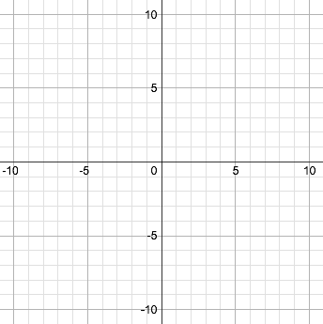
4. Use the point locator 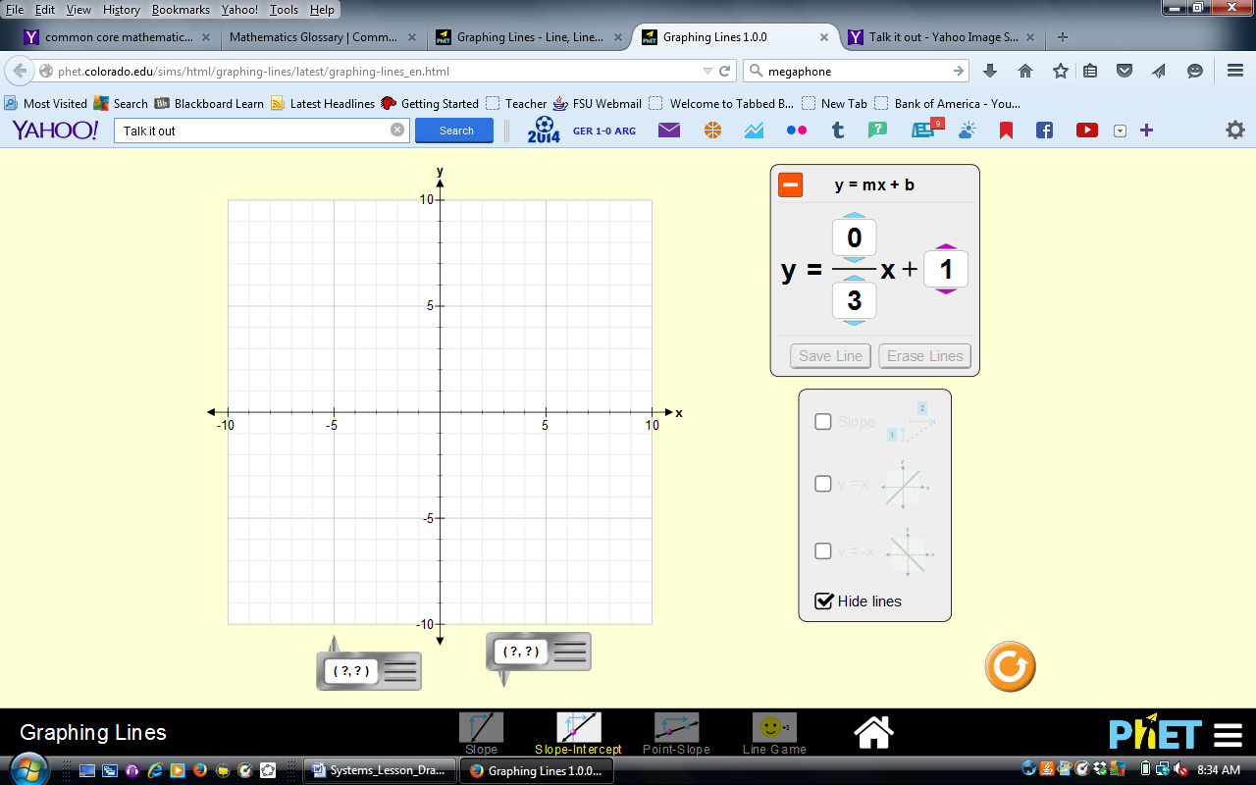
to help you determine the exact point of intersection and complete the table above. What do you think it means when the two graphs intersect?


- With a partner, discuss and summarize your ideas about the following questions:
Do you think these two lines will ever cross again? Why do you think that?

- Erase both lines in the system of equations to create a new one.
- Create a line and use the button to preserve it. Create a second line that will NEVER intersect the first.

- Sketch both lines in the system of equations below (make it fun—use two colors!) and write their equations in slope-intercept form.

Line 1 | y = _____x + _____
Line 2 | y = _____x + _____
Point of intersection | Remember—these lines should NEVER intersect.


- With a partner, discuss and summarize your ideas about the following questions:
Why do you think these lines will not intersect? If the coordinate plane expanded (if your graph were bigger), would the lines intersect later? What do you notice about their equations?

- Erase both lines in the system of equations to create a new one.

- Create a line and use the button to preserve it. Create a second line that will completely OVERLAPS the first. What do you think has to be true about the equations of the two lines in order for them to completely overlap?

- You’re doing great! Wait here for class discussion before moving on!

Name: ___________________________________ Date: __________________ Period: ______
Exploring Systems of Linear Equations, Part 2
Learning Goals
- Define a system of linear equations and a solution to a system of linear equations.
- Identify whether a system of linear equations has one solution, no solution, or infinitely many solutions based on the graph or equations.
- Create a rule that relates the slope two lines and the number of solutions in the system.

1. For each row of the table, graph the system of equations on a clean coordinate plane.
System | Graph | Solutions
$$y=\frac{2}{3}x+3$$  $$y=\frac{4}{6}x-5$$ |  | ☐ One solution ( , )  ☐ No solutions $∅$  ☐ Infinitely many solutions
$$y=x+2$$  $$y= -2x-1$$ |  | ☐ One solution ( , )  ☐ No solutions $∅$  ☐ Infinitely many solutions
$$y=\frac{1}{2}x+3$$  $$y=\frac{-3}{-6}x+\frac{18}{6}$$  *Hint: can you simplify the second equation first? |  | ☐ One solution ( , )  ☐ No solutions $∅$  ☐ Infinitely many solutions
$$y=\frac{4}{5}x+2$$  $$y=\frac{4}{5}x-6$$ | Try this without graphing. How do you know how many solutions will there be? | ☐ One solution ( , )  ☐ No solutions $∅$  ☐ Infinitely many solutions
$$y=\frac{1}{4}x+2$$  $$y=\frac{2}{8}x-(-2)$$ | Try this without graphing. How do you know how many solutions will there be? | ☐ One solution ( , )  ☐ No solutions $∅$  ☐ Infinitely many solutions
$$y=\frac{2}{5}x+2$$  $$y=\frac{4}{3}x+1$$ | Try this without graphing. How do you know how many solutions will there be? | ☐ One solution ( , )  ☐ No solutions $∅$  ☐ Infinitely many solutions

2. Look back to the warm up…. Athletic Awesomeness charges $4 to enter, and $2 per game played. Sports Stars charges $3 per game, but only costs $1 to enter. Complete the chart below for this system of equations.

Equations in the system | Graph | Solutions
$$y=____x+_____$$  $$y=____x+_____$$ |  | ☐ One solution ( , )  ☐ No solutions $∅$  ☐ Infinitely many solutions  What does the solution mean in this situation?

3. Answer the following questions on an index card with your name on it.
a) Describe a system of linear equations and its solution.
b) How can you determine whether a system of linear equations has one solution, no solution, or infinitely many solutions by looking at the graph?
c) How can you determine whether a system of linear equations has one solution, no solution, or infinitely many solutions by looking at the equation?

Systems of Linear Equations Graphic Organizer

Solutions of a System of Linear Equations

If the system of linear equations has… | Sample system of equations | What is true about the slopes and y-intercepts in the equations? | What do the graphs look like?
One solution
No solutions $∅$
Infinitely many solutions

Solve the system image: http://www.keepcalm-o-matic.co.uk/p/keep-calm-and-solve-the-system-of-equations/
Talk it out image: https://www.pinterest.com/pin/187462403213195267/
Exit ticket image: http://www.keepcalm-o-matic.co.uk/p/keep-calm-and-write-your-exit-ticket/

