 | Exploring Slope and Speed

PRE-PLANNING | PRIOR KNOWLEDGE
PRE-PLANNING | - Know that any two points define a line  - Know that coordinate points have two components, x and y  - Know the formula for speed (distance/time)
PRE-PLANNING | LEARNING GOALS
PRE-PLANNING | - Explain how the slope of a line is computed  - Determine the slope of a graphed line  - Calculate the slope of a line given two points on the line  - Determine the speed of an object based on data from a graph
PRE-PLANNING | Common Core Standards | Common Core Practices
PRE-PLANNING | CCSS.Math.Content.8.EE.B.6  Use similar triangles to explain why the slope m is the same between any two distinct points on a non-vertical line in the coordinate plane; derive the equation y = mx for a line through the origin and the equation y = mx + b for a line intercepting the vertical axis at b.  NGSS Science Content MS-PS3-1  Construct and interpret graphical displays of data to describe the relationships of kinetic energy to the mass of an object and to the speed of an object.  Crosscutting Concept  Scale, Proportion, and Quantity: Proportional relationships (e.g. speed as the ratio of distance traveled to time taken) among different types of quantities provide information about the magnitude of properties and processes. | 1. Make sense of problems and persevere in solving them  2. Reason abstractly and quantitatively  5. Use appropriate tools strategically  7. Look for an make use of structure
PRE-PLANNING | MATERIALS
PRE-PLANNING | - PhET Graphing Lines simulation:  https://phet.colorado.edu/sims/html/graphing-lines/latest/graphing-lines_en.html  - Computers/tablets for each student  - Notecards for each student  - “Exploring Slope and Speed” Activity Sheet for each student (see below)
LESSON CYCLE | WARM-UP 5 minutes
LESSON CYCLE | Activate prior knowledge by leading a discussion or having students journal about the following questions:  - What is the formula for speed (how is speed measured)?  - What does slope measure about a line?
LESSON CYCLE | INTRO 7 minutes
LESSON CYCLE | Teacher will… | Students will…
LESSON CYCLE | - Distribute and collect notecards.  - Distribute activity sheets. | Explore the Slope screen of the sim and write down 1–3 questions on a notecard.
LESSON CYCLE | GUIDED EXPLORATION 30 minutes
LESSON CYCLE | Teacher will… | Students will…
LESSON CYCLE | - Circulate the room to be available for questions and ask probing/pushing questions, such as;  #2–3 Pair-Share: Have students turn and share with their partner their answers to questions 2–3. Instruct students to collaborate on their response to #4. Call on some pairs to share their response with the class.  #8-9 Pair-Share: Have students turn and share with their partner their answers to questions #8-9. Call on some students to share with the class.  #12-13 Pair-Share: Have students turn and share with their partner their answers to questions #8-9. Call on some students to share with the class.  OPTIONAL MATH AND LAB EXTENSTIONS: Some teachers might want to include a math extension. I have included a page with a review of how to determine slope, though you could certainly complete the simulation without including the math review. For students familiar with linear equations, you can review the formula y= mx + b.  The experiment outlined in the beginning of the sim can be easily recreated, as time and supplies permit. You can find numerous labs on speed and height ramp that require students to collect data, however for this lab construction of a ramp is to reinforce the concept of slope (bigger slope, higher ramp, greater speed).  OPTIONAL CLAIM-EVIDENCE-REASONING EXTENSION: Additional opportunity for analysis and scientific writing for teachers/students who are familiar with writing CERs. | Work on the front of the activity sheet while interacting with the Slope screen of the sim.  Discuss #2–3 with their partner. Collaborate to define slope in #4.  Be attentive when sharing out #4. Update or modify answer to #4 based on class discussion.  Continue working on the back of the activity sheet, discussing #5-6 with partners.  Share with their partner their answers to #8 and 9.  Collaborate to define the relationship of slope and speed in #10.  Be attentive when sharing out #10. Update or modify answer to #10 based on class discussion  Share with their partner their answers to #12 and 13.  Collaborate to define the relationship of and distance/time graph and slope in #12.  Be attentive when sharing out #13. Update or modify answer to #13 based on class discussion
LESSON CYCLE | DISCUSSION 15 minutes
LESSON CYCLE | Teacher will… | Students will…
LESSON CYCLE | - Facilitate a class discussion to bridge an understanding across representations. Remind students to close their laptops or turn around so that the sim does not distract them from listening. Use an established teaching strategy such as popcorn discussion (one student answers, calls on the next student to talk), think-pair-share (pose question, allow time to think, turn and talk to partner), or group discussions (print out questions and have groups talk to each other and write down consensus to share aloud with class). Sample questions include:  - What is the connection between the top of the fraction and the graphed line (or points on the line)?  - What is the connection between the bottom of the fraction and the graphed line (or points on the line)?  - Which lines don’t have a slope at all? Why don’t they have a slope? What did the slope equation look like?  - What is the relationship between lines with the same slope? (Refer to #5–6.)  - Why is it useful to have a formula to calculate slope?  - Why it useful to have a formula to calculate speed?  - How can you determine the speed of an object from a graph? (Refer to #7)  - What is the connection between the slope of a line and the speed of an object?  - Redistribute notecards to individual students. Facilitate a discussion about notecards:  - Did anyone answer a question that they had at the beginning of the activity? What was it?  - Did anyone not answer a question? Share out and call on someone who can answer it. | Share responses to discussion questions.  Share out answered and unanswered questions and call on another student who can answer.

Name: ___________________________________ Class: __________________ Date: ____________________

Exploring Slope and Speed
Learning Goals
- Explain how the slope of a line is computed (review)
- Determine the slope of a graphed line
- Calculate the slope of a line given two points on the line
- Explain how the slope of a line can be used to determine the speed of an object

QUESTION: How does the slope of a line relate to the speed of an object?

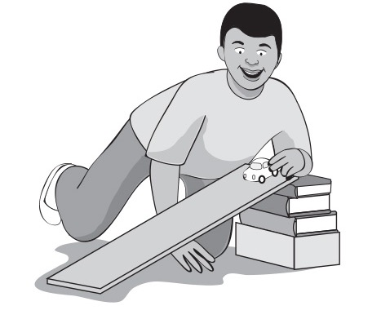
Julio wanted to test the effect that different heights have on the speed of a car rolling down a ramp. For his experiment, Julio made sure that he used the same car with the same mass. He had a stopwatch to record the time it took for the car to reach the bottom of the ramp in each trial. He constructed the following two ramps with only the height being different. For each trial, Terrance placed the car at the top of the ramp and started the stopwatch as he released the car. He stopped the stopwatch when the car reached the bottom of the ramp.

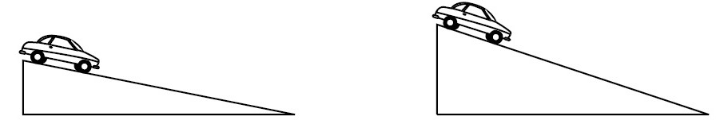

Ramp 1 Ramp 2

Which car do you think would travel down the ramp in the shortest amount of time? Why?

OPTIONAL MATH EXTENSION

BACKGROUND INFORMATION/REVIEW: For this simulation, you will to need to know how to calculate the slope of a line. To calculate the slope, you need to look at 2 points on the line, (x1, y1) and (x2, y2).

The equation used to calculate the slope from two points is as follows:
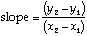

On a graph, this can be represented as follows:

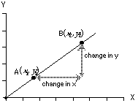

There are three steps in calculating the slope of a straight line when you are not given its equation.

- Step One: Identify two points on the line.
- Step Two: Select one to be (x1, y1) and the other to be (x2, y2).
- Step Three: Use the slope equation to calculate slope.

FINDING THE SLOPE
- Explore the slope screen for 5 minutes and write down 1–3 questions that you have.

- Create three lines with different slopes. Sketch your lines and complete the table below.
 | 1 | 2 | 3
Sketch | 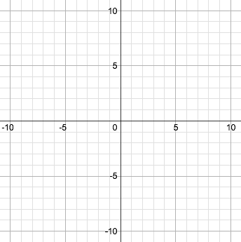
Coordinates of two points on line | ( , ) and ( , ) | ( , ) and ( , ) | ( , )and ( , )
Calculate slope | 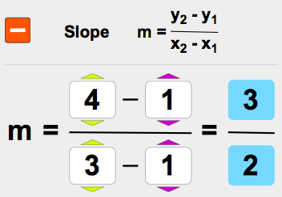

- In the fraction that represents slope, describe how the top and bottom numbers (numerator and denominator) relate to the graph.

- Compare your responses for #2–3 with your partner. Write a description of slope that relates the fraction and the graph:

- Describe how to calculate the slope of a line between any two points.

SPEED AND GRAPHING
Madame Curie, Isaac Newton, and Neil Degrasse Tyson are enjoying an afternoon of playing Pictionary. After a few hours, everyone is getting sore from all of the sitting, so they decide they should do something active. Knowing how much Isaac Newton enjoys apples, Neil Degrasse Tyson suggests they see who can walk and balance an apple on their head for 10 meters in the shortest amount of time.

- Newton completes 10 meters in 9 seconds.
- Madame Curies completes 10 meters in 4 seconds.
- Tyson completes 10 meters in 7 seconds.

- Create a distance vs. time graph for each scientist. Remember to put time on the x-axis and distance and the y-axis.

- Calculate each person’s speed using the formula
$speed=\frac{distance}{time}.$

 | Newton | Curie | Tyson
Sketch | 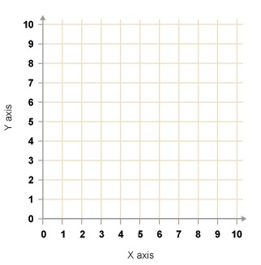
Speed (m/s)

- Who won the race? Who was second? Who was third?

9. Determine the slope of the lines from what your previous graphs of speed.
 | Newton | Curie | Tyson
Coordinates of two points on line | ( , ) and ( , ) | ( , ) and ( , ) | ( , )and ( , )
Calculate slope

10. Compare your responses for #8 and 9 with your partner. Write a description of how the speed of an object relates to its’ slope.

DETERMINING THE SPEED OF AN OBJECT USING THE SLOPE OF A LINE
11. Create three lines with three different slopes. You should start your line at (0,0). The line should end at 10 on the x axis but may end anywhere along the y axis (quadrant 1). Calculate speed the same way you did in the Speed and Graphing section. Use the  feature to save your lines.
Sketch
Speed

Coordinates of two points on line | ( , ) and ( , ) | ( , ) and ( , ) | ( , )and ( , )
Calculate slope

12. What does the slope of a distance vs. time graph indicate about an object’s motion?

13. How is Julio’s ramp (from the beginning of the lesson) similar to the slope of a line?

LAB EXTENSION
Try duplicating Julio’s experiment from the beginning of the lesson. What was your result?

OPTIONAL CLAIM-EVIDENCE-REASONING/ANALYSIS

QUESTION: How does the slope of a line relate to the speed of an object?

CLAIM:

EVIDENCE:

SCIENTIFIC REASONING:

