Student Worksheet
“ Mass In Motion” : The Story of Momentum
An online lab that provides an introduction to momentum through data collection and analysis.

Name: ________________________________________ Section: _________________________
Lab Partners: ____________________________________ Date: ___________________________
Level I – Minimum Difficulty

Purpose: To provide each student with an interactive experience exploring the concept of
momentum and its conservation.

Discussion: With your lab partner, discuss how you would define momentum. Record your definition of momentum in the space below.
____________________________________________________________________________________________________________________________________________________________________________________
Find the definition of momentum using your textbook or computer. Write this definition in the space below. How does this definition compare to the one you wrote above?
__________________________________________________________________________________________________________________________________________________________________________________________________________________________________________________________________________________________________________________________________________________________________________________________________________________________________________________________________
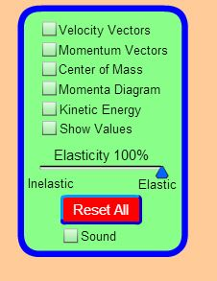
Lab Instructions:
- Click on the following link or copy/paste it in your browser.
http://phet.colorado.edu/en/simulation/collision-lab

- Click on the collision lab icon.

- Uncheck all boxes in the menu box and
make sure that the slider for elasticity is placed
to the far right (100% elasticity). (See Figure 1.0)

Figure 1.0

- Move the sliders in the data table so that the mass of ball-1 and ball-2 are both 1.0 kg. (Figure 1.1)

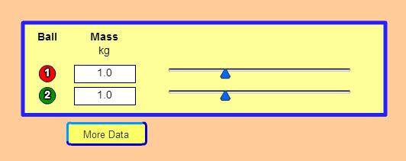
Figure 1.1

After adjusting the mass of ball-1 and ball-2, click on the tab that’s labeled “More Data”.
Using the data table below, copy the information that appears on your screen after you clicked on the “more data” tab. Once completed, work with your lab partners to answer the questions below.

Table 1
Ball | Mass | Position | Velocity | Momentum
Ball | kg | m | m/s | kg m/s
  1 | 1.0
2 | 1.0

- Based on the recorded data, which object above is moving? __________________________________

- What is the momentum of the moving object? ______________________________________________

- What is the momentum of the object that is motionless? ______________________________________

- Based upon the answers you gave in question 7 and question 8, what might one establish about the
relationship that exist between motion and momentum?

____________________________________________________________________________________________________________________________________________________________________________________________________________________________________________________________
- If all other factors stayed the same, what would happen to the momentum of ball-1 in you doubled the mass of ball-1 to 2kg ? ________________________________________________________________

- If all other factors stayed the same, what would happen to the momentum of ball-2 if you doubled the mass of ball-2 to 2kg ? ________________________________________________________________

- Notice that your answer in question 10 showed that momentum would double if mass doubled, however, your answer in question 11 showed the momentum of ball-2 remained at 0 kg m/s even after you doubled its mass. How was it possible for ball-1 to experience a change in momentum while ball-2 did not? Examine the new data with your lab partner and explain why this happened.
____________________________________________________________________________________________________________________________________________________________________________________________________________________________________________________________
Change the velocity of ball-2 to 4.00 m/s and complete Table 2.
Table 2
Ball | Mass | Position | Velocity | Momentum
Ball | kg | m | m/s | kg m/s
1 | 2.0 |  | 1.00
2 | 2.0 |  | 4.00

- What is the new velocity of ball-2 since it has started moving? ________________________________.
- What is the new momentum of ball-2 since it has started moving? _____________________________.
Change the position of ball 1 to 3.00m and the position of ball-2 to 1.00 m.
- Did the position of ball-1 or ball-2 have any effect on momentum ? _____________________________.
- Which two variables have an effect on the momentum of an object?

  - mass and position b. mass and velocity c. position and velocity

- Write the formula for calculating the momentum of an object: _______________________________

Lab written and designed by Stephen N. Clontz, M. Ed.

Email comments or suggestions: sclontz@whiteville.k12.nc.us

*Teachers, please email me and let me know if you used the lab. I’d welcome your suggestions and comments. This lab has been designed for minimal difficulty (remediation / concept introduction).

