Bending light virtually
In this lab we will use an applet to investigate the bending of light in order to understand how lenses work. Open the applet by running the application at the following URL.
http://phet.colorado.edu/en/simulation/bending-light
Click on the “Run Now!” button once the image in figure 1 loads.
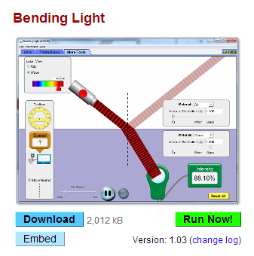
Figure 1

Use the protractor measure beam angles. Always measure beam angles relative to the normal which is a straight line running perpendicular from the surface of the interface between the two materials. Figure 1 shows the protractor being used to measure 60° from normal for the angle of incidence and 40° from the normal for the angle of refraction.
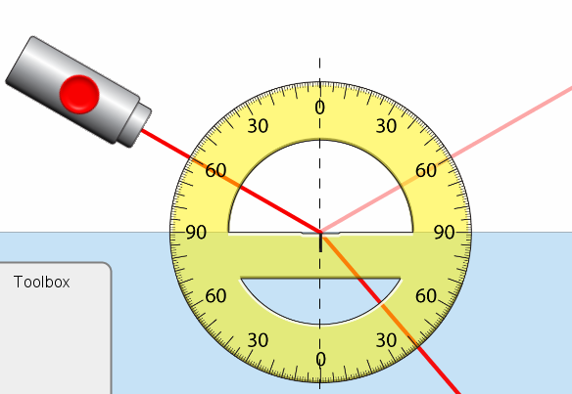
Figure 2

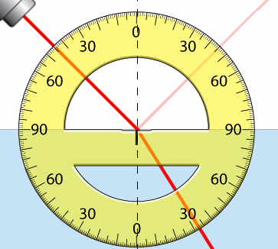
Figure 3

What is the angle of incidence and refraction for the light beam shown in figure 3?

Angle of incidence:
Angle of refraction:

Find the index of refraction of “Mystery Material A” by measuring the angle of incidence and refraction and calculating the index of refraction using Snell’s Law.
Index of refraction for Mystery Material A:

Most materials reflect some light as well as refract light. Sometimes special coatings are applied to lenses to minimize the amount of reflection of the lens.
Use the intensity tool shown in the tool box (figure 1) to measure the intensity of the refracted beam and reflected beam for Mystery Material A.
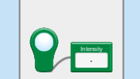
Figure 4

Mystery Material A
Refracted beam Intensity:
Reflected beam intensity:
Sum of refracted and reflected intensity

Find a list of materials and their index of refractions on the Internet and use the table to help identify mystery material A using its index of refraction.
Possible identity of Mystery Material A:

Find the index of refraction of “Mystery Material B” by measuring the angle of incidence and refraction and calculating the index of refraction using Snell’s Law.
Index of refraction for Mystery Material B:

Find a list of materials and their index of refractions on the Internet and use the table to help identify mystery material B using its index of refraction.
Possible identity of Mystery Material B:

Use the intensity tool to measure the intensity of the refracted beam and reflected beam for Mystery Material B.
Mystery Material B
Refracted beam Intensity:
Reflected beam intensity:
Sum of refracted and reflected intensity

Select the “More Tools” tab at the top of the application as shown in figure 5. Notice that more tools are available including a “speed” meter.

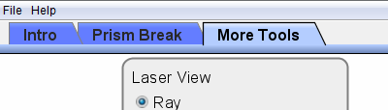
Figure 5

Find the index of refraction of “Mystery Material A” by measuring the speed of light in the material and calculating the index of refraction by dividing the speed of light in air by the speed of light in the material.
Index of refraction for Mystery Material A:

Does your answer match the index of refraction calculated by using Snell’s law?

Find the index of refraction of “Mystery Material B” by measuring the speed of light in the material and calculating the index of refraction by dividing the speed of light in air by the speed of light in the material.
Index of refraction for Mystery Material B:

Does your answer match the index of refraction calculated by using Snell’s law?

Turn on the wave view of the light by selecting the option “Wave” in the laser view box shown in figure 6. Select “Glass” as the second material.
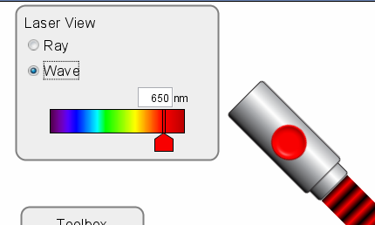
Figure 6

Does the wave look different once it enters the glass?

What property of the wave is changed?

Why?

Change the wavelength of the laser beam to Green and the Blue. What, if anything, changes when you do this other than the color of the beam and Why?

If both materials in the simulation are changed to glass what happens to the beam and why?

Use Snell’s law to calculate what should happen to the beam.
Glass to Glass interface
Incident beam angle:
Refracted beam angle:
Calculated Index of refraction:

Select the “Prism Break” tab at the top of the application.
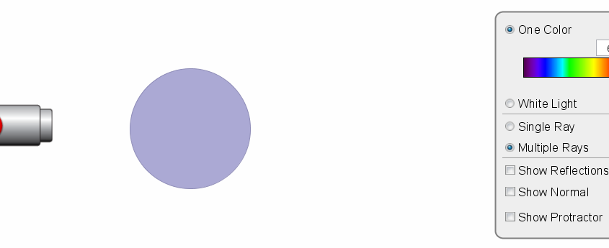
Figure 7

Use the “Multiple Rays” option and drag the circular prism in front of the laser as shown in figure 7. Switch on the laser and observe the results.
What do the laser beams do?

Does changing the distance from the laser to the prism change the effect?

