Basic Stoichiometry PhET Lab Name
Let's make sandwiches!
Introduction:
When we bake/cook something, we use a specific amount of each ingredient. Imagine if you made a batch of cookies and used way too many eggs, or not enough sugar. YUCK! In chemistry, reactions proceed with very specific recipes. The study of these recipes is stoichiometry. When the reactants are present in the correct amounts, the reaction makes products. We are going to look at what happens when there are more or less of some of the reactants present.

Procedure: PhET Simulations Play with the Sims Chemistry Reactants, Products, and Leftovers OPEN IN HTML 5
(http://phet.colorado.edu/sims/html/reactants-products-and-leftovers/latest/reactants-products-and-leftovers_en.html)
Part 1: Making Sandwiches:
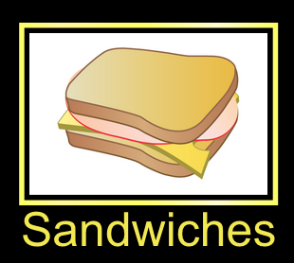
- A cheese sandwich requires 2 slices of bread to 1 slice of cheese. If there is exactly twice as many slices of bread as cheese, then there will be no leftovers. What happens if you have two slices of bread and two slices of cheese? You have a slice of cheese left over!
- Use the simulation to play around with this two-reactant synthesis reaction. Take some time and familiarize yourself with the simulation buttons
- At the bottom of the screen, change the coefficients of the reactants to 2:1.

- Notice that there is now one sandwich with no leftovers!
- Complete situations B through D. A has been done for you as an example.
Situation | Bread Used | Cheese Used | Sandwiches Made | Excess Bread | Excess Cheese
A | 4 slices | 5 slices | 2 sandwiches | 0 bread | 3 cheese
B | 2 slices | 3 slices
C |  |  | 2 sandwiches | 1 slice | 0 slices
D | 6 slices |  | 3 sandwiches |  | 4 slices

- Look at situation A. The cheese in this case is said to be in excess. The other reactant (bread) has no leftovers. The bread in this case is the limiting reactant.

- In situations B, C, and D, determine the limiting reactant: B: _____________ C: _____________ D: _____________

Part 2: Real Chemical Reactions:

- Select “Molecules” towards the bottom of your screen. We can now work with real chemical reaction, one that creates a very entertaining BOOM!
- What is the lowest molecule ratio for the reaction of hydrogen and oxygen to produce water? That is, balance the following equation:

- Complete the table below while making water H₂O from hydrogen H₂ and oxygen O₂:
Hydrogen Molecules H₂ | Oxygen Molecules O₂ | Water Molecules H₂O | Excess H₂ | Excess O₂
4 molecules | 4 molecules
7 molecules | 6 molecules
 |  | 4 molecules | 0 molecules | 0 molecules
6 molecules | 8 molecules
 |  | 4 molecules | 1 molecules | 0 molecules
- Towards the top, select . Ammonia is a very important chemical in industry and farming.
- Complete the table below:
Molecules N₂ | Molecules H₂ | Molecules NH₃ | Excess N₂ | Excess H₂
3 molecules | 6 molecules
6 molecules | 3 molecules
 |  | 4 molecules | 2 molecules | 0 molecules
6 molecules | 4 molecules

- Towards the top, select , which will produce two products, water and carbon dioxide CO₂.
- Balance the equation for the combustion of methane:
- Complete the table below:
molecules CH₄ | molecules O₂ | molecules CO₂ | molecules H₂O | Excess molecules CH₄ | Excess molecules O₂
4 molecules | 4 molecules
3 molecules | 6 molecules
 |  | 2 molecules | 4 molecules
 |  | 3 molecules

Stop for check point: Teacher signature for this page: ___________________________


Part 3: The BEST PART:
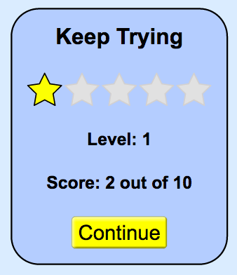
- Go to the game section. To do this click on a button called “Game” that has a smiley face, which is at the bottom of the screen.
- There are three levels. Each level has 5 challenges. When you think you have the number of molecules necessary, click the “Check” button. You will be awarded points if you get the equation correct. You only get two attempts.
- Complete all 5 attempts. When you get to the final screen (see image to the right), write down your score and show your teacher your score before moving on… else you get to do it again!
- Once you have completed Level 1, you will continue to Level 2. Then you will try Level 3.
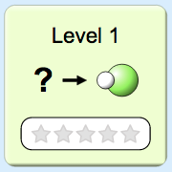  Level 1 Score:  ______ / 10  Teacher Signature:  ____________________ | 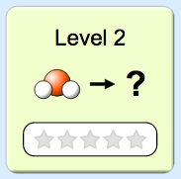  Level 2 Score:  ______ / 10  Teacher Signature:  ____________________ | 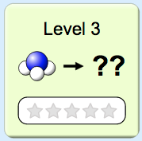  Level 3 Score:  ______ / 10  Teacher Signature:  ____________________

