PhET Balancing Chemical Equations Name_________________________________________Hr_______

iPad Link: http://phet.colorado.edu/sims/html/balancing-chemical-equations/latest/balancing-chemical-equations_en.html

Background:
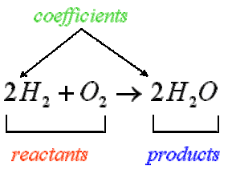
This online lab will allow you to balance chemical equations. Chemical equations represent chemical changes called chemical reactions. Below is a chemical equation of hydrogen gas reacting with oxygen gas to create water.

Notice the items on the left of the arrow sign are the reactants. The items to the right of the arrow sign are the products. There is only one product in this example reaction. Also notice the numbers labeled as coefficients. These coefficients tell you how many molecules of each compound you need for the reaction. For instance, you will need 2 molecules of H₂ with 1 molecule of O₂, which will create 2 molecules of H₂O.

The value of the coefficient is based on the number of atoms of each element on the left of the equation being the same as on the right of the equation. When the coefficients are correct, the equation is balanced. Use the PhET app to determine the coefficients of various chemical equations.
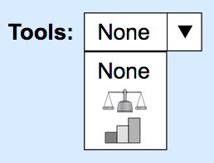
Part 1: Introduction
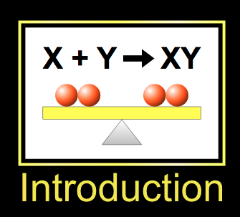
- Select Introduction.
- Refresh the page if you ever need to start over.
- Notice the “Tools” menu. Please choose one.
- Towards the bottom of the screen are three reactions you are to balance.
- Use the arrows next to the compounds to change the coefficients.
- Below is an example of a formula NOT balanced.

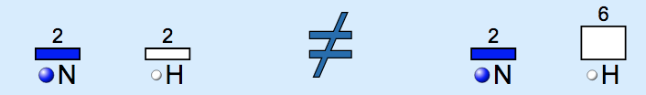
- You must keep working until you get the smiley face (see to the right).
- Once you get the smiley face, write down the coefficients in Steps #9-#11.
- Balanced the formula for “Make Ammonia.” Write your coefficients below.
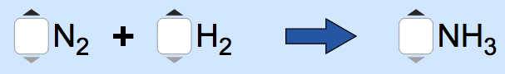
- Balanced the formula for “Separate Water.” Write your coefficients below.
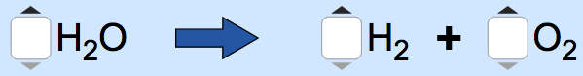
- Balanced the formula for “combust methane.” Write your coefficients below.
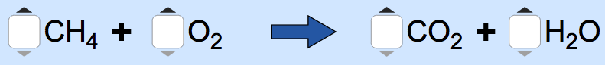
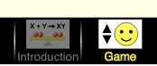
Part II: The Game
- When you are done with Part I. Go to the game section. To do this click on a button called “Game” that has a smiley face, which is at the bottom of the screen.
- There are three levels. Each level has 5 equations for you to balance. When you think you have balanced the equation correctly, click the “Check” button in the middle. You will be awarded points if you get the equation correct. You only get two attempts.
- For each challenge you will write down the equation with the correct coefficients in the table below. Also write down your score for that level. Show your score to the teacher, who will then sign the paper.
- Once you have completed Level 1, you will continue to Level 2. Then you will try Level 3.
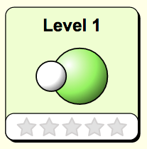  Level 1 Score:  ______ / 10  Teacher Signature:  ____________________ | Equation with CORRECT coefficients.
 | Challenge 1
 | Challenge 2
 | Challenge 3
 | Challenge 4
 | Challenge 5

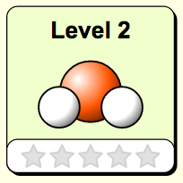  Level 2 Score:  ______ / 10  Teacher Signature:  ____________________ | Equation with CORRECT coefficients.
 | Challenge 1
 | Challenge 2
 | Challenge 3
 | Challenge 4
 | Challenge 5

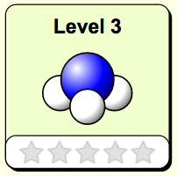  Level 3 Score:  ______ / 10  Teacher Signature:  ____________________ | Equation with CORRECT coefficients.
 | Challenge 1
 | Challenge 2
 | Challenge 3
 | Challenge 4
 | Challenge 5

