Alana Nabirali
3-05-15

Digital Curriculum Technology Lesson

Title: Building Electric Circuits and comparing the brightness of Light Bulbs.

Introduction:
In this activity you will investigate the physical science of electrical circuits by exploring various electrical pathways required to light a light bulb. By the end of this activity, you will use different objects to conduct the flow of electricity to light the bulb.

Click this link: http://phet.colorado.edu/en/simulation/circuit-construction-kit-dc

This is a screen shot of the website:

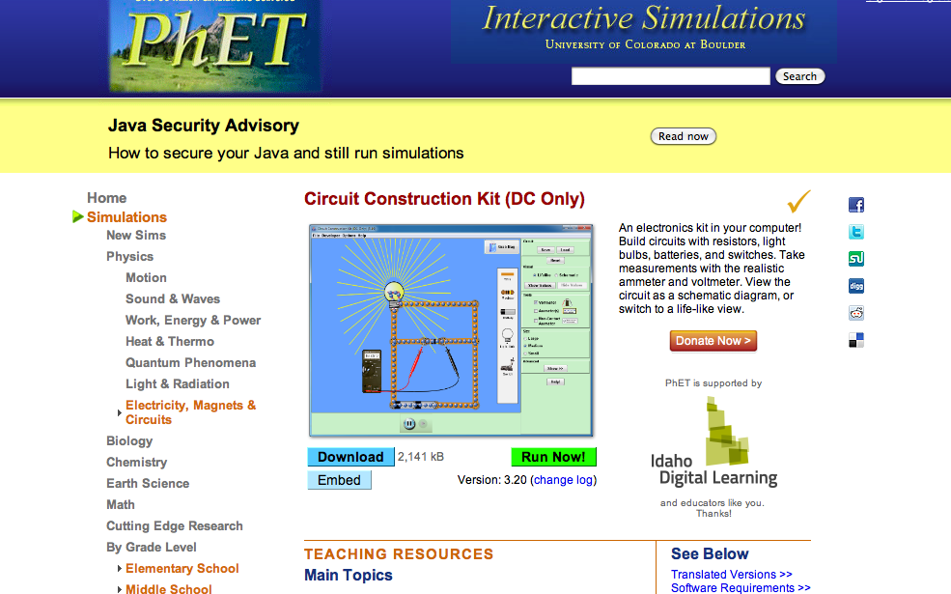

2. Click “Run Now” and wait for the sim to load.

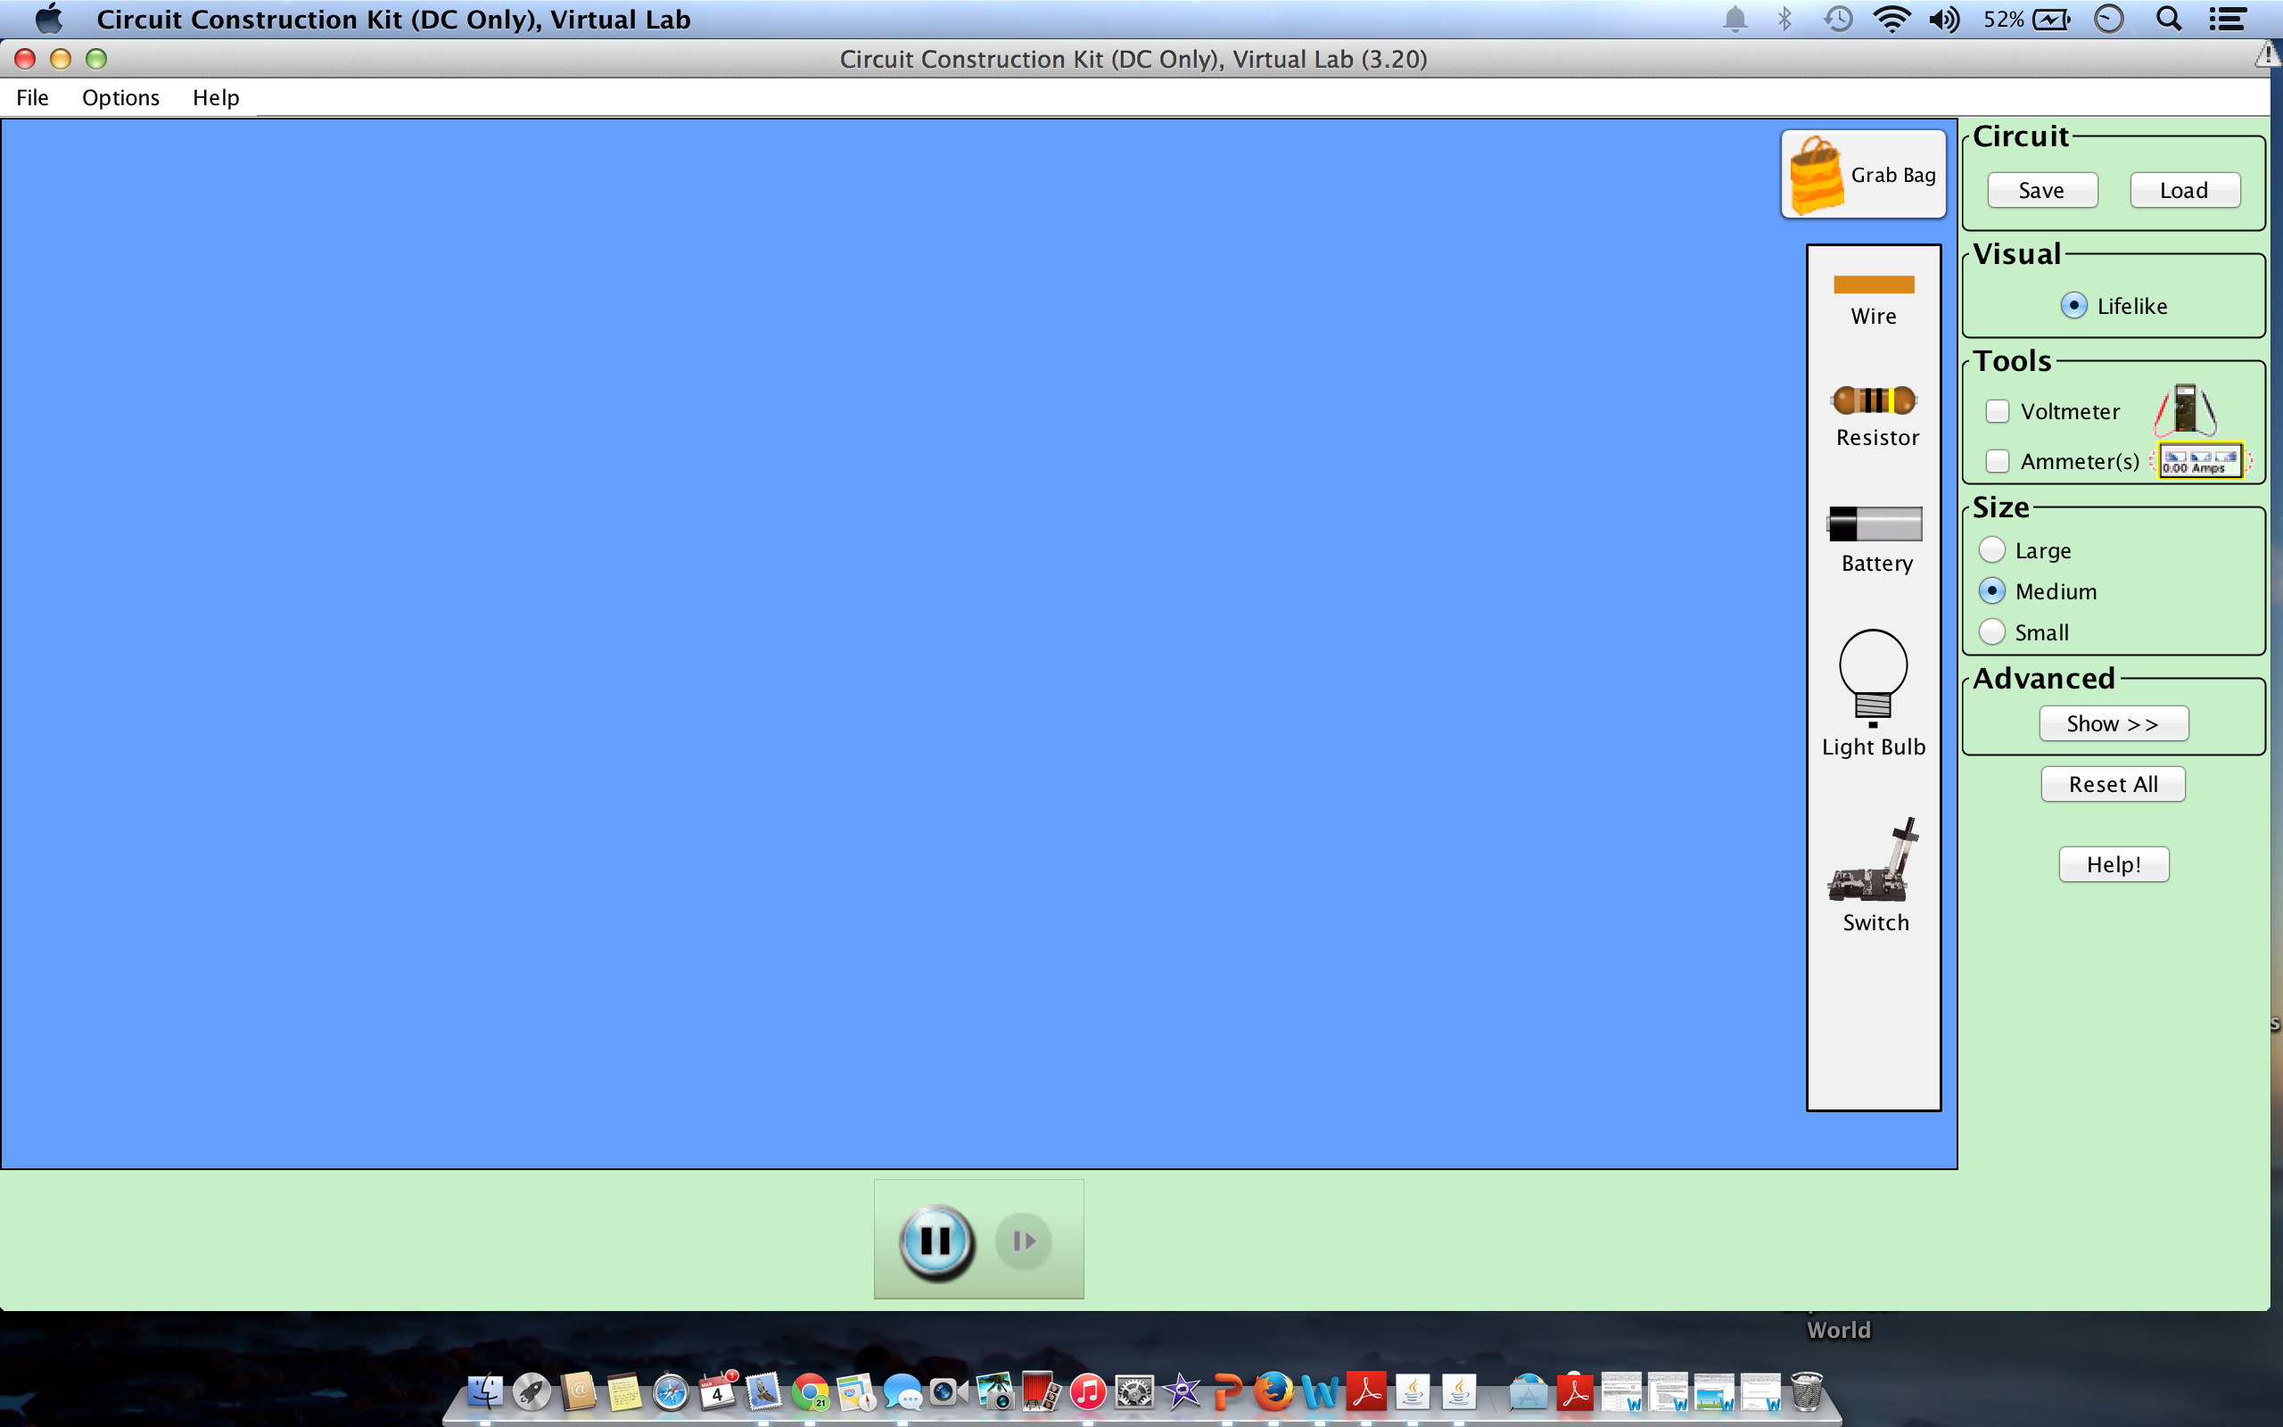

Switch between this document and the sim “Circuit Construction Kit (DC Only)” to complete the activity.

Exploration Phase:

1. Drag objects located on the left side bar to the blank screen.

2. Build an electric circuit using the objects dragged on the blank screen.

3. Using the grab bag predict which objects will be stronger conductors of electricity on a scale of 1 (least) to 7 (highest).

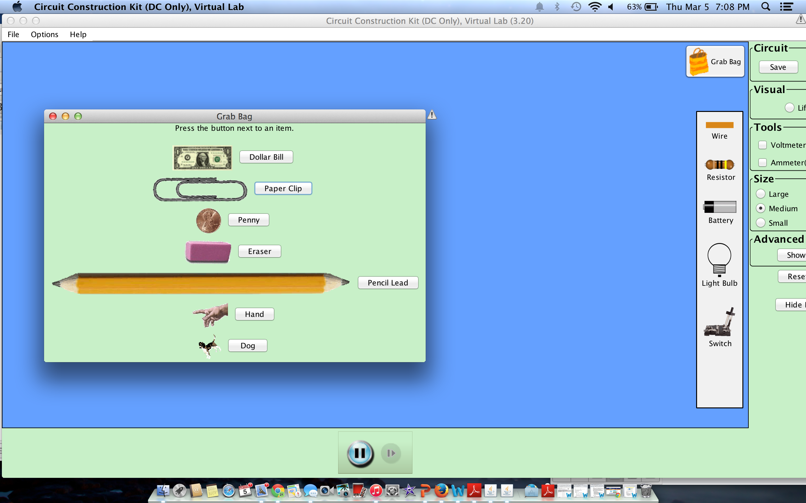

Objects: Scale: 1-7
Dollar Bill | 1
Paper Clip | 6
Penny | 7
Eraser | 2
Pencil | 5
Hand | 4
Dog | 3

4. Try different objects in the “grab bag” and experiment using your constructed circuit to see which objects produces a stronger circuit resulting in a brighter glow of a light bulb.

Conductive: Paper clip, Penny, Lead
Questions

1. What do the items that conduct electricity have in common?
They are made out of some sort of metal

2. Which object had the greatest effect the light bulb brightness?
The Penny’s.

3. Which object surprised you that you thought would have had an effect on the light bulb brightness?
The lead
Explanation Phase:

Aim: How do we build a series circuit and parallel circuit to compare the brightness of light bulbs?

Terminology:
Circuit: a source of electricity (battery) and a load (light bulb), which are connected in a continuous “circle” of wires or other conductors which electricity can flow through.

Opened Circuit: When there is a break somewhere in the circuit (a light is burned out or a wire is not properly connected), the circuit is called “open” and electricity cannot flow through.

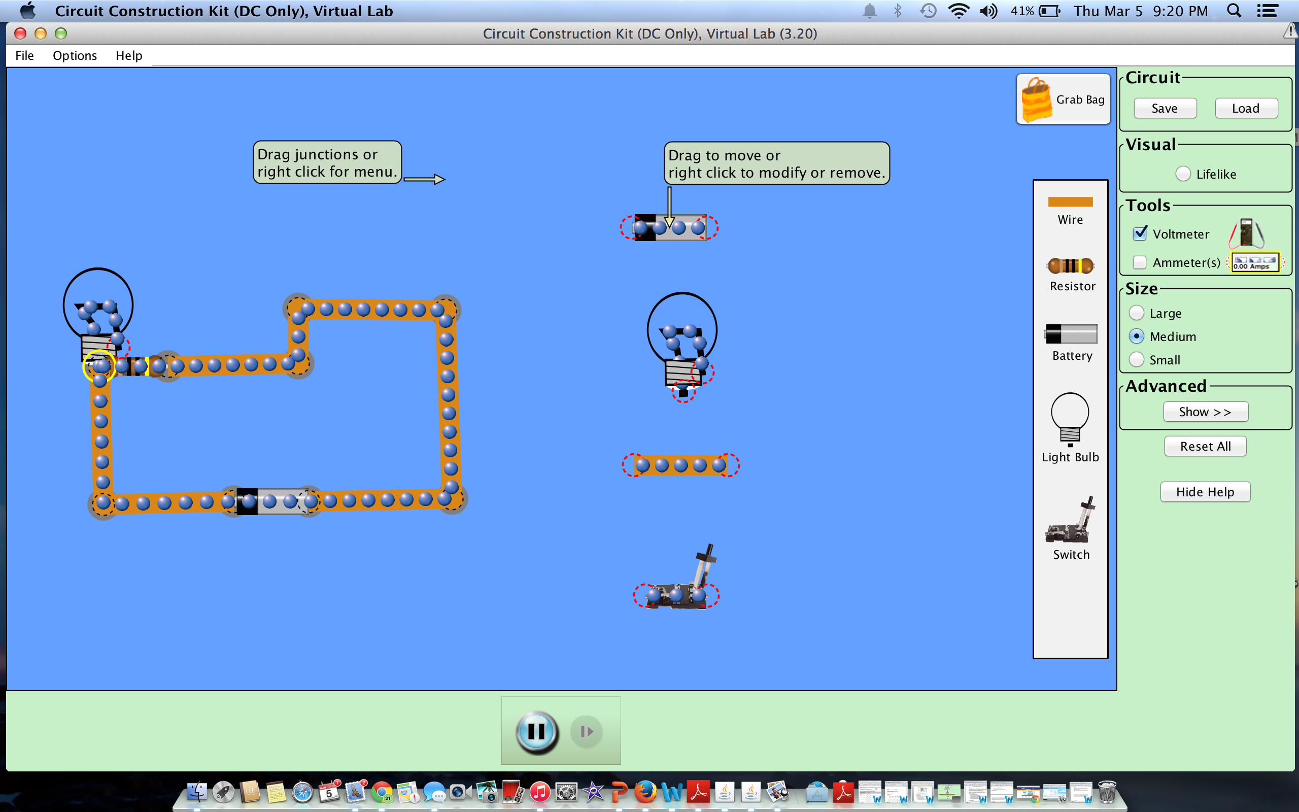

Closed Circuit: When electricity is flowing, the circuit is complete (closed), which means electrons can flow through.

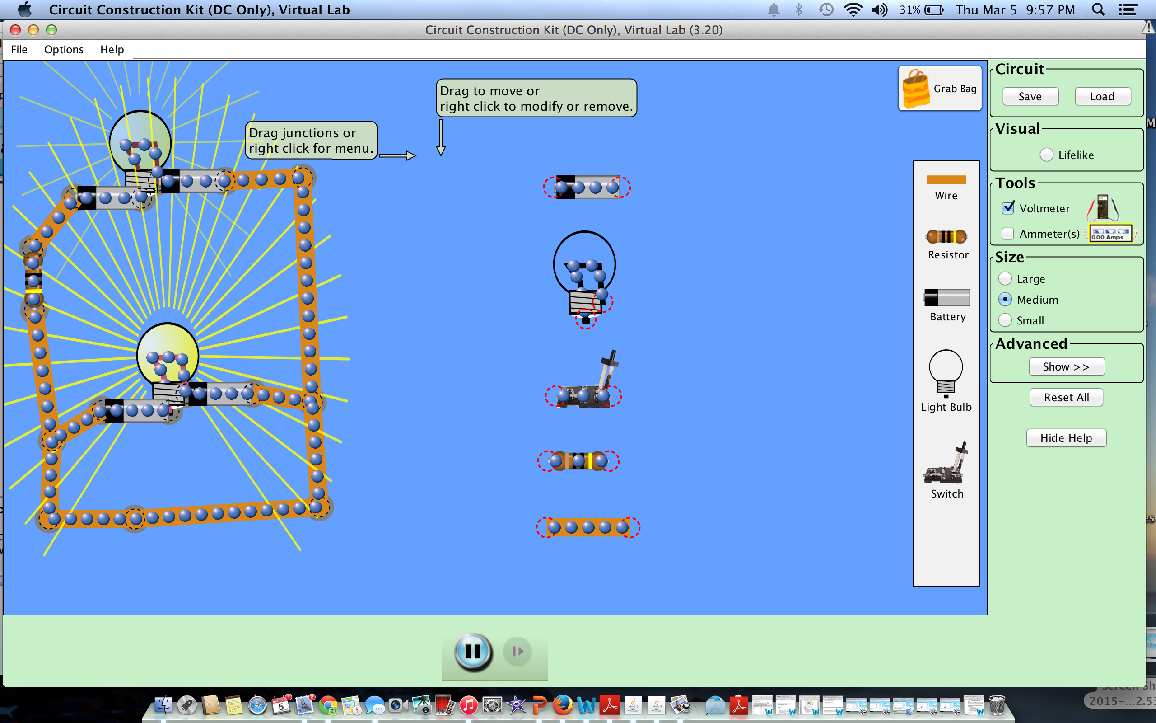

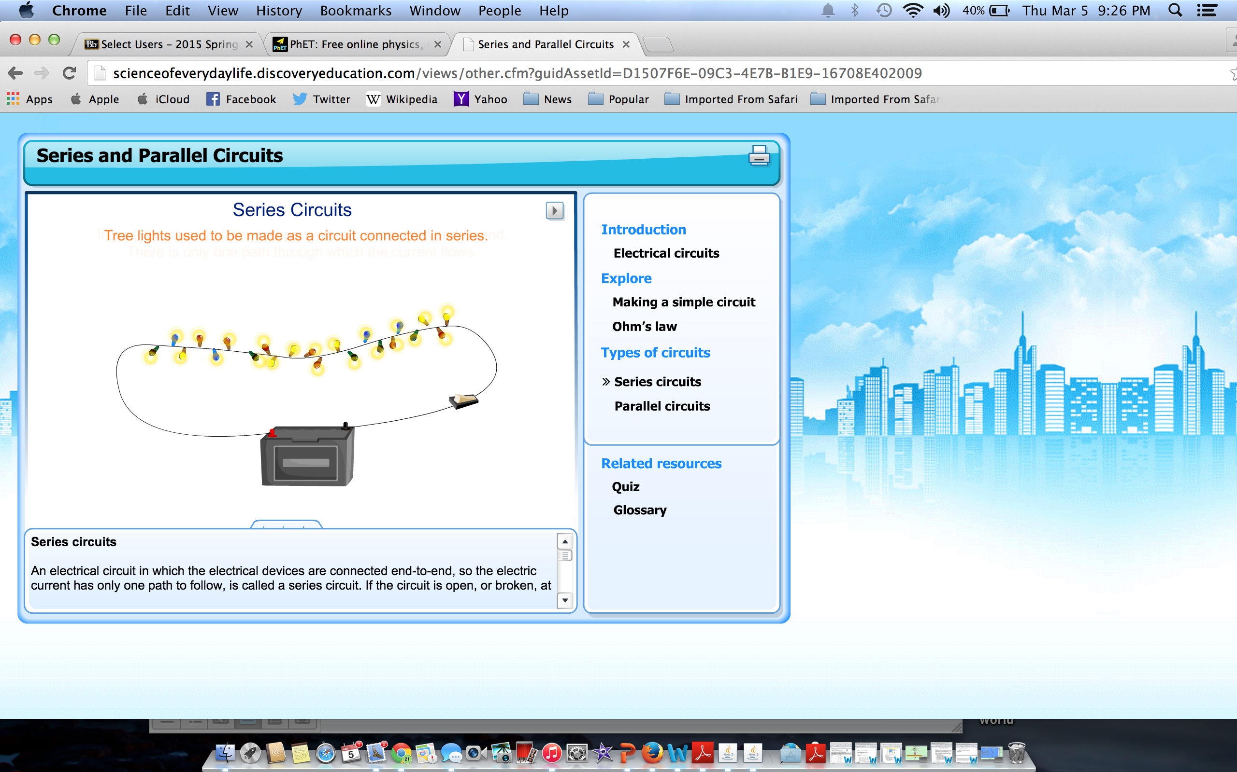

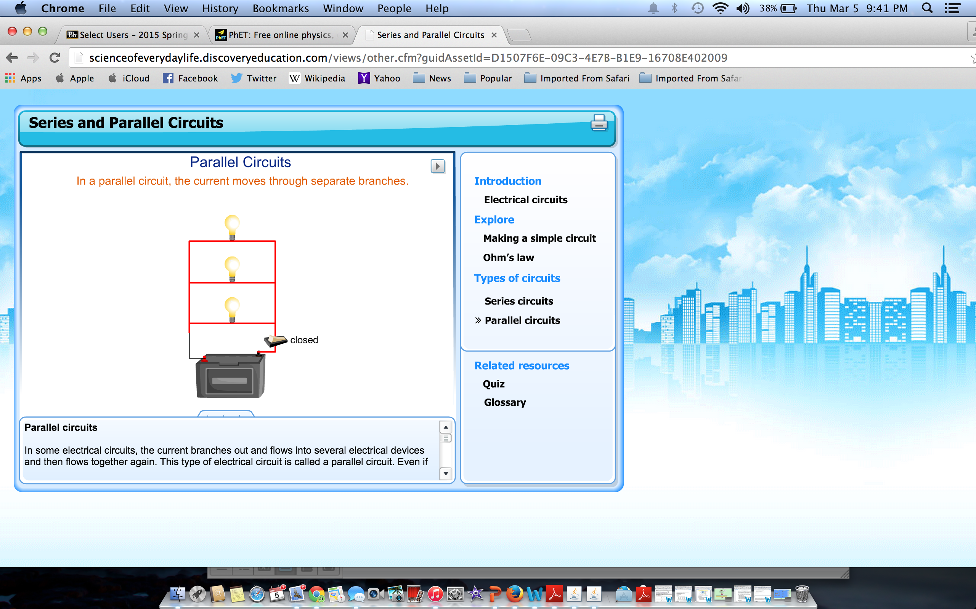

Application Phase:

Create your own Series and Parallel Circuits using the sim. Take a screen shot of your model and paste it below. Explain why this model is a Series or Parallel Circuit.
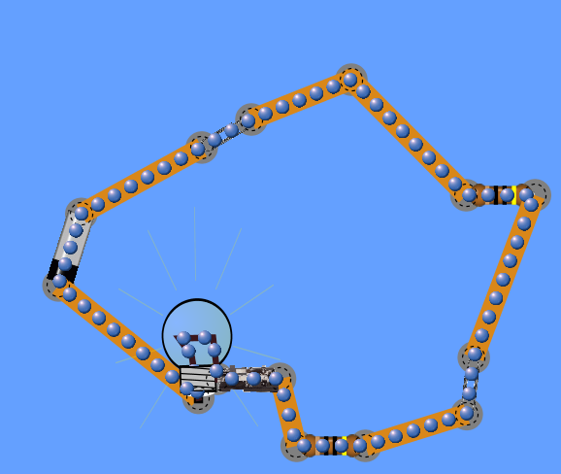
This is a series circuit because the electrical current has only one path to follow.
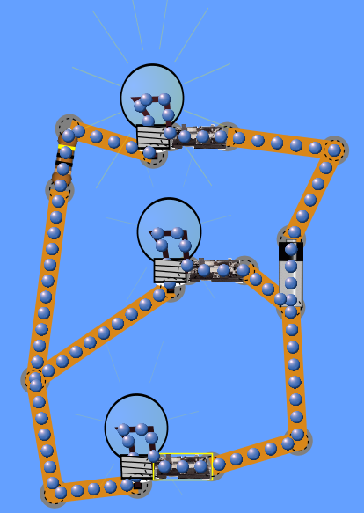This is a parallel circuit because the current branches out to light each lightbulb and then comes back together again.

Conclusion:

Write your own explanation based on the following question:

What path do electrons take through each type of circuit?
Clockwise?

Finished! Congratulations on the completion of your activity.

You are glowing with knowledge!

