Title: Comparing Fractions with Like Numerators and Denominators

Introduction:
In this activity you will explore fractions. You will be looking closely at numerators and denominators to determine their relationship to size in order to compare fractions with the same numerator or denominator.

1. Click this link: http://phet.colorado.edu/
This is a screen you will see:

2. Click the “Play with sims”
3. Type “Fractions Intro” into the search box. Then, click “”search.”
3. Click “Run Now!”
4. After it loads, this screen will appear:
5.Click “Accept and Continue”

Exploration:
- Click on the “intro” tab.

- Explore changes you can make to the numerator and denomenator using the up and down arrows.

- Change the representation of the fraction by clicking the images. See below.

Words to Know

Numerator: The number above the line that tells how many equal parts of the whole are being counted.

Denominator: The number below the line that tells how many equal parts are in the whole.

Writing Fractions:
Fractions can be written a couple of ways. It might be easiest for you to use the backslash key ( / ) to record fractions. For example $\frac{1}{4}$ could be written 1/4.

Predictions

- Make a prediction or the order of the following fractions from least to greatest:

1/3, 1/5, 1/2

Prediction:

2/4, 1/4, 3/4

Prediction:

- Are there any fractions that are the same? Explain.

Explanation:

Aim: To create a rule to compare fractions with like numerators or denominators.

Click “Reset All.” You’re screen should look the one below:

Set your denominator to 4. Use the sim to create each fraction. Choose the model that matches below and record the letter in the table. Then record the total number of equal parts in the whole. The first one is done for you.

a. 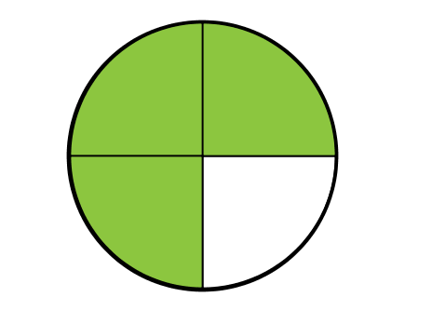 b. 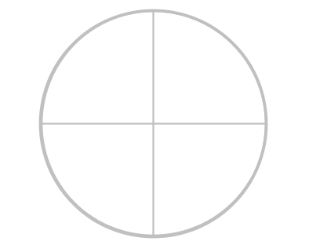 c. 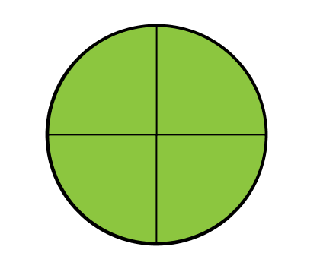
d. 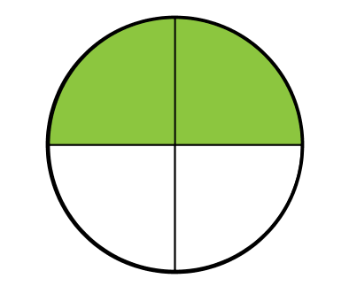 e. 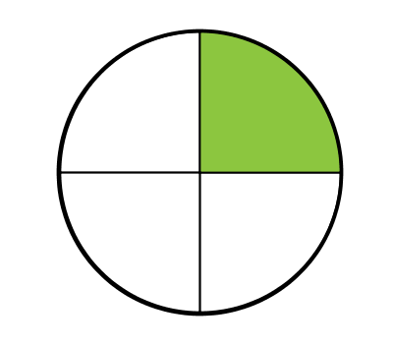

Fraction | Model (above) | Total Equal Parts in the Whole
0  4 | b | 4
1
4
2
4
3
4
4
4

Order the fractions from least to greatest.

Write a rule for comparing fractions with the same denominator.

If the denominator is the same, then…

Look back to your prediction. Was your prediction correct or incorrect? Explain.

Set your numerator to 1. Use the sim to create each fraction. Choose the model that matches below and record the letter in the table. Then record the total number of equal parts in the whole. The first one is done for you.

a. 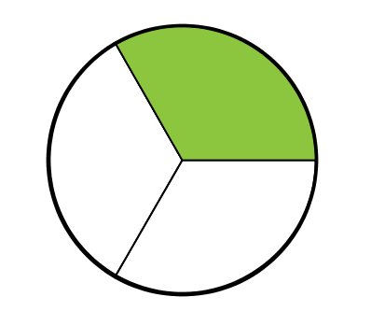 b. 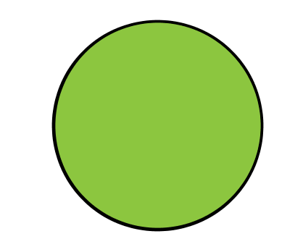 c. 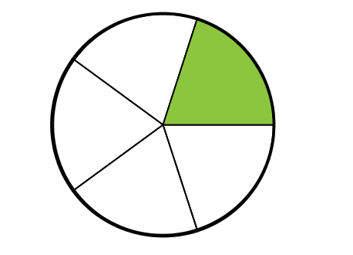
d. 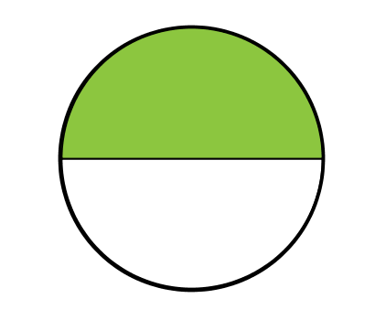 e.

Fraction | Model (above) | Total Equal Parts in the Whole
1  1 | b. | 1
1
2
1
3
1
4
1
5

Order the fractions from least to greatest:

Write a rule for comparing fractions with the same numerator and explain:

If the numerator is the same, then

Look back to your prediction. Was your prediction correct or incorrect? Explain.

Application:

Apply your rules to order the fractions in the problems below from least to greatest.

- $\frac{4}{6}$ , $\frac{2}{6}$ , $\frac{5}{6}$

Order:

- $\frac{2}{4}$ , $\frac{2}{5}$ , $\frac{2}{3}$

Order:

The End

