Title: Tug Wars: May The Pulling Force Be With You!

Introductions
In this activity you will investigate the physical science of the pull force. You will learn what happens when an object is pulled on either side with a rope.

1. Click this link: http://phet.colorado.edu/
This is a screen shot of the website:

2. Click the ‘search’ bar
3. Type in ‘Forces and Motions (Basics)’.
4. Wait until this screen appears:

4. Click the button that says ‘Run in HTML5’

5. It will take time to load and then this screen appears:
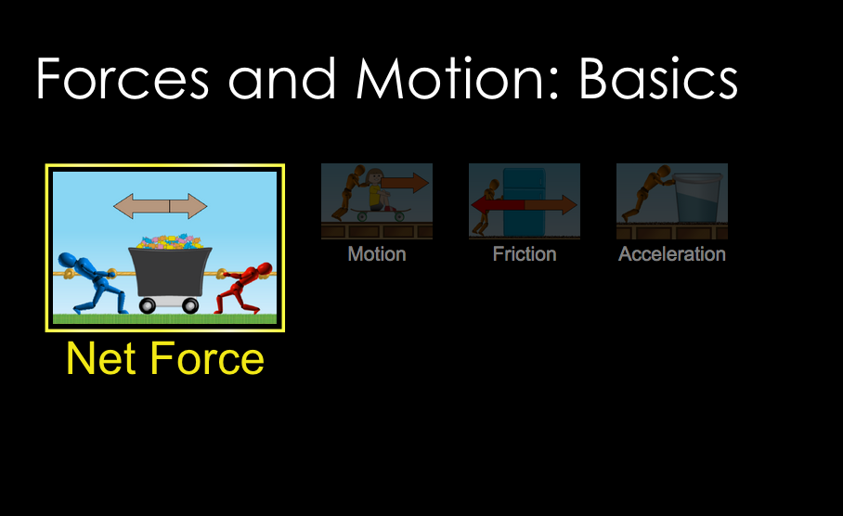
6. Double click ‘Net Force.’

Switch between this document and the sim to complete the activity.

Exploration Phase

1. Place various blue or red people on the parts of the rope and press ‘Go!’

2. Freely explore different combinations of blue and red people.

3. Press the ‘return’ button to rest the cart to the middle.

Here are some concepts:

Objects placed on the left cause left pulling force.
Objects placed on the right cause a right pulling force.

Questions

- How do you make the cart move towards the left?

- How do you make the cart move towards the right?

- How do you make the cart stay in the center and not move?

Explanation Phase

Aim: Create a rule that describes the condition of a cart that is not moving.
Describe the rule here:

Check on the ‘Sum of Forces’ box and the ‘Values’ box and make the screen look like this:

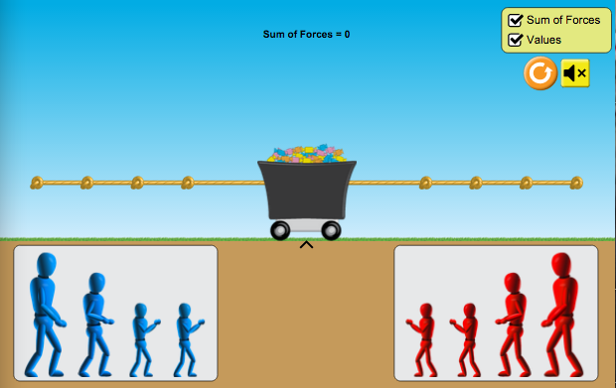

Mystery humans: Find the force each human can pull:

Mystery Object | Force each human can pull (N)
Large
Medium
Small

Use the sim and fill in the blanks of the following table for 6 different conditions of the rope being pulled. After each trial press the go button and see which direction the cart moves. To reset the cart after each trial, press the orange button with the arrow inside.

Assume that the humans used can be called ‘Large’ or ‘L’ for the largest, ‘Medium’ or ‘M’ for the middle size and ‘Small’ or ‘S’ for the two smallest. If there is no one on a side, put an ‘X’ in the box. You may place the humans on any part of the rope.

Trial | Left Side | Left Force (N) | Right Side | Right Force (N) | Sum of Forces (N) | Direction cart moves (Left, right, or stays still)
1 | L |  | X | 0
2 | X | 0 | S S
3 | M |  | L
4 | L M |  |  |  | 200
5 | S S |  |  |  | 0
6 |  |  | L |  | 0

Come up with a rule for the condition of a cart that is not moving.

Write here:

Use your rule and your two charts from above to help you answer the following questions: If a cart is moving to the right at 150 N and there is a Large human on the left side, what force must be pulling the cart to the right? Calculate.

Which humans can be on the right side to make this force possible?

Check your answer with the cart.

Application Phase

Click the ‘Motion’ button on the bottom of your page. Check all the boxes in the yellow box (‘Force’, ‘Values’, ‘Masses’ and ‘Speed’)

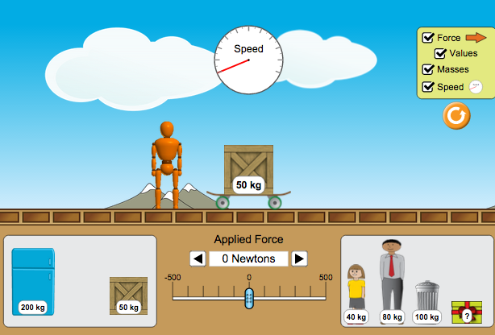

1. Which direction do you think the cart will move when you push it?

2. How is this the same or different than when you pull it? What can you say about the similarities or differences between pushing and pulling?

3. Press the right arrow until you have increased the force to 100 Newtons. Which direction does the cart move?

4. Reset the trial by pressing the orange button with the arrow inside of it. Press right the arrow until you have increased the force to 150 Newtons. Which direction does the cart move? Is it moving faster or slower than 100 Newtons?

5. Reset the trial by pressing the orange button with the arrow inside of it. Press left the arrow until you have increased the force to -100 Newtons. Which direction does the cart move?

Conclusions: What do you notice about pushing the cart versus pulling the cart?

Is the value of the force positive or negative when you push?

Is the value of the force positive or negative when you pull?

Compare the data from the tug a war and the pushing experiment and explain:

Finished: Congratulations. You won the Tug War!

