Jacqueline Sutton
Measuring Mass With Springs
In this activity you will investigate the physical science of various masses and springs.

- Click this link: http://phet.colorado.edu/
This is a screen shot of the website: 
- Click the “Play with sims” button.
- Click “New Sims” -> Click “Masses and Springs” -> Click “Run Now!”
- It will take time to load and then this screen appears: 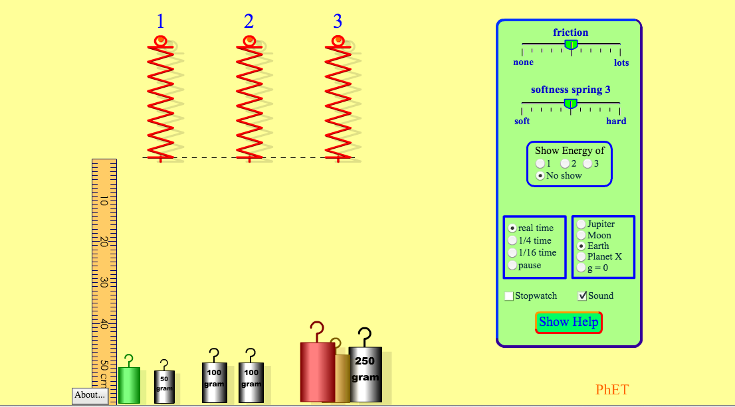
Switch between this document and the sim to complete the activity

Exploration Phase:

- Place various objects on the springs
- Freely explore the effect of adding friction, making the spring softer and harder, and changing the environment of the springs.

Questions:
- What happens to a spring when a lighter object is added to it?

- What happens to a spring when a heavier object is added to it?

3. Explain why you think this happens.

Explanation Phase:
Aim: Create rule that describes the relationship between the mass and the movement of the spring.
Describe the rule here:

Reset the sim. Make sure the reference line is here:

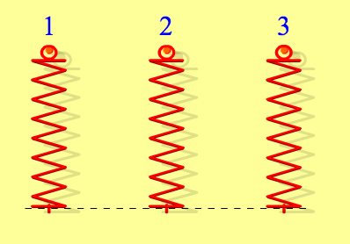

Use the sim and fill in the blanks of the following table for 3 different conditions of the springs. Use the draggable ruler provided to make measurements. The ruler should be aligned with the reference line as seen below. 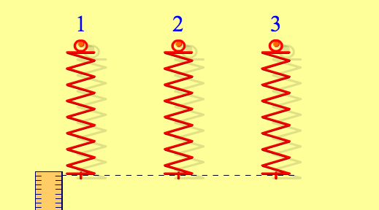
Mass of Object (g) | What was the extension of the spring? (cm)
50 grams
100 grams
250 grams

Come up with a rule for the length of the spring when a mass is added to it based on the completed chart.
Write here:

Use your rule to complete the chart below.
Mass of Object (g) | What was the extension of the spring? (cm)
40 grams
 | 7 cm
 | 12 cm
 | 19 cm
300 grams
500 grams
 | 56 cm
1,000 grams

Application Phase
Use the rule you created to find the mass of the mystery objects.

Mystery Object | Mass (grams) | What was the extension of the spring? (cm)
Red Object
Green Object
Gold Object

How were you able to calculate the mass of the mystery objects?

Finished: Congratulations! You can now spring on forward!

