Scaling Shapes
PRE-PLANNING | PRIOR KNOWLEDGE
PRE-PLANNING | - How to calculate area and perimeter of an irregular polygon.  - Area is measured in square units and perimeter is measured in linear units.  - Identify similar shapes as having the same shape but possibly a different size. (More advanced: similar shapes have congruent corresponding interior angles and proportional corresponding sides.)  - Identify the scale factor of similar shapes by comparing dimensions.
PRE-PLANNING | LEARNING GOALS
PRE-PLANNING | - Predict the area and perimeter of shapes that have been scaled by factors of 2 or 3.  - Generalize how the area and perimeter of a shape will change after being scaled by a factor of s.
PRE-PLANNING | Common Core Standards | Common Core Practices
PRE-PLANNING | CCSS.Math.Content.7.G.A.1  Solve problems involving scale drawings of geometric figures, including computing actual lengths and areas from a scale drawing and reproducing a scale drawing at a different scale. | 2. Reason abstractly and quantitatively  7. Look for and make use of structure
PRE-PLANNING | MATERIALS
PRE-PLANNING | - PhET Area Builder simulation:  https://phet.colorado.edu/sims/html/area-builder/latest/area-builder_en.html  - Laptop/Chromebook/tablet for each student or pair  - Seating chart that has heterogeneous pairings of students.  - “Scaling Shapes” Activity Sheet for each student (see below)  - Two colors of post-it notes
LESSON CYCLE | THINK-PAIR-SHARE 8 minutes
LESSON CYCLE | THINK: Activate prior knowledge by having students journal about the following prompt.  Are these two figures similar? Explain how you know. Find the scale factor, if applicable.  1. 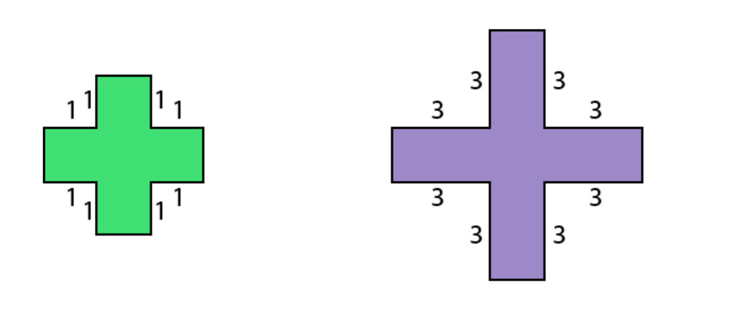  2. 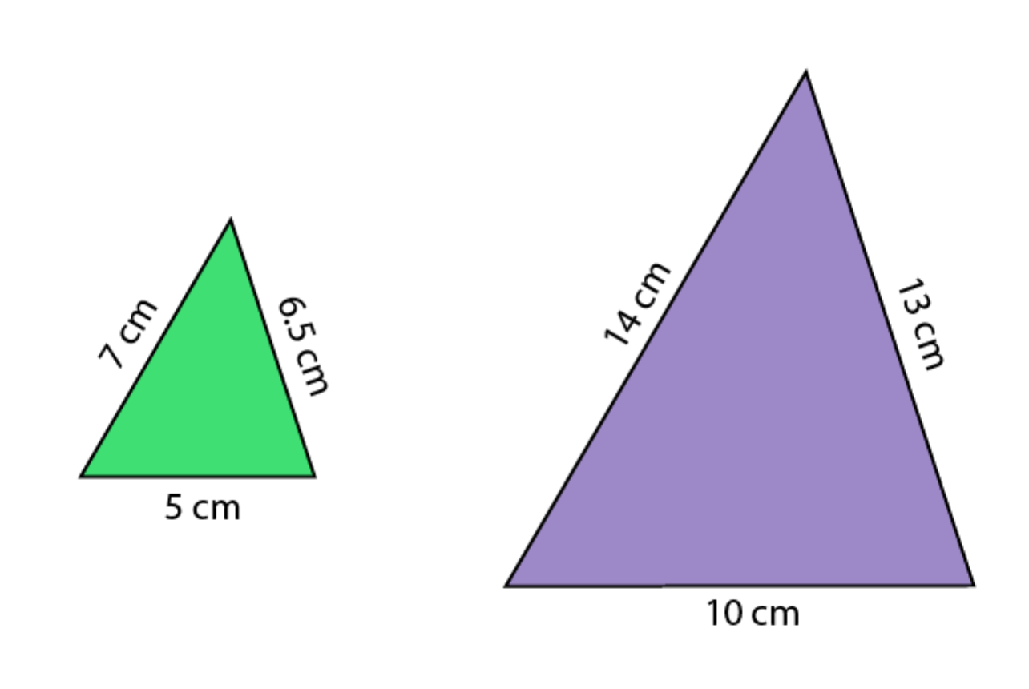  3. 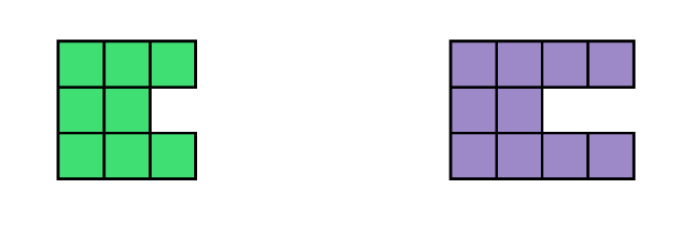  PAIR: Have students discuss their responses with their partner.  SHARE: Elicit responses from partners to share with the entire class.
LESSON CYCLE | INTRO 5 minutes
LESSON CYCLE | Teacher will… | Students will use computers and worksheet to…
LESSON CYCLE | - Instruct students to open up the sim by going to phet.colorado.edu, click on HTML5 Sims, then click on Area Builder.  - Explain that they will play with the Explore screen for 5 minutes before starting the activity.  - Ask students to share any tools they uncovered that you think would be useful for the activity- such as the dimensions tool:  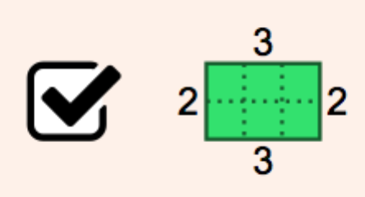  - Distribute one activity sheet to each student.  - Allow time to read directions independently or call on students to take turns reading aloud. | Explore the first screen of the sim for 5 minutes. Be prepared to share a few things they discovered.  Work individually or in partners on a laptop/Chromebook/tablet, discussing the prompts on the worksheet.
LESSON CYCLE | GUIDED EXPLORATION 15 minutes
LESSON CYCLE | Teacher will… | Students will use computers and worksheet to…
LESSON CYCLE | - Circulate the room to be available for student questions and to ask probing/pushing questions. If a student is struggling with the task, it can help to probe for more information.  - How did you come up with your prediction?  - How will you build your scaled shape? What is your strategy?  If they are following the directions perfectly but not naturally making connections, they may benefit from a push.  - How did you come up with your prediction?  - Why is #2 limiting the side length to 4 units?  - Are you surprised at the results for area and perimeter of your scaled shape? What do you think the rule is?  - What patterns are you noticing?  - Divide the front board into two sections:  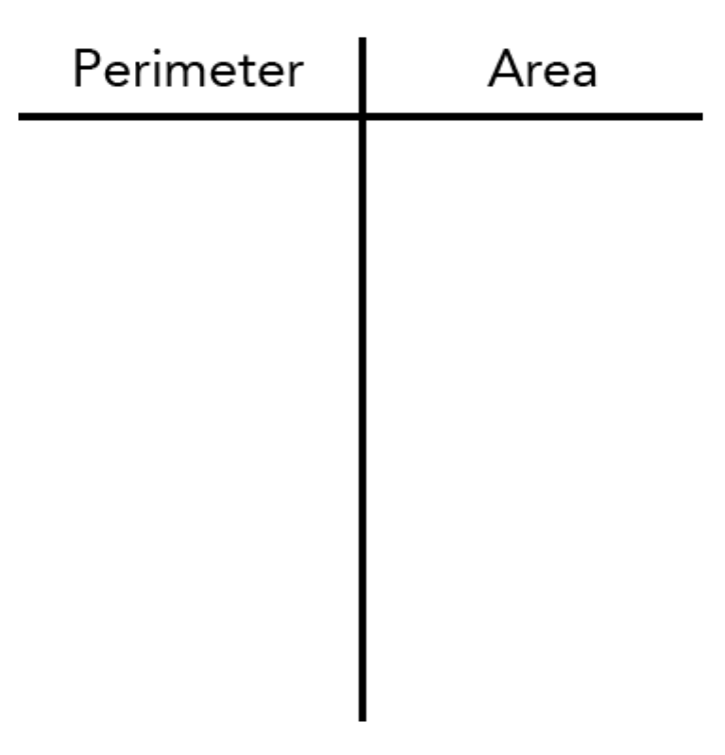  - As partners finish, group them with another partnership to discuss Part III in a group of 4. Have them write their responses on post-it notes and stick them on the front board. | Build a shape on their own computer, then trade computers with their partner.  Make predictions, then test by building a scaled shape.  Compare results.  Discuss Part III in groups and write observations about perimeter on the pink post-it note and area on the blue post-it note.  Stick post-it notes on the board.  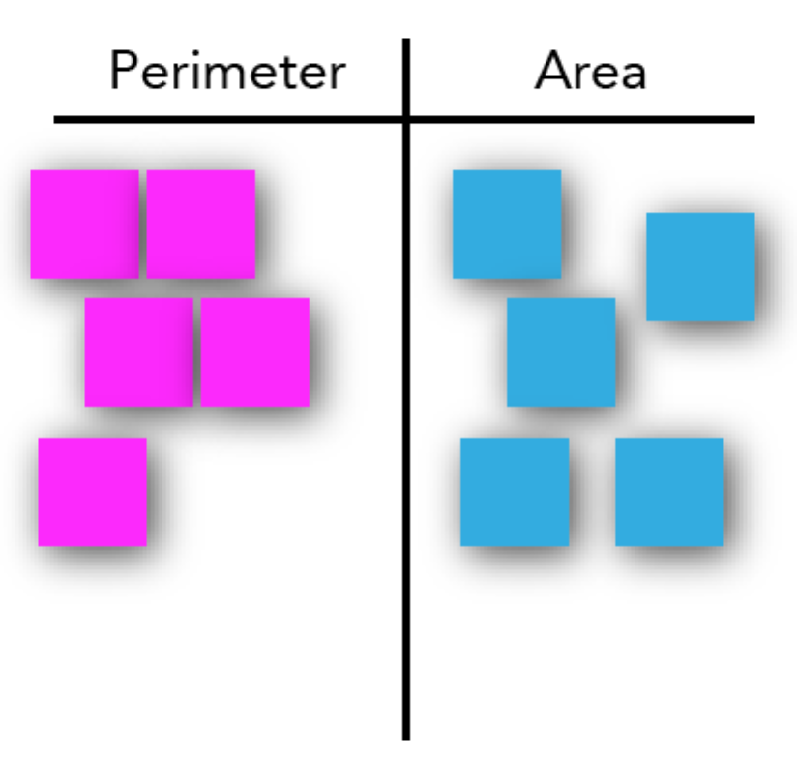
LESSON CYCLE | DISCUSSION 15 minutes
LESSON CYCLE | Teacher will… | Students will…
LESSON CYCLE | - Remind students to close their laptops or turn around so that the sim does not distract them from listening.  - Use an established teaching strategy such as popcorn discussion (one student answers, calls on the next student to talk), think-pair-share (pose question, allow time to think, turn and talk to partner), or group discussions (print out questions and have groups talk to each other and write down consensus to share aloud with class). Sample questions include:  - What is the rule for calculating the new perimeter of a scaled shape? How do you know?  - What is the rule for calculating the new area of a scaled shape? How do you know?  - Why are the rules different for perimeter and area?  - Extension: Predict the rule for calculating the volume of a scaled cube (or any 3D shape) if you change the side length. | Put away their device and engage in discussion.  Justify the scaling rules for perimeter and area.  Justify why perimeter and area have different rules when scaling 2D shapes.  Predict the rule for 3D shapes and justify answer.
LESSON CYCLE | SUMMARY 10 minutes
LESSON CYCLE | Teacher will… | Students will…
LESSON CYCLE | - Allow students time to work on application and summary questions in Part IV.  - Circle the room and listen to conversations about the questions. If you hear good discussions, ask those students to share with the class when you review the summary questions.  - Elicit responses to summary questions using an established classroom procedure such as writing work on the board, projecting student work under a document camera, or having students compare in groups. | Answer application questions on worksheet while collaborating with their with partner/group.

Name: ______________________________ Class: _____________ Date: ____________________
Scaling Shapes
Objective: Generalize how scale factors affect the area and perimeter of any shape.
Part I. Scale factor of 2
- Explore: Take 5 minutes to explore the Area Builder sim before beginning this worksheet.
- Build a Shape: Click the toggle so that you can view two boards at a time. Build a shape no larger than 4 unit wide or tall, sketch it below, and use the information panel to record the area and perimeter. Minimize the information panel.
- Predict: Trade computers with your partner. Ask them to write down their predictions for the area and perimeter of the scaled shape.
- Verify: On the second board, have your partner build a similar shape that is scaled by a factor of 2. Sketch it below and maximize the information panel to compare the results with your prediction.
Shape #1
Original | 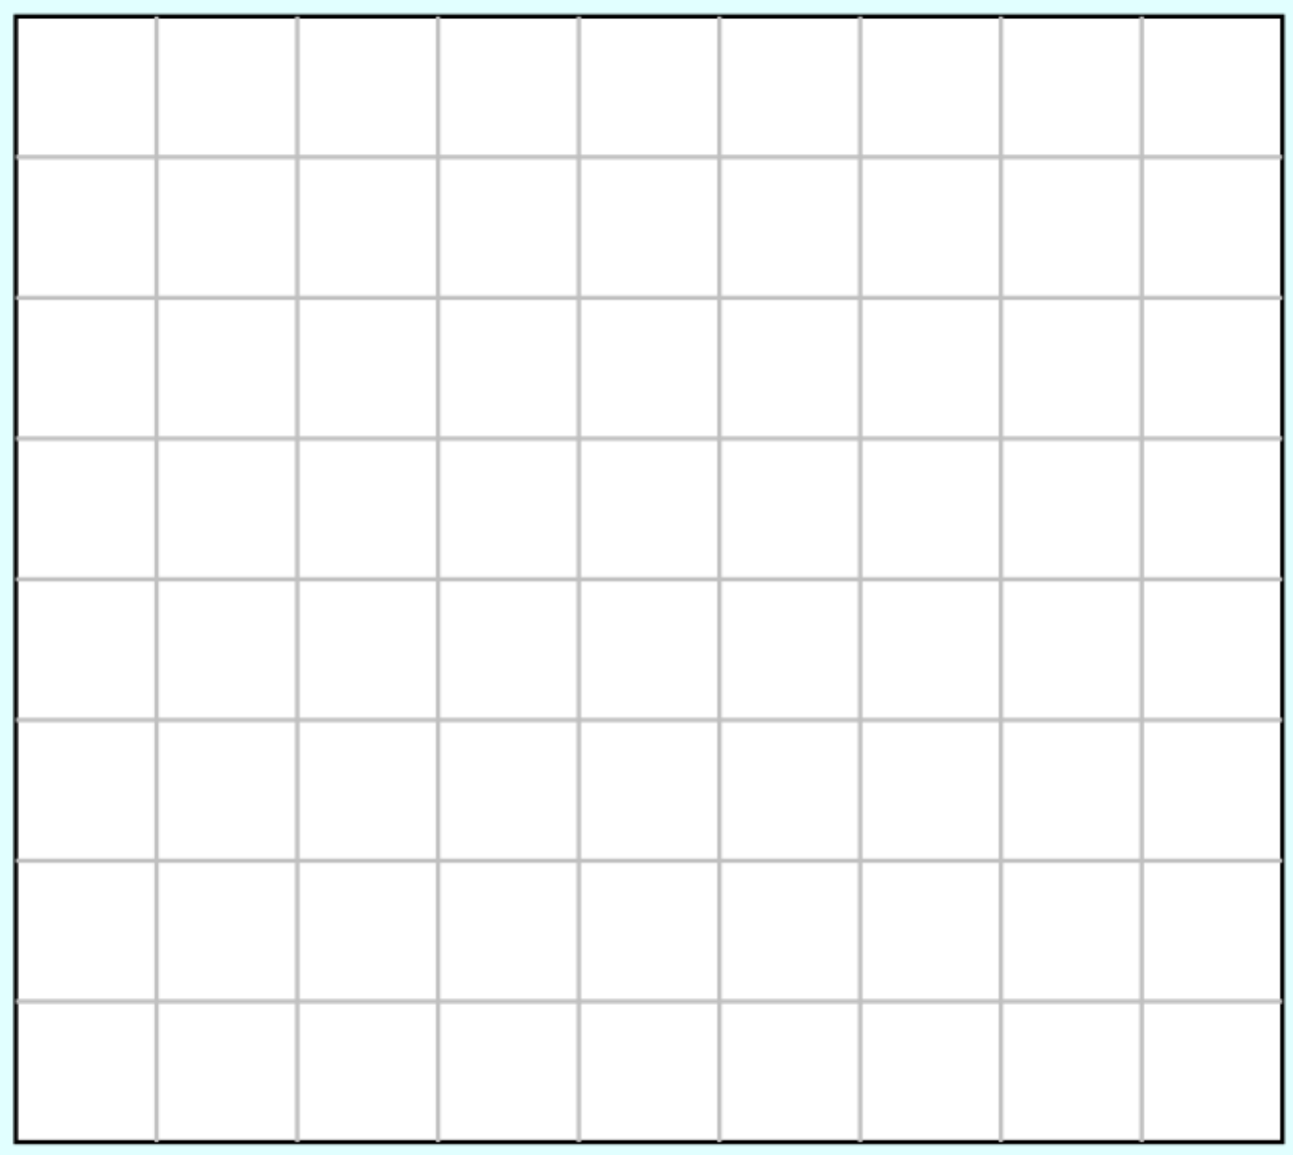 | Area =  Perimeter =
Scaled ×2 |  | Predict…  Area =  Perimeter =
Scaled ×2 |  | Actual  Area =  Perimeter =

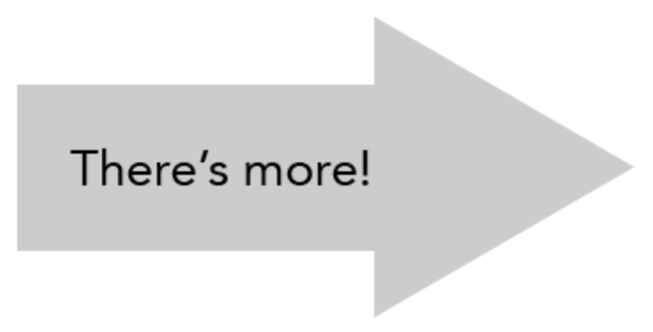
Part II. Scale factor of 3
- Build a Shape: Click the toggle so that you can view two boards at a time. Build a shape no larger than 3 unit wide or 2 units tall, sketch it below, and use the information panel to record the area and perimeter. Minimize the information panel.
- Predict: Trade computers with your partner. Ask them to write down their predictions for the area and perimeter of the scaled shape.
- Verify: On the second board, have your partner build a similar shape that is scaled by a factor of 3. Sketch it below and maximize the information panel to compare the results with your prediction.
Shape #2
Original |  | Area =  Perimeter =
Scaled ×3 |  | Predict…  Area =  Perimeter =
Scaled ×3 |  | Actual  Area =  Perimeter =

Part III. Group Share
Compare your predictions and actual results for Parts I and II.
- Perimeter: What patterns do you observe between Part I and Part II? What differences do you notice? If you can agree on a rule for how perimeter changes with scaling, write it on a pink post-it note.
- Area: What patterns do you observe between Part I and Part II? What differences do you notice? If you can agree on a rule for how perimeter changes with scaling, write it on a blue post-it note.

Part IV. Apply
- What are the new area and perimeter of this shape if it is scaled by a factor of 4? Justify your answer.


- A shape has an original area of 5 and perimeter of 12. What are the new area and perimeter if it has been scaled by a factor of 2.5? Justify your answer.

- Generalize: Explain to someone how to calculate the new area and perimeter of a scaled shape if they know the original area and the scale factor.

- Challenge: A shape has an original area of a and a perimeter of p. What are the new area and perimeter if it has been scaled by a factor of s?

