Name Date

C.A.S.T.L.E. PHET UNIT 1 LAB 1

Each of these review activities is a mirror of the physical C.A.S.T.L.E. lab we have done in class. All will require using PHET Circuit Construction Kit (AC+DC). Please google PHET Circuit Construction Kit (AC+DC), open the page and “RUN” the lab.

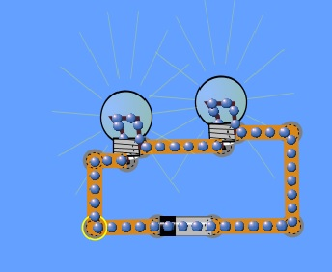
Unit 1 Lab 1:
Build the lab as pictured to the right. If it works you should have 2 dimly lit bulbs.

As this is your first lab here are a few small tips.
-Right click on objects to delete them or change their properties
-Right click on junctions (where two objects connect) to disconnect the two items.
-To lengthen or turn a wire click and drag
-To make a wire ‘bend’ or make an “L” shape just add a new wire in the new direction.
PLAY AROUND AND TRY CLICKING AND CONNECTING THINGS: Most questions you would ask your teacher can be answered by trying things out first yourself in the program.

Having built the image above answer the following questions:

- The small black strip on the battery is the positive (+) side of the battery. The long grey side is the negative (-) end. What end of the battery do the blue electrons “move out” from?

- As one electron leaves the battery on one end, electrons enter on the other. Does this amount appear to be balanced between sides or does one side have more electrons enter/exit?

- Do all electrons start in the battery? If not explain where else the electrons start.

LAB: In the image junctions are labeled A to F: Predict what would happen if you were to disconnect each point, then actually do the experiment and disconnect and observe. Note after disconnecting a junction make sure it is reconnected before testing the next one.
Junction | Does bulb 1 light? | Does bulb 2 light?
A
B
C
D
E
F
PREDICTION OBSERVATION
A
B
C
D
E
F
Bulb 1
Bulb 2
Junction | Will bulb 1 light? | Will bulb 2 light?
A
B
C
D
E
F

C.A.S.T.L.E. Lab PHET UNIT 1 LAB 2

There are several terms we must define before we go on. If you do not already know or have these terms please look them up now and fill them in.

Closed Circuit:

Open Circuit:

Conductor:

Insulator:

LAB: Build the circuit as shown in the image. This time you are leaving an opening, in this opening you will be adding in a variety of objects and determining if you will be able to create a closed circuit and cause the lights to illuminate.
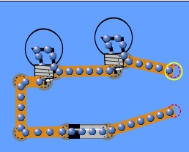

Select an object from the grab bag and insert it into the circuit opening. Make sure all junctions are connected.

Make your prediction on if the grab bag item will cause a bulb to light, then do the experiment and record your observations. You may have to move the wires to connect to both ends of the item.
ITEM | Will the bulbs light? |  | ITEM | Do the bulbs light?
Dollar Bill |  |  | Dollar Bill
Paper Clip |  |  | Paper Clip
Penny |  |  | Penny
Eraser |  |  | Eraser
Pencil Lead |  |  | Pencil Lead
Hand |  |  | Hand
Dog |  |  | Dog
CONCLUSION: Using all four definition words above write a conclusion for this lab.

C.A.S.T.L.E. Lab PHET UNIT 1 LAB 3 & 4
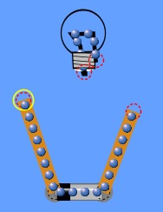
LAB: Build a circuit as pictured. Using the two open wires attempt to touch the parts of the bulbs listed and record if the bulb lights.
Left wire touches | Right wire touches | Result
Bottom of bulb | Bottom of bulb
Side of bulb | Sid of bulb
Glass of bulb | Glass of bulb
Bottom of bulb | Side of bulb
Bottom of bulb | Glass of bulb
Side of bulb | Glass of bulb

- What must occur for the bulb to light?

- What happens when side and side is touched or bottom and bottom is touched?
Look up and define the following term:

Short Circuit:

LAB: Built the partial circuits below as pictured and then attempt to create a closed circuit with only ONE wire. Draw your successful attempt in the space provided; the bulb will light when successful.

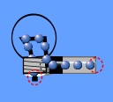
PICTURE OF SUCCESSFUL ATTEMPT:

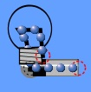
PICTURE OF SUCCESSFUL ATTEMPT:

- Describe the FULL path (closed circuit path) required to light a bulb. Include what is needed for the bulb and battery.

C.A.S.T.L.E. PHET UNIT 1 LAB 5

All labs thus far have shown the electrons leave the negative end of the battery into the long line of electrons in the wires and bulbs all the way to the positive end where electrons go into the battery. There will be several miniature experiments of which you will be responsible for linking together into a larger conclusion.
LAB: Build a circuit as shown to the right.
- Describe the way the electrons move using the term clockwise or counterclockwise:
- Right click on the battery and hit ‘REVERSE’.
- Describe what happens.

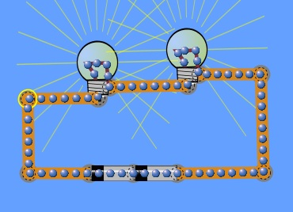
- ‘REVERSE’ the battery back to its original orientation, split its junction and add a second battery as shown.
- Describe the way the electrons move using the term clockwise or counterclockwise.

- Describe what happened to the speed of the electrons.

- Describe what happened to the brightness of the bulbs.

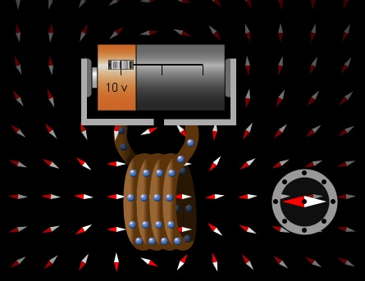
-Add as many batteries as you like to your circuit (I recommend 1 to 3 more) and see if these observations stay the same.
LAB: Google “PHET GENERATOR” https://phet.colorado.edu/en/simulation/generator and Select the TAB “ELECTROMAGNET” Move the compass to the side of the wires.
- Which way do the electrons move?
-Slide the bar on the battery so that the sides change.
2. What happens to the compass?
3. What happens to the direction of the electrons?
CONCLUSION: Make a conclusion of the key points you observed in this lab.

C.A.S.T.L.E. Lab PHET UNIT 1
Introduction to quantitative studies and circuits:
There are several terms we must define before we go on. If you do not already know or have these terms please look them up now and fill them in.

Current:

Battery:

Charge:

Electron:

Current (I) is measured in Amperes or Amps (A). An Ampere is equivalent to C/s.
The charge of an electron is -1.6 x 10⁻¹⁹C.

The formula for current is : Current = Charge/time or I = Q/t

- Q = 10 C 2. Q = 60 C
t = 5 s t = 15 s
I = ? I =?

3. I = 0.5 A 4. I = 80 mA
Q = 10 C t = 6 s
t = ? Q =?

5. If 4000 C of charge pass through a section of wire in 50 seconds, what would the current be?

- If 8000 C of charge pass through a section of wire in 2 minutes, what would the current be?

- A current of 55 Amperes through a wire over 5 seconds will have how much charge pass through it?

- Using your answer above, how many electrons made up that charge?

