Conservation of Energy at the Skate Park

Part A: Thermal Energy

Learning Objective:
Describe how a change in thermal energy of the system affects the motion of molecules at the microscopic level, and the motion of the skater at the macroscopic level.

PhET Friction Simulation:http://phet.colorado.edu/sims/html/friction/latest/friction_en.html
PhET Energy Skate Park Simulation: http://phet.colorado.edu/sims/html/energy-skate-park-basics/latest/energy-skate-park-basics_en.html

Directions:
1. In the microscopic model boxes, draw and describe the motion of the skater’s molecules at her two different positions. Hint: Think about molecules in the friction simulation.
2. In the macroscopic model boxes, draw and describe the energy of the skater at the two positions.
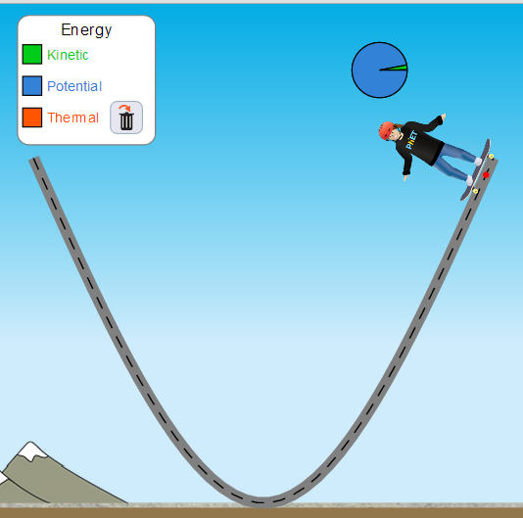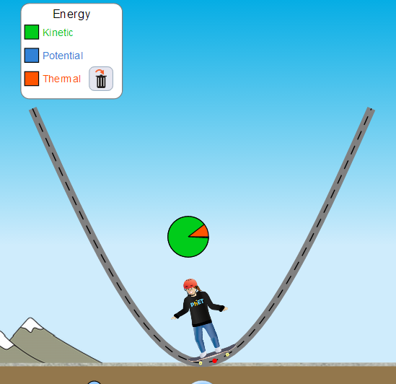
Microscopic Model (Left Image) | Microscopic Model (Right Image)
Macroscopic Model (Left Image) | Macroscopic Model (Right Image)
Part B: Energy Changes in the Skate Park System

Learning Objectives:
1. Differentiate between total energy and various forms of energy in a system.
2. Explain how each model (bar graph and pie chart) shows the total energy of the system, and draw each model for a situation with a different amounts of initial energy.
3. Describe energy changes in a system over time using both words and graphical representations.

Directions: Use the simulation investigate energy in the skate park. Use different tracks on the "Introduction" and "Friction" pages.
1. Describe the system represented by the bar graph and pie chart. Explain your reasoning.
System description
Objects in system | Reasoning

2. Investigate the meaning of “total energy”.
“Total energy” observations from bar graph
At different positions | In relationship to other energy forms

“Total energy” observations from pie chart
At different positions | In relationship to other energy forms

3. Find a way to increase the “total energy”. Draw diagrams of the bar graph and pie chart before and after you increase the “total energy”.
Energy diagrams
 | Before increasing the total energy | After increasing the total energy
Bar graph

Pie chart

What did you do to increase the total energy? ____________________________________

4. Define “total energy” of the system based on your observations.

5. Use “friction” page. Investigate the different forms of energy, and their relative amounts, when the skater is at different positions.
Position of skater | Forms and relative amounts of energy at this position
Top of hill

Middle of hill

Bottom of hill

6. Use trends in the table above to write a “rule” about the changes in energy, including total energy, of the system as the skater moves along the track. Use your own words.

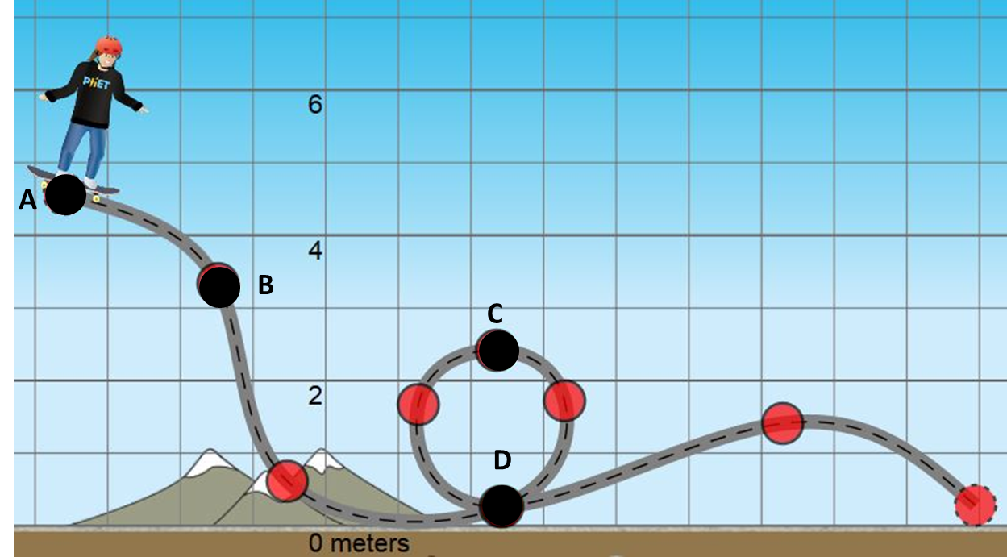
7. Use your experience with the skater system to complete the table below:

Skater’s Position | Describe skater’s speed | Describe energy forms | Graphical representation of energy (bar graph/pie chart/line graph)
A

B

C

D

Part C: Mathematical Model for Conservation of Energy

Learning Objectives:
1. Build , explain, and justify (with the sim) equations for total energy, and conservation of energy.
2. Draw scaled graphical models of energy for an object at a specific position using your energy equations.
3. Write equations for the energy of a system at a specific position using scaled graphical models.

Activity:
1. Based on your observations of total energy at different times and positions, write an equation to show the relationship between the total energy at A and at C. Use the diagram in #7, page 4.
Equation:

2. Use your observations about the relationship between total energy and the different forms of energy (KE, PE, ThE) to build a general equation for the total energy (E_{tot}) in the system.
E_{tot} =
Briefly explain your reasoning.

3. Write out the expanded total energy equations for the skater at positions A and C (in terms of KE, PE, and ThE). Then, combine your two equations to write one equation that shows the relationship between these forms of energy at two different positions (A & C).


5. Compare your new equation with your neighbors’, come to consensus on the best equation, then have your teacher sign off on your equation.

6. Follow the example below to write an equation and sketch a graphical model of the energy in each situation.

System | Equation for Total Energy | Graphical Model of Energy
EXAMPLE  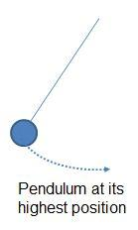 | EXAMPLE  E _{total high}=PE_{high}+KE_{high}+ThE_{high}  so…  E_{total high} = PE_{high} | EXAMPLE  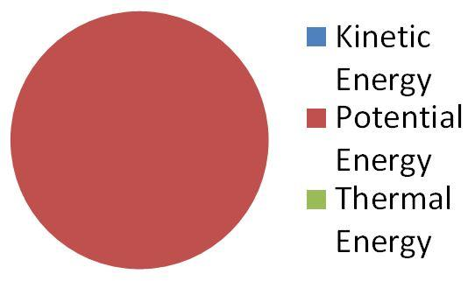
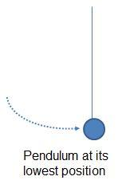

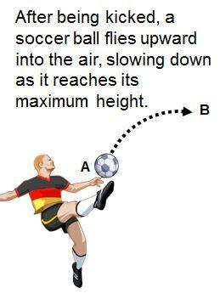

7. Use your energy equations to complete the missing information in the table below:

System | E_{at B} | KE_{at B} | PE_{at B} | ThE_{at A} | E_{at B} | KE_{at B} | PE_{at B} | ThE_{at B}
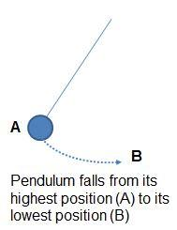 | 16J | 0J | 16J | 0J |  |  | 0J | 2J
 |  |  | 1.1J | 0.3J | 24J | 6.3J |  | 0.7J
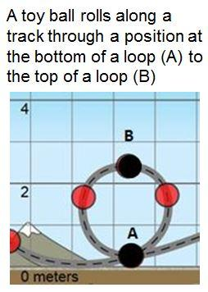 |  | 14.5J | 1J | 0.5J |  | 4.5J |  | 0.9J
(sketch & describe a situation that matches) | 10J | 5J | 5J | 0J |  | 9J | 0.5J

Part D: Applying Conservation of Energy to Solve Real-World Problems

Learning Objectives:
1. Use your energy model and equation to solve energy related problems.
2. Evaluate claims regarding roller coaster designs using evidence and reasoning from your energy model and the sim to support your conclusion.

Directions:
Solve problems, then prepare a white-board to share your answers in a summarizing discussion.
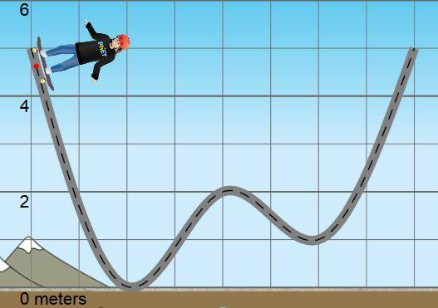
1. A skater begins at a height of 5m, and rolls along a track (see diagram on right). Two students make claims about the changes in the skater’s energy and motion.

Student A: As the skater moves along the track, some of her kinetic energy is converted to thermal energy, so she will lose energy, causing the total energy of the system to decrease. Because the total energy of the system decreases, the skater will not be able to use as much energy to get up the track and will not get back up to her original starting height on the far side of the track.

Student B: As the skater moves along the track, friction will transform some of her kinetic and potential energy into thermal energy, but the total energy of the skater-track system still remains the same. Since the total energy of the system is still the same, the skater will still be able to make it to the top (5m) of the far side of the track.

a. Evaluate each student’s claim and reasoning by identifying the parts you agree or disagree with, and explain your own reasoning.
Student | Agree With….because…. | Disagree With…because…
A
B

b. Write your own prediction of what will happen to the skater, and justify your reasoning.

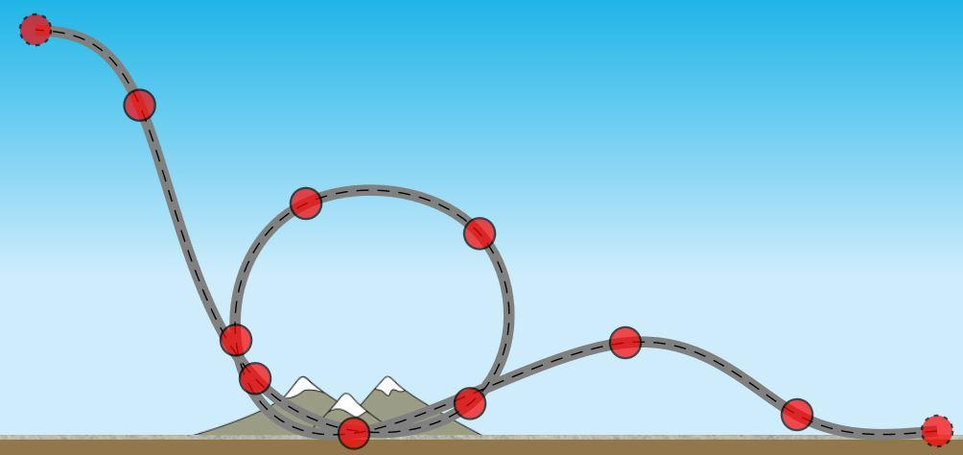
2. An engineering student designed a loop for a roller coaster (see image on right), but did not factor in the effect of friction when calculating the measurements for the design. What changes could be made to the design to ensure that the riders will go fast enough to make it around the loop? Justify your reasoning with evidence from the simulation or the equations.

3. A 1000 kg roller coaster begins on a 10 m tall hill with an initial velocity of 6m/s and travels down before traveling up a second hill. As the coaster moves from its initial height to its lowest position, 1700J of energy is transformed to thermal energy by friction. In order for the roller coaster to safely travel over the second hill, it must be moving at a velocity of 4.6m/s or less at the top of the second hill. What is the maximum height the second hill can be?
