TITLE
Electrolyte and non-electrolyte solutions

AUTHORS
Robert Parson (University of Colorado Boulder)
Trish Loeblein (University of Colorado Boulder)

COURSE
Introductory / Preparatory Chemistry

TYPE
Interactive Lecture Demonstration Guide

TEACHING MODE
Lecture Demonstration

LEARNING GOALS
Students will be able to:
- Explain the difference between electrolytes and nonelectrolytes in terms of conductivity, the nature of the compound, and dissociation.
- Describe and visualize what happens at the atomic or molecular scale when an electrolyte or a nonelectrolyte dissolves in water

COPYRIGHT
This work is licensed under a Creative Commons Attribution 4.0 International License.
This license allows users to share and adapt the materials, as long as appropriate attribution is given (with a link to the original), an indication if changes have been made, and an indication of the original licensing.

Electrolyte and non-electrolyte solutions

KEYWORDS
ionic compounds, molecular compounds, dissociation, conductivity, ionic bonding, covalent bonding, solute, solution, ion, electrolyte

COURSE
Introductory Chemistry
A 200-300 student first-year college chemistry course intended for students who feel that they are underprepared to undertake first-year general chemistry

PLACEMENT IN COURSE
- Week 5 of a 14-week semester

PRIOR KNOWLEDGE
- Distinction between ionic and molecular compounds according to the type of bonding
- Chemical composition (metal + non-metal vs. non-metal only) can be used to classify compounds as ionic or molecular.
- No prior knowledge of the composition of solutions on the sub-microscopic scale was assumed

LEARNING OBJECTIVES
After this activity, students will be able to… | Simulation Used
- Explain the difference between electrolytes and nonelectrolytes in terms of conductivity, the nature of the compound, and dissociation.  - Describe and visualize what happens at the atomic or molecular scale when an electrolyte or a nonelectrolyte dissolves in water | Sugar and Salt Solutions

RESOURCES
Sugar and Salt Solutions
http://phet.colorado.edu/en/simulation/sugar-and-salt-solutions

CONCEPTUAL CHALLENGES
Students at this level have just been introduced to atoms, ions, and ionic vs. covalent bonding, and have difficulty determining what particles a given compound breaks up into when it goes into solution.

Activity Timeline and Details
Total time ~ 30-40 min
Section | Approx. Duration | Details
Conductivity  (Sim demo) | 10 min | Section goal  - Relate conductivity observations to dissolved salt vs. sugar in solution  Preface  - Review definitions of ionic and molecular compounds discussed in previous lectures  REVIEW Concept Question  individual response with discussion encouraged  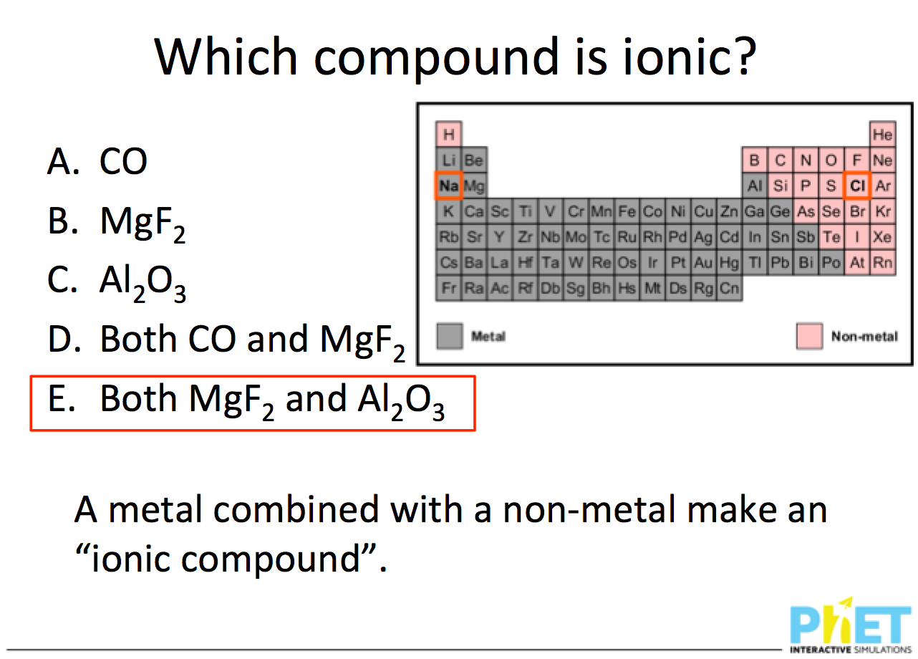  SIM Demonstration (macro tab)  - Close the concentration graph  - Begin by placing the conductivity probe in the water, and then adding some salt to show the light bulb begin to glow.  - Ask students for suggestions of experiments to try, as you demonstrate the available controls in the simulation (faucets, evaporation, salt shaker)  - Reset all and switch to sugar to compare conductivity, asking for student observations. Mix both solutes and ask for student predictions.  - Prompt students with challenges such as, “How could you prove that there is salt in a solution?”
Conductivity (benchtop demo) | 10-15 min | Section goal  - Connect the observations and inferences students made using the sim to conductivity measurement on the benchtop  Benchtop Demonstration  - Compare two unknown solutions labeled “1” and 2”, highlighting that are the visibly the same (colorless, odourless, clear liquids)  - Use a conductivity meter to test each (rinsing off the conductivity probe in between) and then ask:  Concept Question  individual response with discussion encouraged  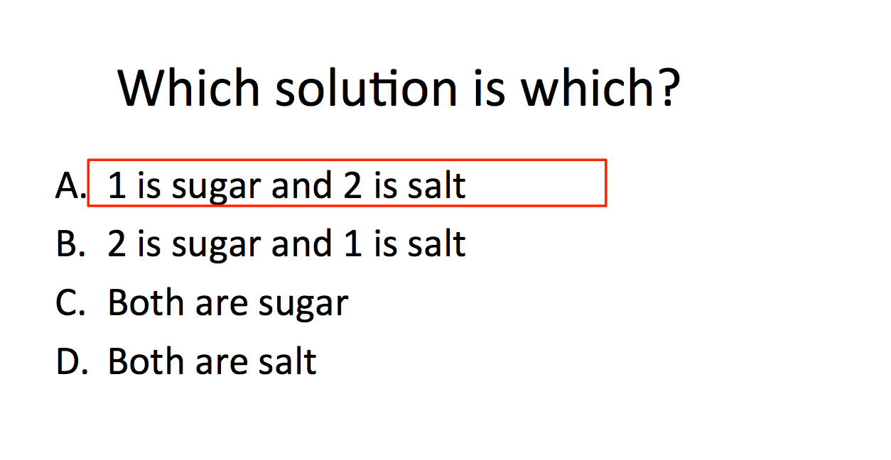  Sample response distribution: 82% correct  Benchtop Demonstration (continued)  - Used the conductivity meter to test the conductivity of distilled water –it is zero within the precision of the meter.  - Ask students why this doesn’t mean it is safe to use electronic equipment when sitting in a bathtub – students recognized that tap water is not the same thing as distilled water, in that it contains dissolved ions.  - Test the conductivity of tap water.  - Return to the sim to demonstrate there that distilled water does not measurably conduct electricity.  Facilitation note  The fact that even pure distilled water does, in principle, conduct electricity at a very low level because of the autoionization of water into H+ and OH- was alluded to briefly but not discussed since it lies outside the scope of an Introductory Chemistry course.  follow-up class discussion question (Optional)  - What would happen if I didn’t rinse the probe off between solutions? Does this depend on what order I test the solutions?  Summary  Introduce the terms “electrolyte” and “non-electrolyte”, relating these back to the sim and benchtop demonstrations
Atomic / sub-microscopic scale behavior of compounds in water | 10 min | Section goal  - Help students identify what ions an ionic compound breaks up into when dissolved in solution  Concept question  individual response with discussion encouraged  Sample response distribution: 66% correct  Follow-up sim demonstration (micro tab)  - Show students NaCl and sucrose dissolving using the micro tab of the sim, and prompt students to discuss with peers  Re-poll Concept question  After class discussion and re-polling of previous question  Sample response distribution: 81% correct  Sim Demonstration (Micro tab)  - Present two contrasting cases:  - NaCl (two monoatomic ions) vs. NaNO₃ (a monoatomic ion combined with a polyatomic anion)  - NaCl vs. CaCl₂ – use the Concentration graph to show the differing ratios of ions  Follow-up class discussion  - Ask students if they notice anything unrealistic about the sim – whether the sim was leaving something out.  - If any students comment that water is not shown as molecules, move to the Water tab of the sim, which does show both solute and solvent as molecules.

