INVESTIGATION OF A SOLUTION’S COLOR

GETTING STARTED
This activity uses two computer simulations. Download each one.
Beer’s Law Lab: http://phet.colorado.edu/en/simulation/beers-law-lab

Color Vision: http://phet.colorado.edu/en/simulation/color-vision

BEER’S LAW LAB
- Explore the controls in the Concentration screen of this sim for a few minutes.

- Can the cation of the solute affect the color of a solution? Can the anion of the solute affect the color of a solution? Provide supporting evidence for each of your responses.

- How does the concentration of a solution affect its appearance? Does changing the concentration change the color, or the intensity of the color?

- A beverage company is having trouble with production. The color of their drink mix is supposed to be light red (consistent with a 0.80 M solution), but that is not always the case. What is going wrong? Provide a plausible reason for each observation.
- The color intensity is to too low, it is too pale.

- The solution color is wrong! It looks blue.

- The solution started out with the correct color intensity, but over time the appearance changed, becoming darker. The employees are sure nothing was added to the open vat.

- Explore the controls in the Beer’s Law screen for a few minutes.

Note: A spectrometer measures the amount of light absorbed by a sample in comparison to the amount emitted by the light source. In this tab you can investigate how a UV-Vis spectrometer functions. When a solution becomes more concentrated it looks darker (the color intensity increases). A spectrometer allows you to measure and quantify this phenomenon.

- Select the drink mix and direct green light though the solution.

- Where is the green light most intense?

- Where is the green light least intense?

- Where is the intensity of the light changing?

- Investigate the intensity of the green light passing through the drink mix and graph your results.

- When green light (wavelength 508 nm) passes through 1 cm of a drink mix solution the absorbance is 1.20. What is the concentration of the drink mix solution?

- If the absorbance = 0.60, what is the concentration?

- If the absorbance = 0.30, what is the concentration?

- Each time the concentration is cut in half, what happens to the concentration?

- The output from a spectrometer for many wavelengths is called a spectrum (plural is spectra). A UV-Vis spectrum is shown for a KMnO₄ solution, with data generated in the simulation. Collect a few data points; check that you get the same absorbance values.

- Label the regions corresponding to the primary colors red, green, and blue.

- What color is the KMnO₄ solution?

- Which primary colors are absorbed by the KMnO₄ solution, and which are not?

- Now use the sim to collect data and sketch the spectrum for a different solution.

- What color is this solution? Which primary colors does it absorb? Which ones does it not absorb (these are transmitted)?

COLOR VISION
Why does a solution appear a particular color?

To help answer this question, open the Color Vision simulation. In the RGB screen, you can change the relative amounts of the primary colors reaching the observer.
Notice how the color of the KMnO₄ solution is reproduced when the eye observes red, blue, but not green (this is consistent with the spectrum!).

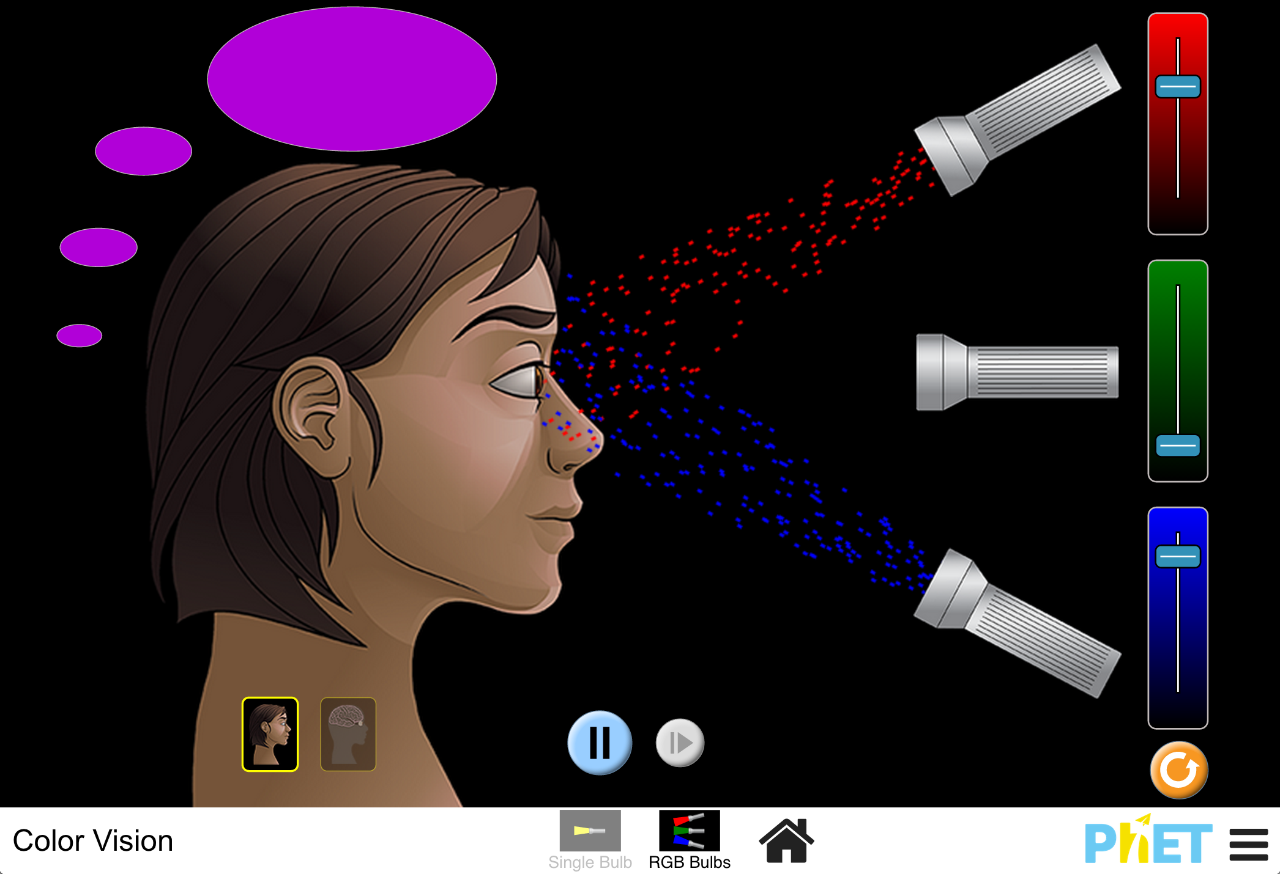

- Try to reproduce the color of the solution you analyzed in the Color Vision simulation.
- Examine your spectrum and determine the relative amounts of red, green, and blue to direct to the observer.
- Does this produce the correct color?

