TITLE
States of Matter Lecture Demonstration

AUTHORS
Robert Parson (University of Colorado Boulder)
Trish Loeblein (University of Colorado Boulder)

COURSE
Introductory / Preparatory Chemistry

TYPE
Interactive Lecture Demonstration Guide

TEACHING MODE
Lecture Demonstration

LEARNING GOALS
Students will be able to:
- Identify the familiar states of matter using atomic and molecular pictures.
- Interpret the unusual properties of water using atomic and molecular pictures.
- Predict how varying the temperature changes the behavior of the atoms or molecules.

COPYRIGHT
This work is licensed under a Creative Commons Attribution 4.0 International License.
This license allows users to share and adapt the materials, as long as appropriate attribution is given (with a link to the original), an indication if changes have been made, and an indication of the original licensing.

STATES OF MATTER LECTURE DEMONSTRATION

KEYWORDS
States of matter, physical change, phases and phase changes, density, temperature, evaporation

COURSE
Introductory Chemistry
A 200-300 student first-year college chemistry course intended for students who feel that they are underprepared to undertake first-year general chemistry

PLACEMENT IN COURSE
- First week of the semester

PRIOR KNOWLEDGE
- No prior chemistry or physics knowledge was assumed

LEARNING OBJECTIVES
After this activity, students will be able to… | Simulation Used
- Identify the familiar states of matter using atomic and molecular pictures.  - Interpret the unusual properties of water using atomic and molecular pictures.  - Predict how varying the temperature changes the behavior of the atoms or molecules. | States of Matter: Basics

RESOURCES
States of Matter: Basics
http://phet.colorado.edu/en/simulation/states-of-matter-basics

CONCEPTUAL CHALLENGES
Students at this level are familiar with states of matter on the macroscopic scale, from everyday life and from earlier science courses, but are not yet comfortable with thinking about matter in terms of the behavior of atoms and molecules.

Activity Timeline and Details
Total time ~ 20 min
Section | Approx. Duration | Details
Introduction and States of Matter | 15 min | Section goal  - Elicit student’s prior knowledge of states of matter and connect this knowledge to atomic-level representations and pictures  Class discussion (4-5 min)  - Begin with the open-ended question, “What are the states of matter?” and prompts for students to describe properties of these states using their own encourage them to discuss their ideas using their own words, rather than to try to repeat what they read in textbooks.  Concept Question 1  individual response with discussion encouraged  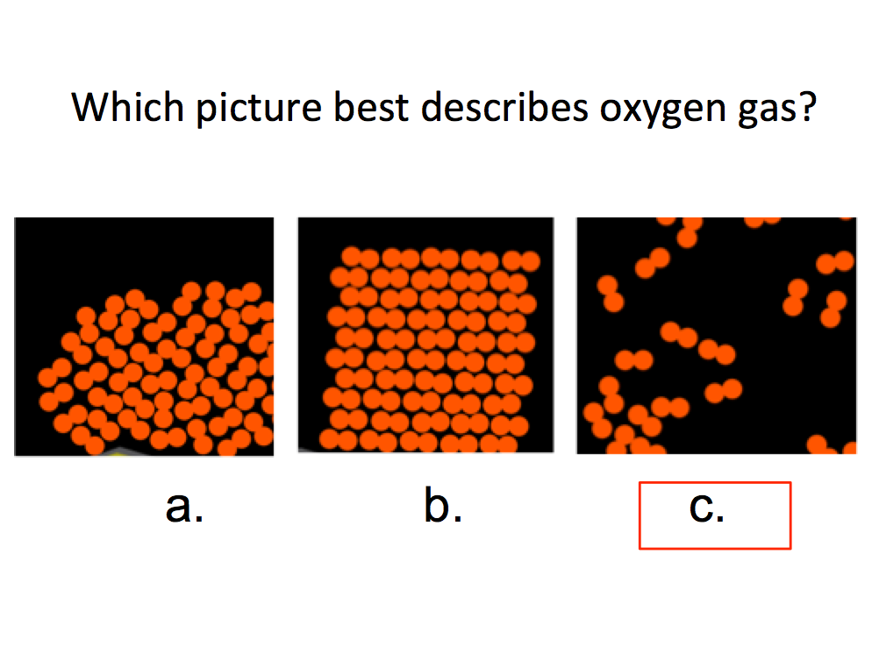  Sample response distribution: 97% correct  Demonstration (3 min)  - Open States of Matter: Basics, and explore first the behavior of O₂ in the solid, liquid, and gaseous states, then contrast with Ne.  - Water was deliberately not shown during this exploration.
Introduction and States of Matter  Continued | --- | Concept Question 2  individual response with discussion encouraged  Sample response distribution: 52% correct  CLASS DISCUSSION (1 min)  - Ask students if they had learned about any unusual properties of water that made it different from other liquids. If students do not mention any properties about ice expanding on their own, ask about their experiences/observations of ice cubes in water.  CONCEPT QUESTION 2 (repeated after class discussion)  Sample response distribution: 74% correct  CLASS DISCUSSION (1 min)  - Ask for students who had changed their answers to explain to the class why their reasoning had changed.  Follow-up Demonstration (1 min)  - Use the sim to explore the solid, liquid, and gaseous states of water.
Effect of temperature on molecules and atoms | 5 min | SECTION GOAL  - Have students use molecular-scale pictures to relate temperature changes to the motion of atoms and phase changes  Concept Question 3  individual response with discussion encouraged  - Choice (a) is intended to check if students ascribe the properties of macroscopic materials to their constituent atoms and molecules as described in the literature  Sample response distribution: 90% correct  DEMONSTRATION  Using Argon as the sample, increase the temperature in the sim to the point where atoms just begin to escape the liquid phase before posing the following question:  CONCEPT QUESTION 4  individual response with discussion encouraged  Sample response distribution: 79% correct (20% chose B)

