Where Should I Live?
Objective: Students will be able to analysis and explain the benefits of environmental adaptations by observing an online simulation and recording the results from a PhET simulation.

TASK 1:
- Begin on the Equator setting. 
- Add a friend (button on the bottom of the habitat simulator screen).
- Add mutation brown fur to the population. Brown fur mutation button is on the left hand side of the screen.
- Observe the rabbit population expand for a few generations. Watch the green gauge bar at the bottom of the simulator screen to watch the number of generations occurring.
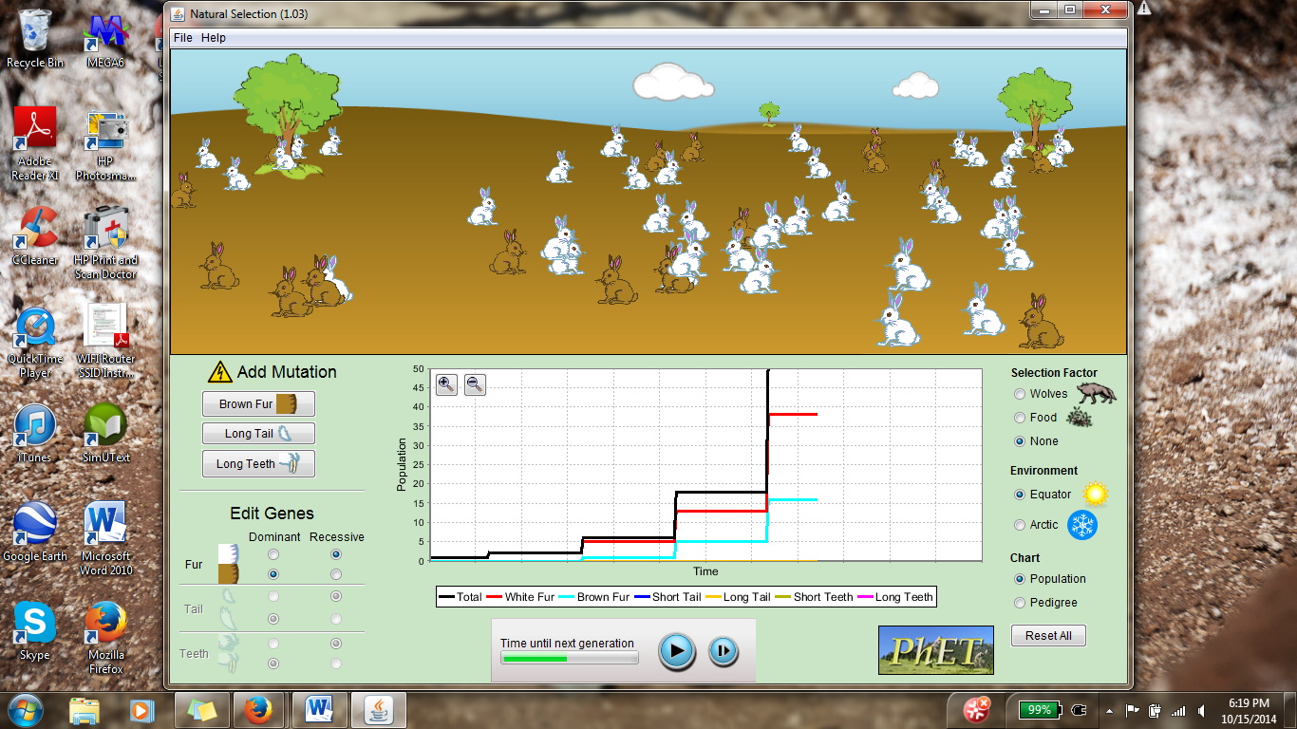
- Add wolves to the habitat. Wolf addition button on the right hand side of the screen.
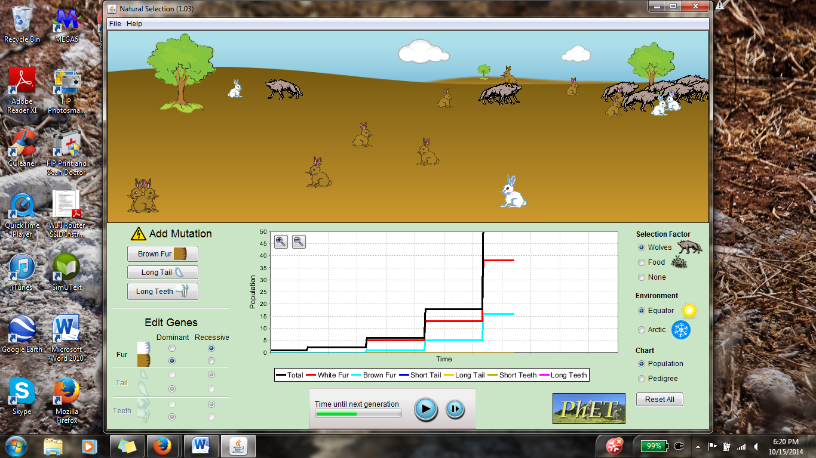
- Observe the rabbit population and pause the simulation. Record which rabbit fur color the wolves are consuming the most. Use the key at the bottom of the chart to differentiate the white vs brown fur population levels.
TASK 2:
- Reset the simulation and change the environment to the artic setting. 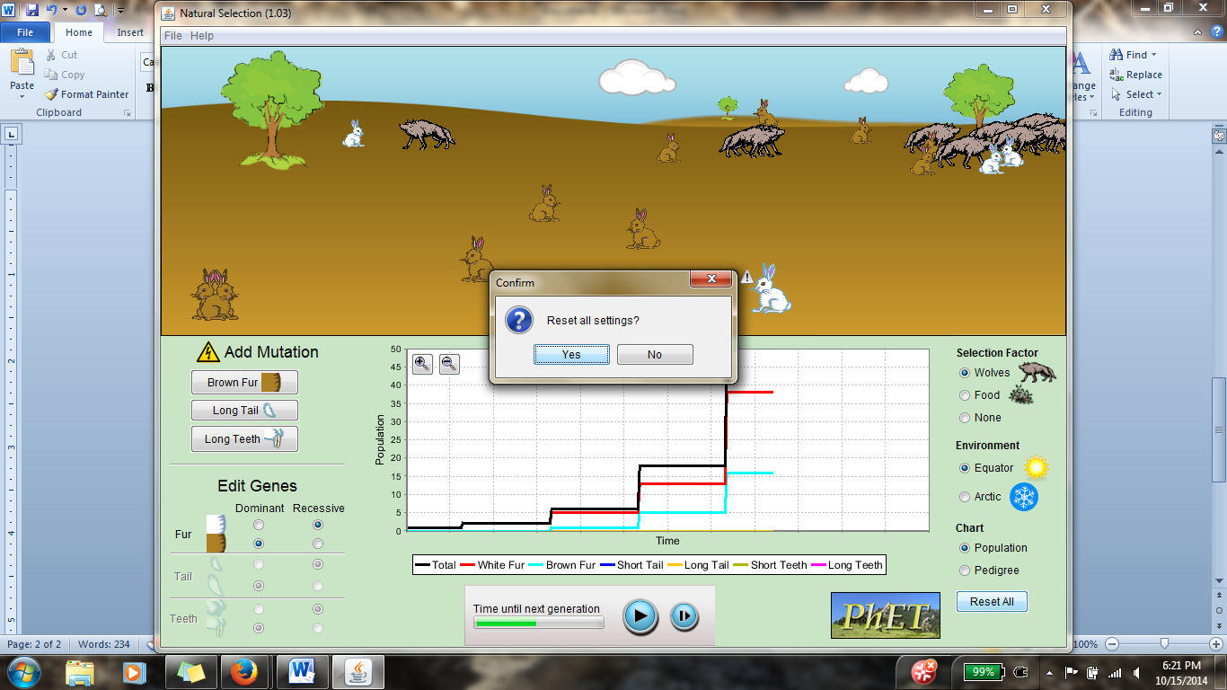
- Add a friend (button on the bottom of the habitat simulator screen).
- Add mutation brown fur. Let the population build for a few generations. Minimize the chart screen with the magnifying glass to see the data being recorded.
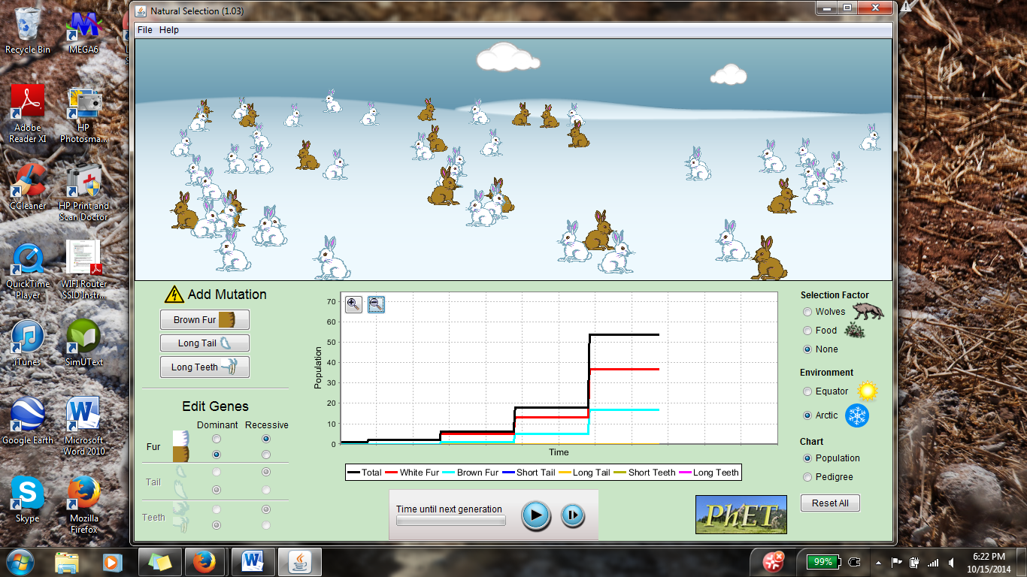
- Add wolves to the habitat. Minimize the chart screen again to observe the data recorded.
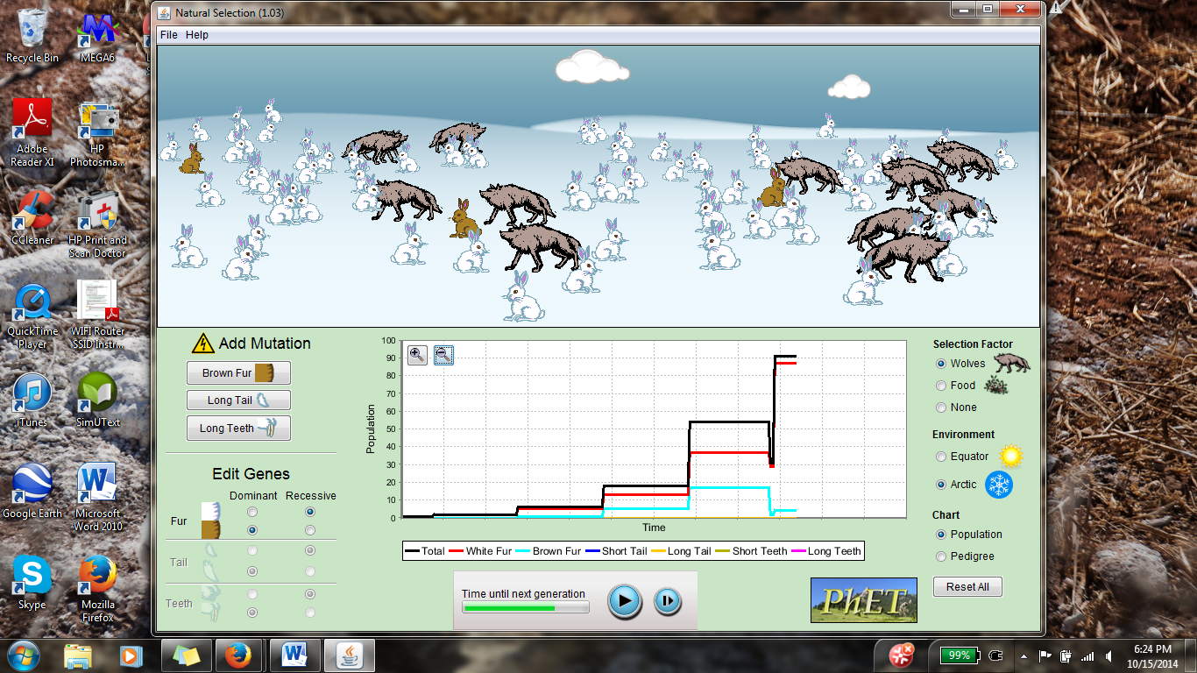
- Observe the rabbit population and pause the simulation after a few seconds. Record which rabbit fur color the wolves are consuming the most. Use the key at the bottom of the chart to differentiate the white vs brown fur population levels.
Discussion Questions:
- What is the wolves’ role in the habitat simulation?

- How does the rabbit fur color relate to the environment?

- Make a hypothesis on what would happen to the rabbit population if the wolf population was present at one time but removed from the habitat. How would the rabbit population be affected? (Test your hypothesis if you have time.)
ANSWER KEY:
- The wolves’ role in the habitat is to maintain and control the rabbit population growth. The control of the rabbit population ensures that the rabbit population doesn’t over expand and take over the habitat.

- The brown rabbit fur color is an advantageous trait at the equator habitat because it allows the rabbits to blend in with their environment, allowing them to reproduce and pass on their genes to the next generation. The white rabbits at the equator habitat are more visible to wolves and therefore, are predated upon more frequently.

The white rabbit fur color is an advantageous trait in the arctic habitat for the same reasons as the brown furred rabbits in the equator habitat. The brown rabbits in the arctic habitat are predated upon more frequently by the wolves because they are more visible in the snow.

- After running the simulation where the wolves were removed from the habitat, the rabbit population expands and takes over the world!
