Name(s): __________________ Electrostatics/Charge Period:_____
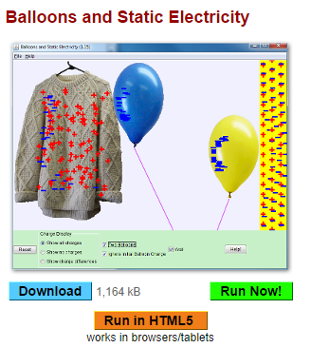
Go to: http://phet.colorado.edu/en/simulation/balloons
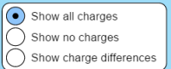
If you have a chromebook or tablet, run the simulation in html5. Otherwise, you can download or run now. Be sure the show all charges choice is selected. Use only 1 balloon for now.
1. Before you do anything in the simulation, describe the initial conditions of the charges ( + and -) in the sweater, balloon and wall.

2. Grab the balloon and briskly rub it on the sweater many times. Describe the amount and type of charge on both the balloon and sweater.

3. Why do you think this happened?

4. Release the rubbed balloon near the sweater. What happens? Explain why.

5. Next, try a charged balloon near the wall? What happens? Describe the charges in the wall itself too.

6. Select two balloons. Charge one only slightly, charge the other much more. Place both on the wall. Remove the slightly charged one from the wall so that it will float to the sweater. Then do the same with the highly charged one. What differences do you observe? Explain why this happened.

7. Can you create a situation where a charged balloon is in equilibrium? Try to make is float motionless somewhere. Does it make a difference if it has a little or a lot of charge on it? Explain your findings.

