Day 3: Equivalent Fractions

Target Group: Adaptable for 2-4th grades; Meets 3rd grade CCS

Prior Knowledge: All pieces in a fraction are equivalent in size; Numerators indicate the number of equal parts being considered; Denominators indicate the total number of equal part into which a whole is partitioned.

Lesson Objective: Students will use their knowledge of numerators and denominators to order and compare fractions.
- CCSS.Math.Content.3.NF.A.1
Understand a fraction 1/b as the quantity formed by 1 part when a whole is partitioned into b equal parts; understand a fraction a/b as the quantity formed by a parts of size 1/b.
- CCSS.Math.Content.3.NF.A.3
Explain equivalence of fractions in special cases, and compare fractions by reasoning about their size.

Time: 45 minutes – 60 minutes
Materials:
- Activity Sheet for each student (see below)
- Laptop/Computer for each student
- Build a Fraction Simulation: http://phet.colorado.edu/en/simulation/build-a-fraction
- Projector/document camera (optional)

Time | Procedure | Teaching Tips
10 minutes | - Distribute activity sheets and have students access the Build a Fraction Sim: http://phet.colorado.edu/en/simulation/build-a-fraction  - Explore: Students will review previous learning as they play Build a Fraction for 5 minutes. Monitor student work and encourage students to talk with their partner if they are stuck.  - After 5 minutes, have students open the 3rd tab, “Fraction Lab.” Allow students to explore the features of this tab for 5 minutes.  - Project the sim for everyone to see, and have students share interesting features or observations of the Fraction Lab tab.  - Read today’s objective with the class. Ask students what smaller word “equivalence” sounds like (equal). Tell students that fractions that represent the same amount can have different names and are called equivalent fractions. | - To save time, set up the sim on student laptops prior to lesson; if not possible, have a link students can click or download the sim to the desktop rather than typing in URL.  - Circulate and take note of features that students should share with whole class. (For #2, students will need the rectangle shape. Point out how to change this if a student does not bring it up during discussion.)
10 minutes | - Look at number 1 with students. They will use the Fraction Lab to find 3 other fractions that are equivalent, or the same, as ½. Encourage students to share their ideas with their partner.  - Circulate and take note of how students are solving the problem. There are several strategies that students may use. For example, some students may use the ½ piece and use the partitioning arrows to find fractions of the same size. Others may create more than one representation to compare.  - As students are finishing up, project the Fraction Lab for class discussion.  - Call on students to share equivalent fractions and their strategies for finding them. | - I like to move kids from their desks to our meeting area for whole group discussion.  - Highlight various strategies by calling on students you noted while circulating. This will help struggling students with #s 3-4.
10 minutes | - After class discussion & visuals, send pairs back to their computers to work on problems #3-5.  - Offer assistance if needed, but encourage student partners to work together before helping.  - Share solutions for number 5 with the class. Use a document camera to project student work, if possible. | - Question # 5 may be answered in different ways. Look for students who notice the numerical relationships ($\frac{1}{4}$is two $\frac{1}{8}$ sized pieces; $\frac{2}{8}$ is $\frac{2}{2}$ x $\frac{1}{4}$) and students who use visual representations to explain equivalence. Share model answers highlighting both types of solutions before moving onto #6.
10 minutes | - Guide students to look at the pictorial models of the fractions in the box on the back of the activity sheet. Looking at the models, you can see that the amounts are the same, even though the wholes are cut into different size pieces. Ask students how many sixths are in one third and how many twelfths are in one fourth to elicit the multiplicative property of equivalence.  - In #6, have students turn and talk about the shared relationship between the equivalent numerators and denominators. Students will try to determine if there is a rule for finding equivalent fractions.  - For students who come up with the rule (multiply or divide the numerator and denominator by the same number), they can test different fractions from the front of their activity sheet.  - After most students have finished partner discussion and writing down their ideas, call all students together for a class discussion. Project the sim as students share their thinking. | - Depending on level of students, some may figure out that you can multiply to find equivalent fractions while others may rely on the visual. Be flexible, and share both in the group discussion.

Name _____________________________________________________________ Date_____________________

III. Equivalent Fractions
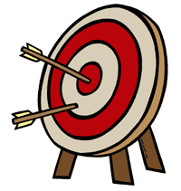
Lesson Objective: We will use our knowledge of numerators and denominators and visual representations to find equivalent fractions.

- Explore: Play with the first tab, “Build a Fraction,” for 5 minutes.

Third Tab: Fraction Lab
2. Find three or more fractions that are equivalent to ½. Sketch your findings below.
½

3. Represent $\frac{4}{6}$ two different ways. 4. Represent $\frac{3}{4}$ two different ways.
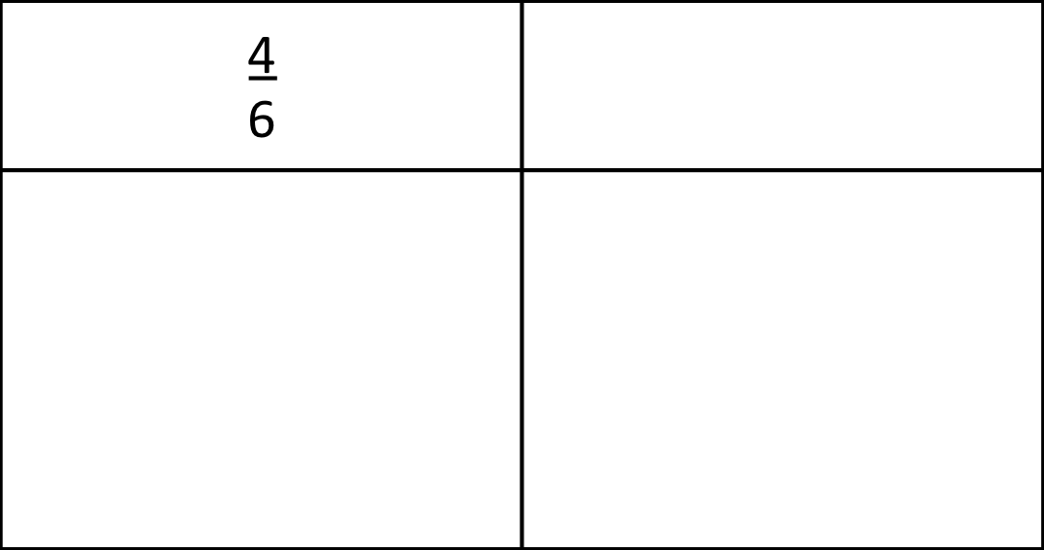

3
4

5. How can you explain to a student who has not played the sim that 1 = 2 ?
Use words, symbols, or pictures to help them see the equivalence. 4 8

$\frac{1}{3}$ = $\frac{2}{6}$ | $\frac{2}{4}$ = $\frac{6}{12}$
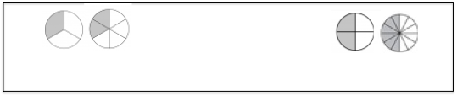
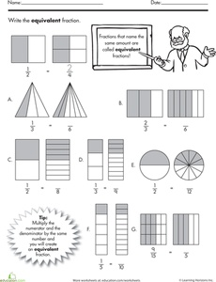
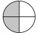

6. Turn and Talk: Try to identify a relationship between the two numerators and the two denominators in each of the equivalent fraction pairs above. Share your ideas.

How can you tell when fractions are equivalent? Can you find a pattern?

