Ladybug Motion in 3rd Grade

This activity provides practice with using motion words and representing motion, and is used in 3rd grade in conjunction with the Battle Creek Science kit science program (Michigan). This activity, combined with a few others (that didn’t use PhET simulations), are used to supplement/replace some of the Force and Motion activities in the Battle Creek kit.

Remind students about the Direction and Speed words they listed in the last activity (earlier in this unit, students learn about words to describe motion—direction, speed, and position). Students learned in the previous lesson that the distance between dots relates to the speed of the object. This idea can be demonstrated in this activity, the “dot pictures” do not need to be prior knowledge.

Show students the ladybug motion PhET simulation (http://phet.colorado.edu/en/simulation/ladybug-motion-2d). Set it up as follows:

- Vectors, Hide Vectors (top box)
- Choose Motion, Manual (second box)
- Trace, Dots (third box)
- Remote Control, Position (bottom box)

These settings will allow you to move the ladybug around the screen and record its path. The path will be traced out with dots. The dots get far apart when the ladybug moves fast, and are closer together when the motion is slow.

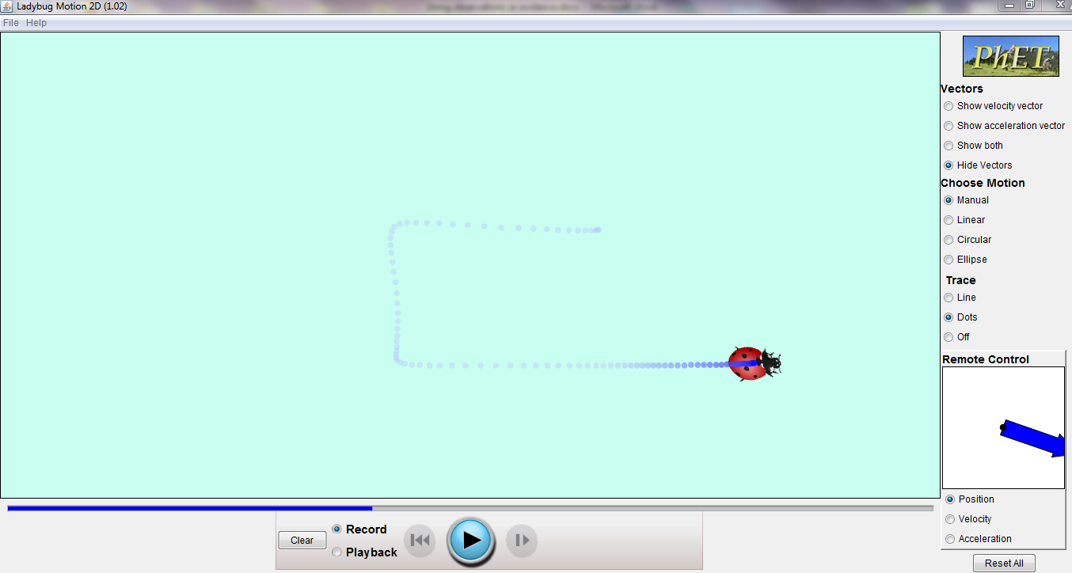

Move the ladybug around the screen in whatever path you choose by clicking on the ladybug and holding the mouse button down as you move. Alternatively, run this on the Smartboard and drag your finger around in a path. Better still, allow students to explore in groups on their own computers, then tell you what they found. The path will automatically be recorded. NOTE—watch the blue bar that begins above the Record panel—this is a timer. Stop moving before it gets all the way across the screen or you will lose the beginning of your motion.
Select the Playback button. The ladybug will reset at its beginning spot. Press the play (blue arrow button) to retrace the path. A slider screen will appear that will let you speed up or slow down the playback. You can reverse, fast forward, and pause (pause is the blue arrow play button) the ladybug.

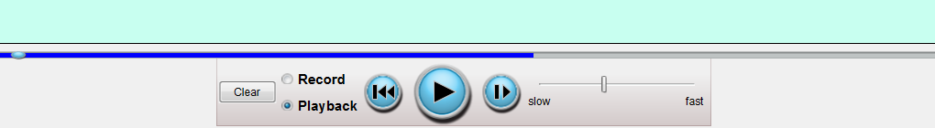

Have students observe the motion of the ladybug. Play the motion back, pausing the motion when the ladybug changes speed or direction. Ask the students how they could describe the motion. You may wish to decide which direction in your room is North, South, etc.

Ask students what the dots mean, what it means when they are close together or farther apart.

Once students are comfortable with how the ladybug moves and what the path shows, clear the screen by selecting the Reset All button in the lower right (NOTE—this resets all the buttons, so reselect the four options).

Hand out the Direction and Speed Words for Ladybug handout (half sheet). Explain to students that they will describe the motion of the ladybug.

Make the ladybug move again and record the motion. Better yet, allow small groups of students to create their own ladybug traces on their own computers. Allow students to discuss/discover how to best play back their ladybug motion to write about it. Allow students to write about the motion (speed, direction) of the ladybug. Prompt, redirect, and have students share as appropriate.

Allow the students to share their papers with 1-2 other people, or discuss a few as a class. Listen for speed and direction words that accurately describe the motion of the ladybug.

Assessment can be formative or summative. Teachers can read through/listen to student responses to check how well they are able to describe motion. Teachers can collect the written responses and score it for content, appropriate word use, writing skills, whatever is appropriate and reasonable for their classroom.


Direction and Speed Words for a Ladybug

Direction and Speed Words for a Ladybug

