Name _____________________________________________________________ Date_____________________

Exploring Kinds of Circuits

Objective: We will use our knowledge of electric circuits to create and analyze different pathways that can light several bulbs at once.

1. Explore: Take 5 minutes to explore the sim and build a working circuit. Draw your successful circuit below and label the electricity source and receiver.


2. Turn and Talk: Share your working circuit with your partner.
- Is there more than one way to create a working circuit?
- What do working circuits require?

Inquiry Question: Can you light several bulbs brightly with one battery?

3. Complete the following table by creating, drawing, and observing circuits that meet the criteria.
Create a circuit using… | Drawing of your circuit: | Did the bulb or bulbs light? |  | Observations  brightness? speed of electrons?
1 bulb, 1 battery, 3 wires |  | Yes | No
2 bulbs, 1 battery, 3 wires |  | Yes | No
2 bulbs, 1 battery, 4 wires |  | Yes | No
Try that one again: Make a different circuit using  2 bulbs, 1 battery, 4 wires |  | Yes | No

4. Turn and Talk:
- Were you able to create a circuit that lights 2 bulbs brightly?
- How is this kind of circuit different from circuits with 2 dimly lit bulbs
or 1 bulb?

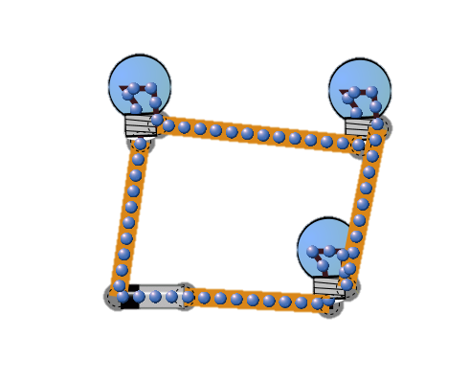
5. Circuit A is a working circuit that uses 3 bulbs and 1 battery. The electrons flow throughout the circuit, but the bulbs do not light brightly. They’re so dim you can hardly tell that they are lit!

Circuit A:

Without the sim, design a circuit that lights 3 bulbs brightly using only 1 battery. Draw your circuit below.

6. Turn and Talk: In Circuit A, what would happen if one of the light bulbs burned out or broke? What about in the circuit you designed?

7.
Type of Circuit | What it is | What it looks like
_________________ Circuit | a circuit that has one pathway for electricity to flow from the source to all receivers
_________________ Circuit | a circuit that has individual pathways from the source to each receiver

8. Imagine you work for a company that designs strings of Christmas lights. Which type of circuit would be the best design to use? Why? Use evidence from your investigation to support your choice.

