II. Exploring Circuits

Target Group: 3rd – 5th grade (meets 4th grade NGSS standard)

Prior Knowledge: This is intended as a follow-up lesson to Lighting a Light Bulb; It can also be adapted to stand alone, in which case students would need to know that circuits are like a loop or pathway that electrons follow from the source receiver.

Lesson Objective: We will use our knowledge of circuits to create pathways that can light several bulbs at once.
- NGSS Standard 4-PS3-2: Make observations to provide evidence that energy can be transferred from place to place by sound, light, heat, and electric currents.
- CDE Physical Science 1.1: Energy comes in many forms such as light, heat, sound, magnetic, chemical, and electrical (1.1a) electricity in circuits requires a complete loop through which current can pass
- CCSS.ELA-Literacy.SL.4.1: Engage effectively in a range of collaborative discussions (1-on-1, in groups, and teacher-led) with diverse partners on grade 4 topics and texts, building on others' ideas and expressing their own clearly.

Time: 45 - 60 minutes
Materials:
- Activity Sheet for each student (see below)
- Laptop/computer for each student
- PhET Sim: Circuit Construction Kit (DC Only) http://phet.colorado.edu/en/simulation/circuit-construction-kit-dc
- Projector (optional)
- String of Christmas lights

Time | Procedure | Teaching Tips
10 minutes | - Distribute Activity sheets and have students access the sim: http://phet.colorado.edu/en/simulation/circuit-construction-kit-dc  - (#1) Explore: Students will reinforce their learning from the previous lesson by exploring the sim and making a successful circuit.  - (#2) Have students Turn and Talk with their partner to share circuit and discuss the question, “Is there more than 1 way to make a working circuit?” “What do working circuits require?”  - A circuit is the pathway that electrons follow to produce electricity. It requires an electricity source (battery) and receiver (bulb). | - Setting up computers with the sim prior to lesson saves time.  - Rather than an introduction that reviews concepts learned in Day 1, students will use (& refresh!) this knowledge in the Explore.  - Share a few students’ drawings of successful circuits under doc cam during review discussion.  - Establish turn&talk norms at the beginning of the year so that students use their discussion &collaboration time effectively.
15 minutes | - Review today’s objective with students.  - We will be creating different types of circuits that will keep several bulbs lit brightly, no matter how many there are or if one bulb goes out.  - Read inquiry question with kids: Can you light several bulbs brightly with one battery?  - (#3) Students will complete the table in order to explore different configurations until they can light 2 bulbs brightly.  - First, all students will create a working circuit with one bulb and one battery to observe the bulb’s brightness.  - Then, students will be tasked with adding a second bulb to that circuit.  - Suggested questions to ask as you circulate:  - What do you notice about the brightness of the bulbs?  - Why do you think this happens?  - Monitor student exploration in order to elicit examples of circuits that light 2 bulbs brightly during whole class discussion. The discussion is an important component of student understanding the 2 different types of circuits.  - After about 15 minutes or as students are wrapping up the table, call students’ attention to the two Turn and Talk questions (#4). | - Project the Activity Sheet and review expectations for each column before setting students off to work on each task.  - Take note of different ways of creating the circuits so that you can call on these students to share.
5 minutes | - (#4) Students will Turn and Talk: Were you able to create a circuit that lights 2 bulbs brightly? How is this kind of circuit different from circuits with 2 dimly lit bulbs or 1 bulb?  - Call on students who had a successful parallel circuit to share with class. Discuss similarities across the solutions and point out how this type of circuit uses only one source, but both receivers have their own pathway for electrons to flow on.  - Draw or display the 2 different types of circuits on the board and discuss the difference. | 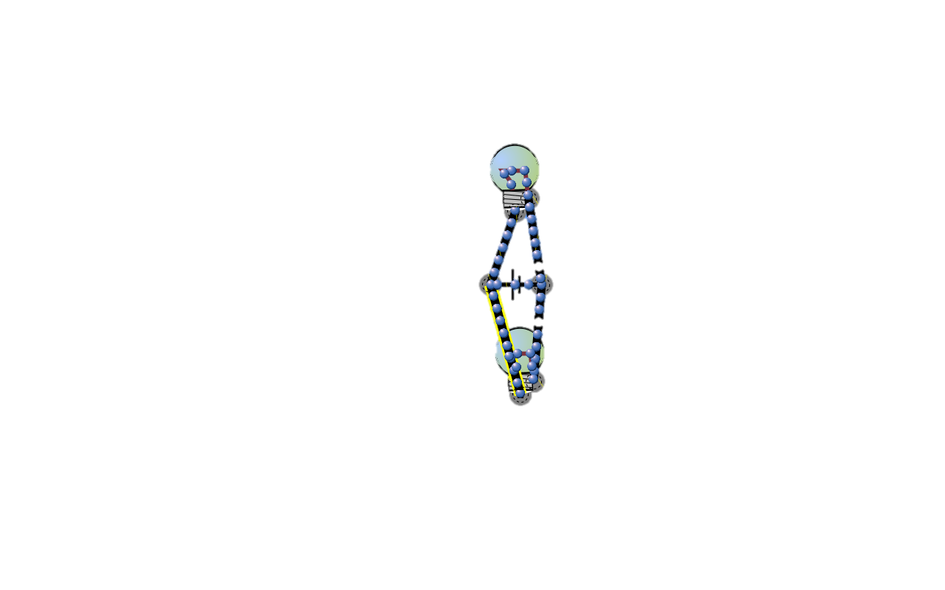    Series: Parallel:
10 minutes | - (#5) Read the situation in #5 with the class.  - Students look at a series circuit with 3 bulbs and then must design another circuit that will light them brightly.  - (6) Students will talk with a partner about what would happen if a bulb burns out in the series circuit (Circuit A). After their discussion, student pairs can test their theories together or it can be done as a whole class, depending on time constraints. | - Remind students that when designing their circuit, they are not testing it with the sim, but using their knowledge from the class discussion above. They will be able to share ideas and test in #6.
5 minutes | - Introduce the terms series circuits and parallel circuits. Students will fill in (#7) the table on their activity sheet as each type of circuit is displayed/discussed. | - In my classroom, we have a Science Wall to anchor student learning. Each time new vocabulary or concepts are introduced, the word, definition, and an illustration/picture (often depicted by a student) are added to the wall. Students use the Science Wall as a reference throughout units.
10 – 15 minutes | - Show students a string of Christmas lights and tell them to imagine that they work for a company that produces these types of lights.  - (#8) Based on their investigation today, which type of circuit would be best for a string of lights? Why?  - Have students discuss ideas and then complete the short constructed response. | - If students need writing support, the teacher might provide scaffolding by guiding these students to use a graphic organizer of pros/cons for each circuit type or providing sentence frames. (i.e “A ________ circuit would be best for a string of lights because __”)

Name _____________________________________________________________ Date_____________________

Exploring Kinds of Circuits

Objective: We will use our knowledge of electric circuits to create and analyze different pathways that can light several bulbs at once.

1. Explore: Take 5 minutes to explore the sim and build a working circuit. Draw your successful circuit below and label the electricity source and receiver.


2. Turn and Talk: Share your working circuit with your partner.
- Is there more than one way to create a working circuit?
- What do working circuits require?

Inquiry Question: Can you light several bulbs brightly with one battery?

3. Complete the following table by creating, drawing, and observing circuits that meet the criteria.
Create a circuit using… | Drawing of your circuit: | Did the bulb or bulbs light? |  | Observations  brightness? speed of electrons?
1 bulb, 1 battery, 3 wires |  | Yes | No
2 bulbs, 1 battery, 3 wires |  | Yes | No
2 bulbs, 1 battery, 4 wires |  | Yes | No
Try that one again: Make a different circuit using  2 bulbs, 1 battery, 4 wires |  | Yes | No

4. Turn and Talk:
- Were you able to create a circuit that lights 2 bulbs brightly?
- How is this kind of circuit different from circuits with 2 dimly lit bulbs
or 1 bulb?

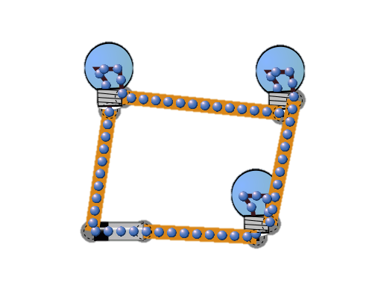
5. Circuit A is a working circuit that uses 3 bulbs and 1 battery. The electrons flow throughout the circuit, but the bulbs do not light brightly. They’re so dim you can hardly tell that they are lit!

Circuit A:

Without the sim, design a circuit that lights 3 bulbs brightly using only 1 battery. Draw your circuit below.

6. Turn and Talk: In Circuit A, what would happen if one of the light bulbs burned out or broke? What about in the circuit you designed?

7.
Type of Circuit | What it is | What it looks like
_________________ Circuit | a circuit that has one pathway for electricity to flow from the source to all receivers
_________________ Circuit | a circuit that has individual pathways from the source to each receiver

8. Imagine you work for a company that designs strings of Christmas lights. Which type of circuit would be the best design to use? Why? Use evidence from your investigation to support your choice.

